

**INFORMATICS INSTITUTE OF TECHNOLOGY**

**DEPARTMENT OF COMPUTING**

**(B.Eng.) in Software Engineering**

Module code: 5COSC021C

**Machine Learning and Data Mining**

**Module Leader:** Mr. Nipuna Senanayake

**Student Name** : Gorakapitiyage Induranga Kawishwara

**Student ID**: 20200688

**UoW ID** : w1913278

Table of Contents

1. Partitioning Clustering 1

1.1. 1st Subtask Objectives 1

1.1.1. Pre-processing Task 1

3

1.1.2. Determine the number of cluster centers via four “automated tools.” 5

1.1.3. Kmeans clustering investigation 10

1.1.4. Code section for silhouette plot 14

**1.2.** **2nd Subtask Objectives** 17

1.2.1. What is pcs principle? 17

1.2.2. PCs that provide at least cumulative score 17

1.2.3. Determine the number of cluster centers via four “automated tools.” 19

1.2.4. Evaluation metrics for k-means clustering. 23

1.2.5. Provide the silhouette plot which displays how close each point. 27

1.2.6. Implement and show the Calinski-Harabasz index 28

2. Multi-layer Neural Network 31

2.1. 1st Subtask Objectives 31

2.1.1. Part A 31

*2.1.2.* *Normalization* 33

2.1.3. Training Neural Networks 34

2.1.4. RMSE, MAE, MAPE, and sMAPE 39

2.1.5. Comparison table 41

2.1.6. Best one-hidden layer & two-hidden layer 42

2.2. 2nd Subtask Objectives 44

2.2.1. make a matrix of inputs 44

2.2.2. Normalization 44

2.2.3. NN model development 45

2.3.4. Comparison table 47

2.3.5. Best MLP network 48

3. References 50

4. Appendix 52

4.1. Part 01 52

4.2. Part 02 73

TABLE OF FIGURES

Figure 1 : get data from file 1

[Figure 2:Code part to remove outliers 2](https://universityofwestminster-my.sharepoint.com/personal/w1913278_westminster_ac_uk/Documents/cw%20report%20induranga_20200688.docx#_Toc134307874)

[Figure 3:boxplot of after removing outliers 2](https://universityofwestminster-my.sharepoint.com/personal/w1913278_westminster_ac_uk/Documents/cw%20report%20induranga_20200688.docx#_Toc134307875)

[Figure 4:boxplot of before removing outliers 3](https://universityofwestminster-my.sharepoint.com/personal/w1913278_westminster_ac_uk/Documents/cw%20report%20induranga_20200688.docx#_Toc134307876)

[Figure 5:scaling_code 3](https://universityofwestminster-my.sharepoint.com/personal/w1913278_westminster_ac_uk/Documents/cw%20report%20induranga_20200688.docx#_Toc134307877)

[Figure 6:after removing outliers and scaling 4](https://universityofwestminster-my.sharepoint.com/personal/w1913278_westminster_ac_uk/Documents/cw%20report%20induranga_20200688.docx#_Toc134307878)

[Figure 7:NBclust code 5](https://universityofwestminster-my.sharepoint.com/personal/w1913278_westminster_ac_uk/Documents/cw%20report%20induranga_20200688.docx#_Toc134307879)

[Figure 8:NBclust_output_1 6](https://universityofwestminster-my.sharepoint.com/personal/w1913278_westminster_ac_uk/Documents/cw%20report%20induranga_20200688.docx#_Toc134307880)

[Figure 9:NBclust_output2 6](https://universityofwestminster-my.sharepoint.com/personal/w1913278_westminster_ac_uk/Documents/cw%20report%20induranga_20200688.docx#_Toc134307881)

Figure 10:elbow code 7

[Figure 11:elbow_output 7](https://universityofwestminster-my.sharepoint.com/personal/w1913278_westminster_ac_uk/Documents/cw%20report%20induranga_20200688.docx#_Toc134307883)

Figure 12:silhouette_code 8

[Figure 13:silhouette_output 8](https://universityofwestminster-my.sharepoint.com/personal/w1913278_westminster_ac_uk/Documents/cw%20report%20induranga_20200688.docx#_Toc134307885)

Figure 14:Gap 9

[Figure 15:Gap_output 9](https://universityofwestminster-my.sharepoint.com/personal/w1913278_westminster_ac_uk/Documents/cw%20report%20induranga_20200688.docx#_Toc134307887)

Figure 16:clustering_code(k=2) 10

[Figure 17:clutering_output(k=2) 10](https://universityofwestminster-my.sharepoint.com/personal/w1913278_westminster_ac_uk/Documents/cw%20report%20induranga_20200688.docx#_Toc134307889)

Figure 18:ratio_calculation(k=2) 11

Figure 19:ratio_calculation_output(k=2) 11

Figure 20:clutering_code(k=3) 12

[Figure 21:clutering_output(k=3) 12](https://universityofwestminster-my.sharepoint.com/personal/w1913278_westminster_ac_uk/Documents/cw%20report%20induranga_20200688.docx#_Toc134307893)

[Figure 22:ratio_calculation(k=3) 13](https://universityofwestminster-my.sharepoint.com/personal/w1913278_westminster_ac_uk/Documents/cw%20report%20induranga_20200688.docx#_Toc134307894)

[Figure 23:ratio_calculation_output(k=3) 13](https://universityofwestminster-my.sharepoint.com/personal/w1913278_westminster_ac_uk/Documents/cw%20report%20induranga_20200688.docx#_Toc134307895)

[Figure 24:sihoutte_plot(k=2) 14](https://universityofwestminster-my.sharepoint.com/personal/w1913278_westminster_ac_uk/Documents/cw%20report%20induranga_20200688.docx#_Toc134307896)

[Figure 25:sihoutte_plot_output(k=2) 15](https://universityofwestminster-my.sharepoint.com/personal/w1913278_westminster_ac_uk/Documents/cw%20report%20induranga_20200688.docx#_Toc134307897)

[Figure 26:Figure 23:sihoutte_plot(k=3) 15](https://universityofwestminster-my.sharepoint.com/personal/w1913278_westminster_ac_uk/Documents/cw%20report%20induranga_20200688.docx#_Toc134307898)

[Figure 27:sihoutte_plot_output(k=3) 16](https://universityofwestminster-my.sharepoint.com/personal/w1913278_westminster_ac_uk/Documents/cw%20report%20induranga_20200688.docx#_Toc134307899)

[Figure 28:code for pca 17](https://universityofwestminster-my.sharepoint.com/personal/w1913278_westminster_ac_uk/Documents/cw%20report%20induranga_20200688.docx#_Toc134307900)

Figure 29:pca_out_1 18

[Figure 30:pca_output_3 18](https://universityofwestminster-my.sharepoint.com/personal/w1913278_westminster_ac_uk/Documents/cw%20report%20induranga_20200688.docx#_Toc134307902)

[Figure 31:pca_output_2 18](https://universityofwestminster-my.sharepoint.com/personal/w1913278_westminster_ac_uk/Documents/cw%20report%20induranga_20200688.docx#_Toc134307903)

Figure 32:Nbclust_code 19

Figure 33:NbClust_output 19

[Figure 34:elbow_code_pca 20](https://universityofwestminster-my.sharepoint.com/personal/w1913278_westminster_ac_uk/Documents/cw%20report%20induranga_20200688.docx#_Toc134307906)

Figure 35:elbow_output_pca 20

Figure 36:code_section_silhouette 21

Figure 37:silhoutte_pca_output 21

Figure 38:gap_code_pca 22

Figure 39:gap_output_pca 22

[Figure 40:code_ for_kmean_pca(k=2) 23](https://universityofwestminster-my.sharepoint.com/personal/w1913278_westminster_ac_uk/Documents/cw%20report%20induranga_20200688.docx#_Toc134307912)

[Figure 41:cluster_pca_output_1(k=2) 23](https://universityofwestminster-my.sharepoint.com/personal/w1913278_westminster_ac_uk/Documents/cw%20report%20induranga_20200688.docx#_Toc134307913)

[Figure 42:cluster_pca_output(k=2) 24](https://universityofwestminster-my.sharepoint.com/personal/w1913278_westminster_ac_uk/Documents/cw%20report%20induranga_20200688.docx#_Toc134307914)

[Figure 43:code_ for_kmean_pca(k=3) 25](https://universityofwestminster-my.sharepoint.com/personal/w1913278_westminster_ac_uk/Documents/cw%20report%20induranga_20200688.docx#_Toc134307915)

[Figure 44:cluster_pca_output1(k=3) 25](https://universityofwestminster-my.sharepoint.com/personal/w1913278_westminster_ac_uk/Documents/cw%20report%20induranga_20200688.docx#_Toc134307916)

[Figure 45:cluster_pca_output2(k=3) 26](https://universityofwestminster-my.sharepoint.com/personal/w1913278_westminster_ac_uk/Documents/cw%20report%20induranga_20200688.docx#_Toc134307917)

[Figure 46:silhoutte_plot_pca(k=2) 27](https://universityofwestminster-my.sharepoint.com/personal/w1913278_westminster_ac_uk/Documents/cw%20report%20induranga_20200688.docx#_Toc134307918)

[Figure 47:silhouette_code_pca 27](https://universityofwestminster-my.sharepoint.com/personal/w1913278_westminster_ac_uk/Documents/cw%20report%20induranga_20200688.docx#_Toc134307919)

[Figure 48:silhoutte_plot_pca(k=3) 27](https://universityofwestminster-my.sharepoint.com/personal/w1913278_westminster_ac_uk/Documents/cw%20report%20induranga_20200688.docx#_Toc134307920)

[Figure 49: the Calinski-Harabasz _formular 28](https://universityofwestminster-my.sharepoint.com/personal/w1913278_westminster_ac_uk/Documents/cw%20report%20induranga_20200688.docx#_Toc134307921)

[Figure 50:the Calinski-Harabasz code(K=2) 28](https://universityofwestminster-my.sharepoint.com/personal/w1913278_westminster_ac_uk/Documents/cw%20report%20induranga_20200688.docx#_Toc134307922)

Figure 51:Calinski-Harabasz code_output(k=2) 29

[Figure 52:Calinski-Harabasz code(k=3) 29](https://universityofwestminster-my.sharepoint.com/personal/w1913278_westminster_ac_uk/Documents/cw%20report%20induranga_20200688.docx#_Toc134307924)

Figure 53:Calinski-Harabasz code_output(k=3) 30

[Figure 54:crate_matrix 32](https://universityofwestminster-my.sharepoint.com/personal/w1913278_westminster_ac_uk/Documents/cw%20report%20induranga_20200688.docx#_Toc134307926)

Figure 55:normalization_code 33

[Figure 56:after_normalization 33](https://universityofwestminster-my.sharepoint.com/personal/w1913278_westminster_ac_uk/Documents/cw%20report%20induranga_20200688.docx#_Toc134307928)

[Figure 57:before_normalization 33](https://universityofwestminster-my.sharepoint.com/personal/w1913278_westminster_ac_uk/Documents/cw%20report%20induranga_20200688.docx#_Toc134307929)

Figure 58:splitting_code 34

Figure 59:testingdata 34

[Figure 60:model_code 35](https://universityofwestminster-my.sharepoint.com/personal/w1913278_westminster_ac_uk/Documents/cw%20report%20induranga_20200688.docx#_Toc134307932)

[Figure 61:best one hidden layer 42](https://universityofwestminster-my.sharepoint.com/personal/w1913278_westminster_ac_uk/Documents/cw%20report%20induranga_20200688.docx#_Toc134307933)

Figure 62:best two hidden layer 43

Figure 63:make_matrix 44

[Figure 64:before_normalization_2nd 44](https://universityofwestminster-my.sharepoint.com/personal/w1913278_westminster_ac_uk/Documents/cw%20report%20induranga_20200688.docx#_Toc134307936)

[Figure 65:after_normalization_2nd 44](https://universityofwestminster-my.sharepoint.com/personal/w1913278_westminster_ac_uk/Documents/cw%20report%20induranga_20200688.docx#_Toc134307937)

Figure 66:best_MLP_AR_Approch 48

[Figure 67:Best_MLP_NARX_network 49](https://universityofwestminster-my.sharepoint.com/personal/w1913278_westminster_ac_uk/Documents/cw%20report%20induranga_20200688.docx#_Toc134307939)

# TABLES

Table 1:comparison table 01 41

Table 2:comparison_table_2nd 47

# Partitioning Clustering

## 1st Subtask Objectives

### Pre-processing Task

Loading several libraries is part of the code for data analysis. After that, the "read_excel()" method from the "readxl" library is used to read an Excel file called "vehicles.xlsx" The -1 number is used to get rid of the first column of the data set, and the data set is split using the data variable to get rid of the string columns. Before outlier removal, a boxplot is made to show how the data is spread out, and a code called "remove_outliers()" is made to find outliers in a single column. The "boxplot.stats()" method is used to figure out the boxplot's median, quartiles, and limits. Values outside these limits are replaced with "NA," which stands for "missing value." This function is applied to each column of the dataset using the "apply()" function. This creates a new dataset in which outlier numbers are replaced with "NA." Finally, a boxplot is made to show how the data are spread out after the outliers have been taken out.

***Code part to get data from data file.***

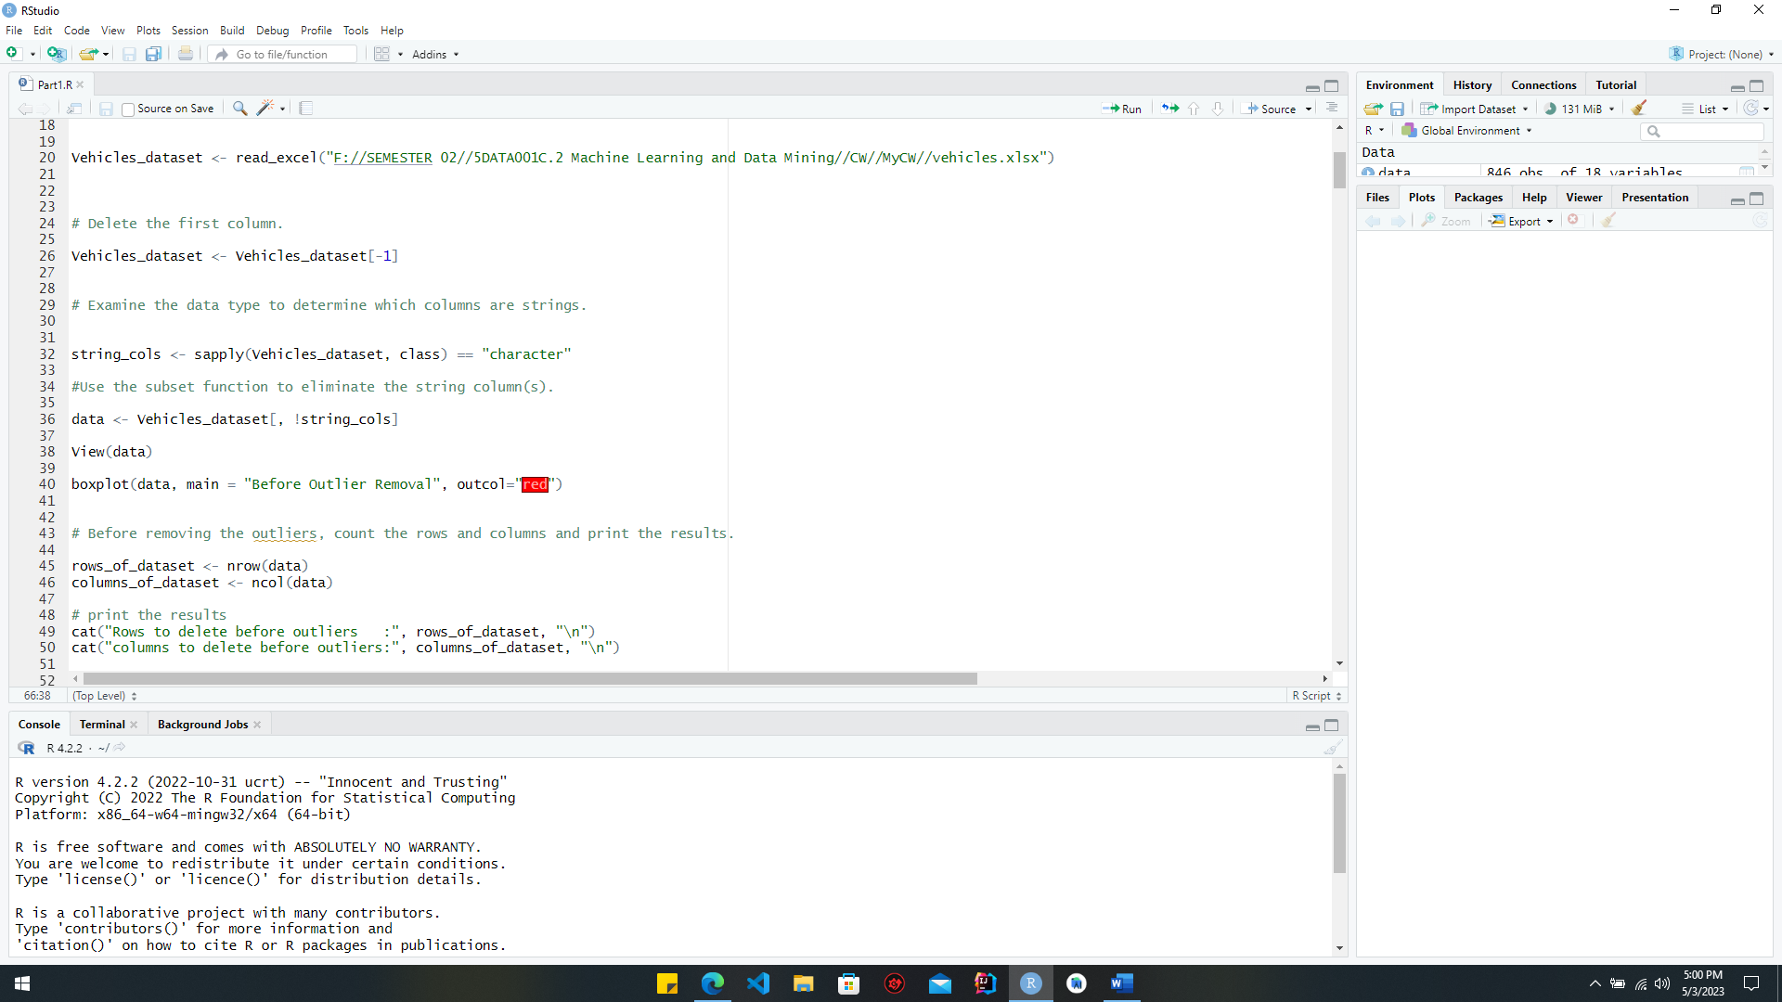

Figure : get data from file

***Code part to remove outliers.***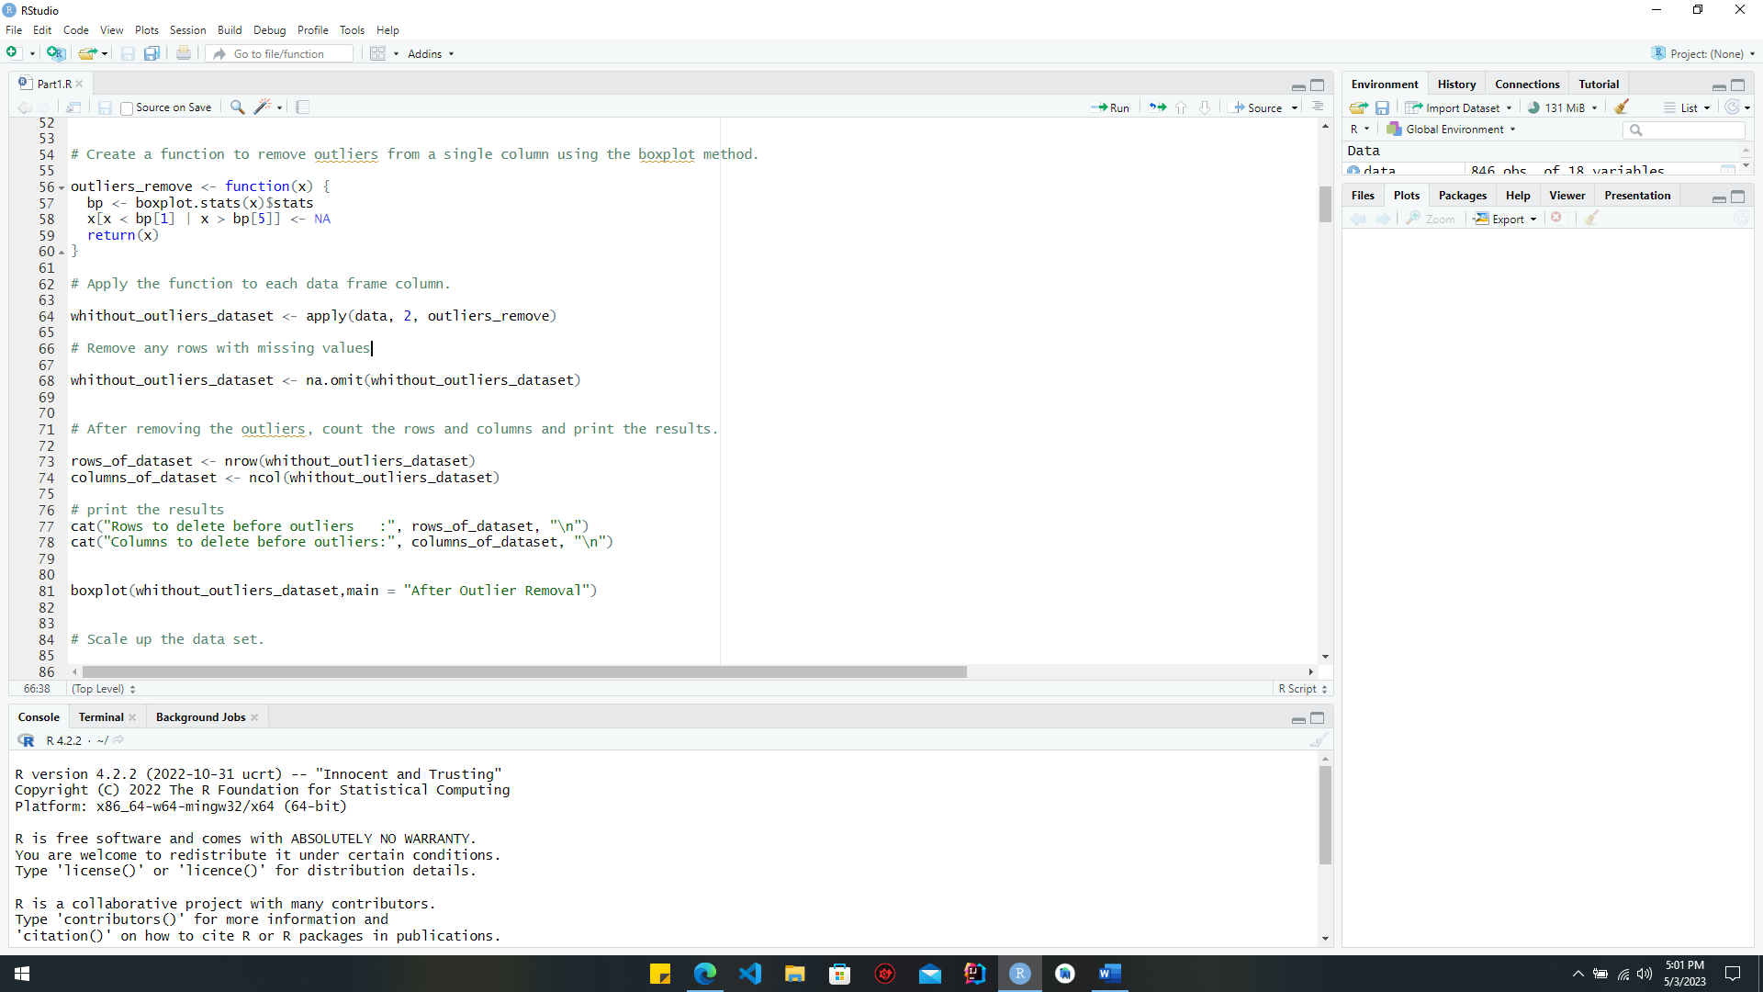

Figure :Code part to remove outliers

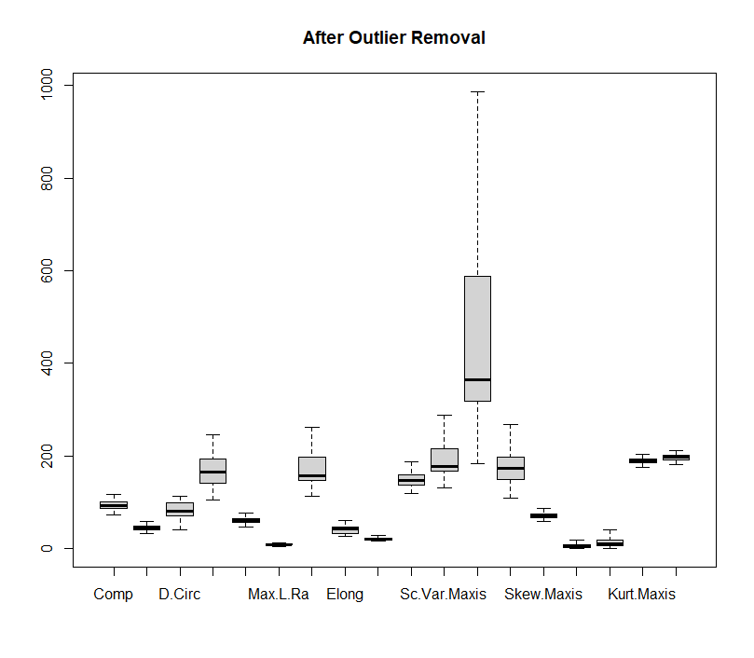***Below chart is a boxplot of before and after removing outliers***

Figure :boxplot of after removing outliers

Figure :boxplot of before removing outliers

***Code part to scaling data***

The "scale ()" method is used to make the "whithout_outliers_dataset" have a mean of zero and a standard deviation of one. The "head ()" method shows the first few rows of the scaled dataset, and a boxplot shows how the variables in the scaled dataset are spread out. The center of the boxplot is zero, and the spread between the two quartiles is equal to two standard deviations. This makes it useful for finding outliers, skewness, and other general characteristics of how the variables are distributed.

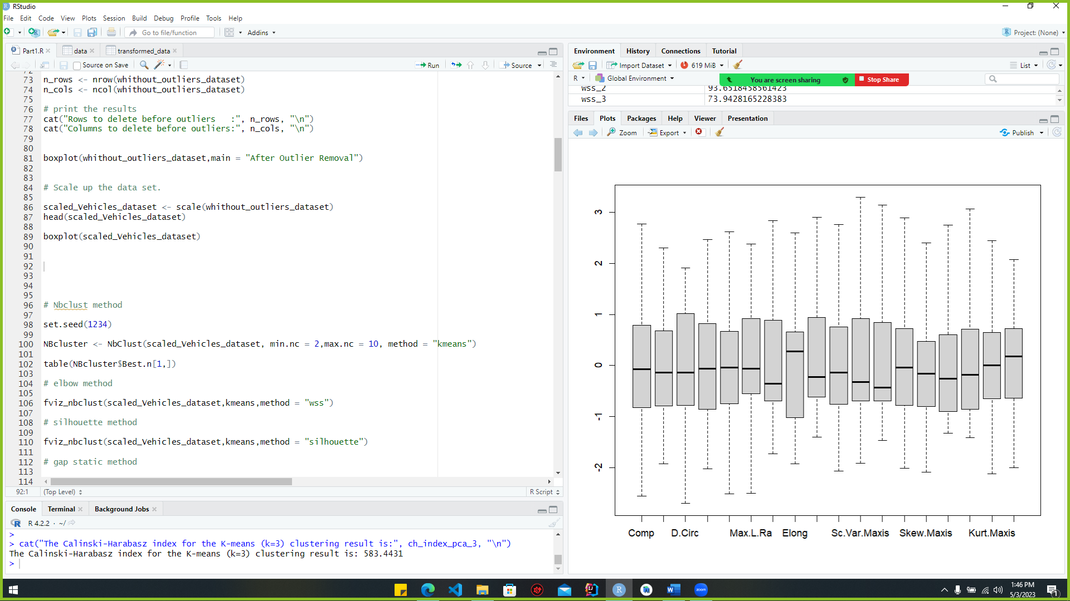

Figure :scaling_code

***Below chart is a boxplot of dataset after removing outliers and scaling***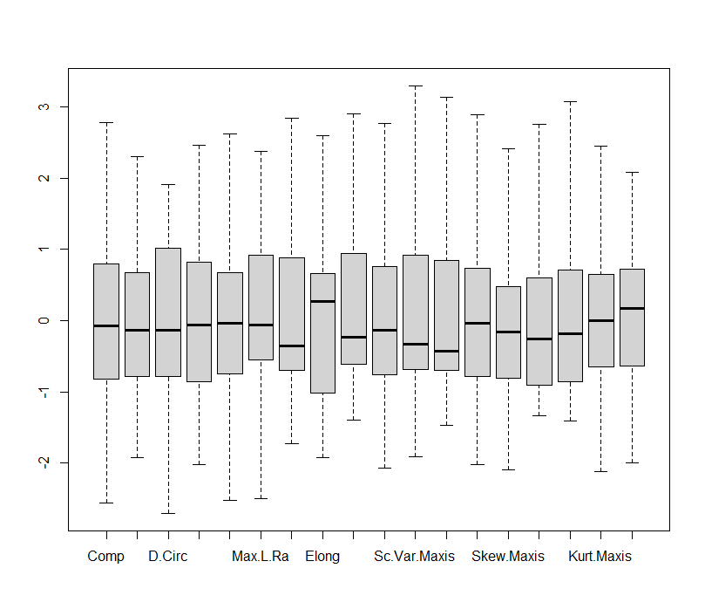

Figure :after removing outliers and scaling

### Determine the number of cluster centers via four “automated tools.”

Having completed procedures like missing value management and outlier elimination, we have a clean data set suitable for subsequent processing, such as clustering. One of these techniques is called k-means, and it requires specifying the desired number of groups. The maximum number of clusters that can be created is different for each dataset. Some methods for counting the number of groups in a dataset are the Elbow method, the Gap statistics, and the silhouette method. Finding the most effective clusters in a dataset based on their shared characteristics is the primary focus of this stage.

To calculate the number of cluster centroids, I utilized the techniques below.

* NBclust
* Elbow method
* Gap statistics
* Silhouette method

#### Code section for NBclust

**The Euclidean distance and the gap is used in the following NBclust method**

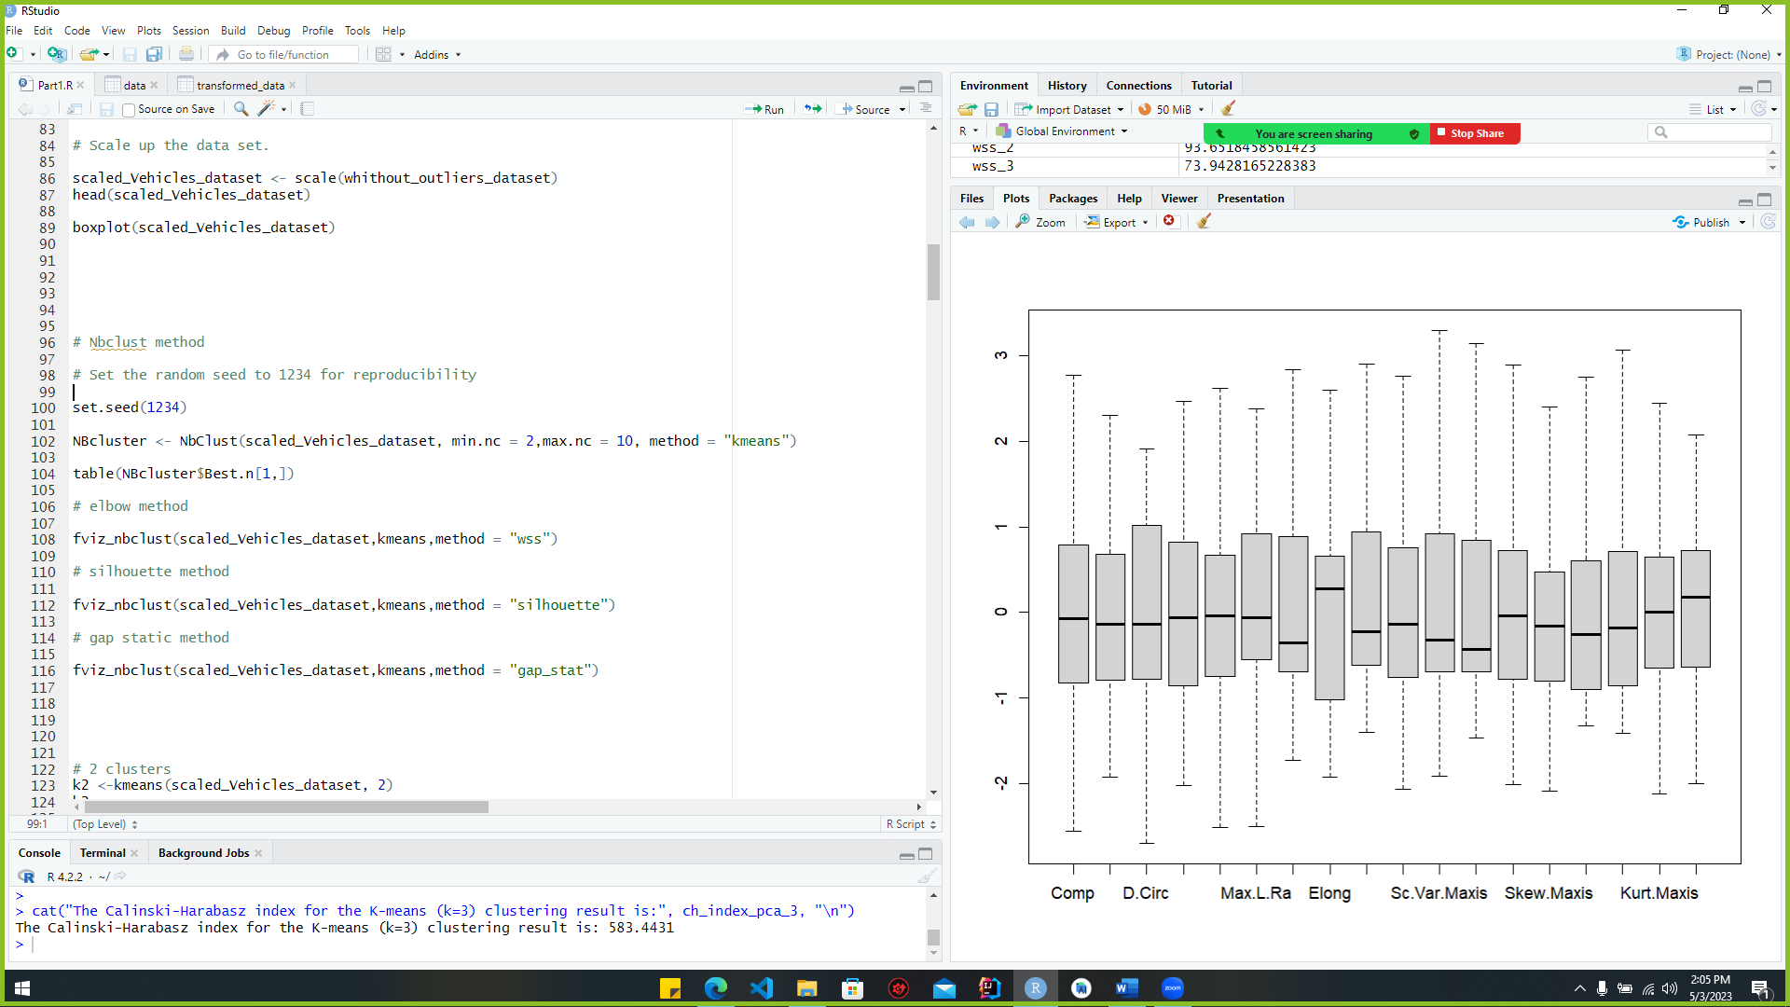

Figure :NBclust code

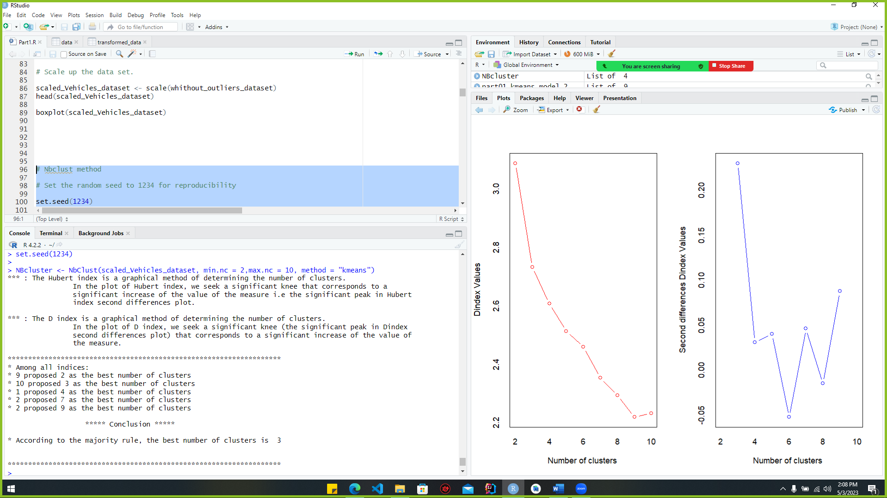See below. The best number of clusters is 3.

Figure :NBclust_output_1

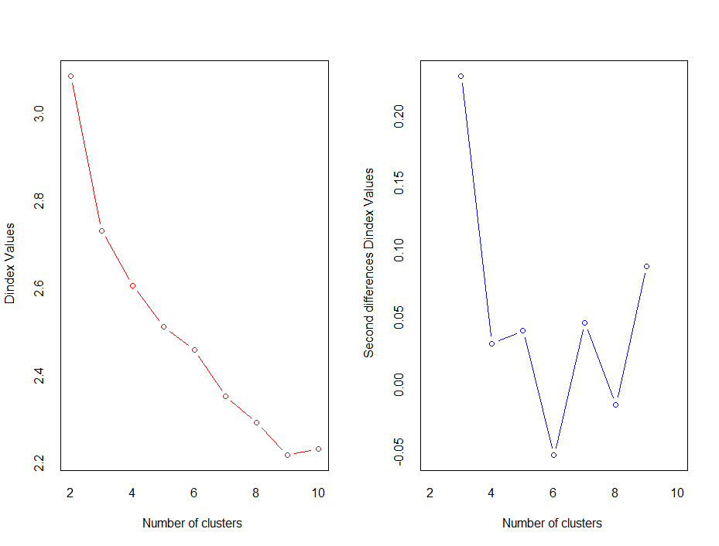

Figure :NBclust_output2

#### Code section for elbow function

The basic idea behind the elbow method is to find the exact number of clusters in a set of data by finding the "elbow point" in the graph where the elbow shape is made. To finish this job, the Within-cluster Sum of Square (WSS) calculation is used.

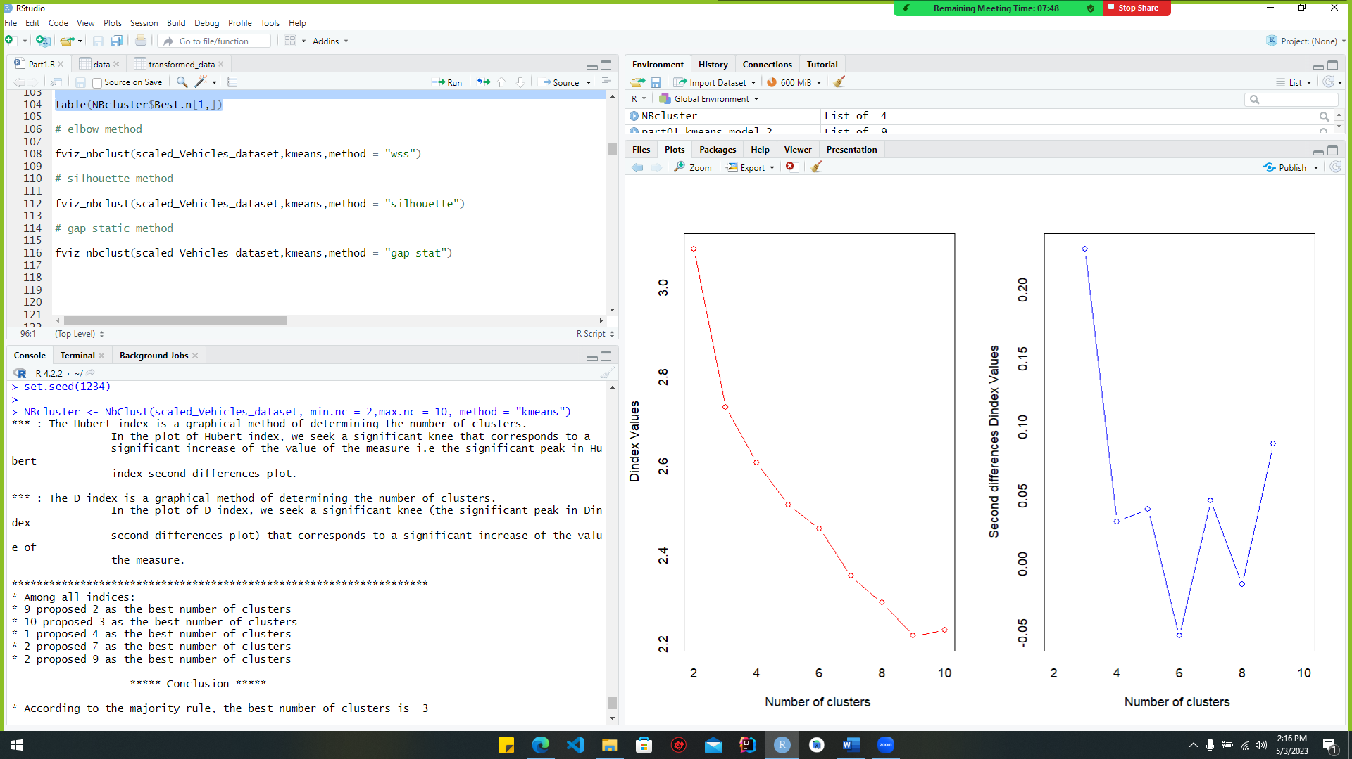

Figure :elbow code

***Output***

By turning on the code part, which is 2, you can get the right cluster hub number for the dataset, which is shown below.

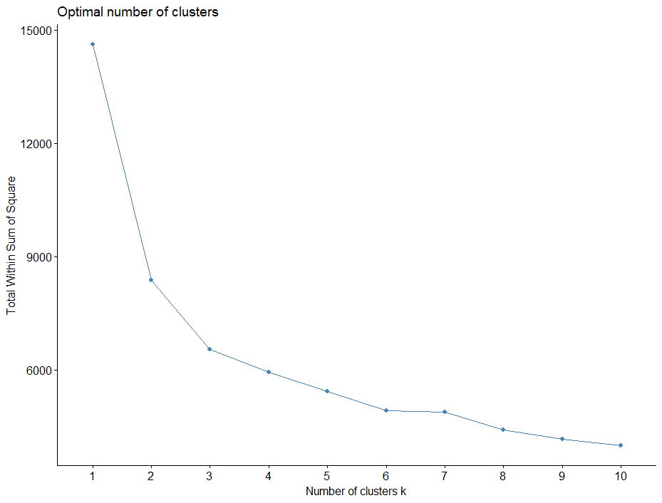

Figure :elbow_output

#### Code section for Silhouette method

The silhouette method can be used to figure out how well a dataset is clustered. To use this method, the Silhouette method is used to figure out how similar each vehicle is to its own cluster compared to other clusters. This is how the Silhouette coefficient for each vehicle is calculated. As a result, it calculates the average silhouette coefficient for each cluster to give a measure of the strength of clustering. By figuring out the average silhouette coefficient for different numbers of clusters, the Silhouette method can also be used to find the best number of clusters. If the average is higher, it means that the grouping is more accurate, and if it's lower, it means that the grouping is less accurate and needs to be fixed.

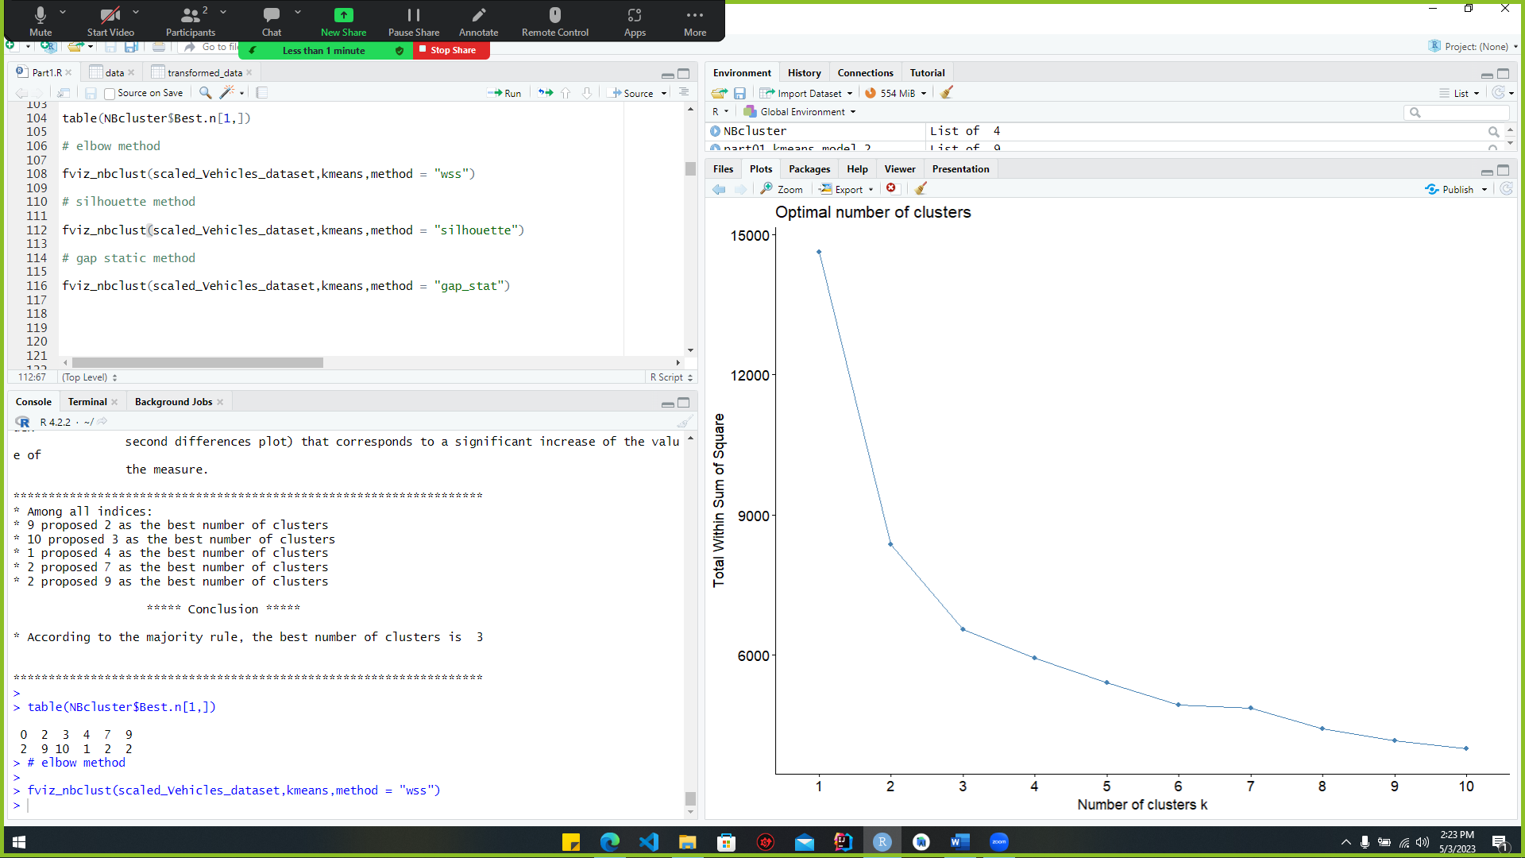

Figure :silhouette_code

***Output***

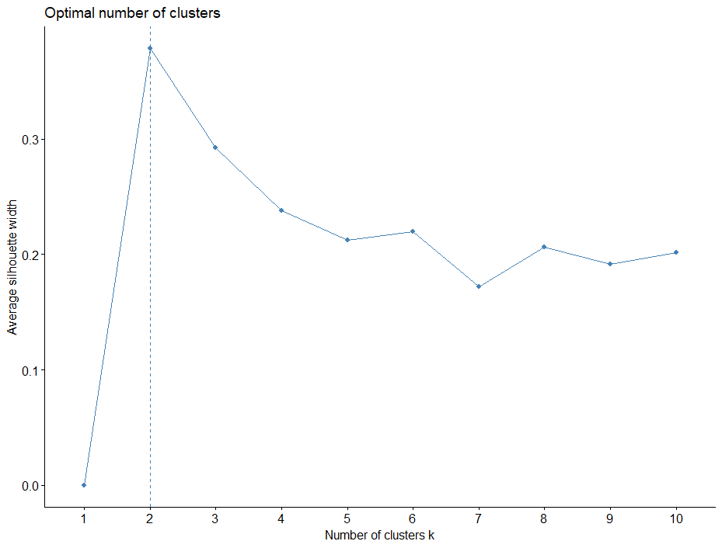Running the code part shows that the dataset has two optimal cluster centers, as seen below.

Figure :silhouette_output

#### Code section for Gap statistics method

The basic idea behind the static gap method is to compare the within-cluster dispersion of a clustering solution that references a data distribution with similar features but no clear clustering pattern. The static gap method can be used to find the best number of groups in a data set. But for the clustering solution to be more appropriate for the data, it should be used along with other methods and domain knowledge.

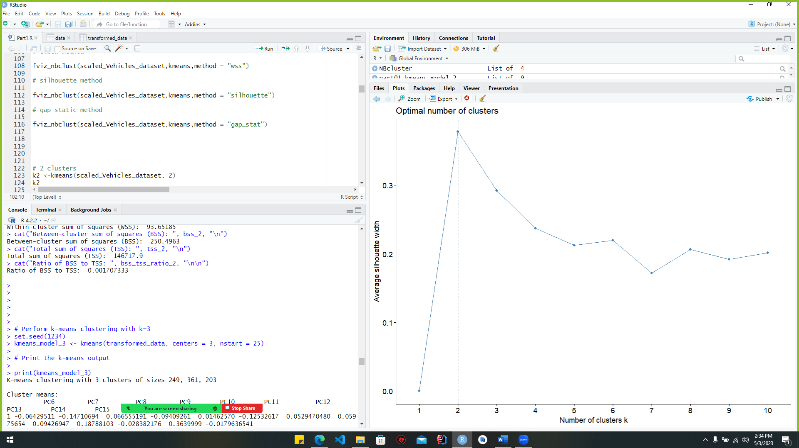

Figure :Gap

Output

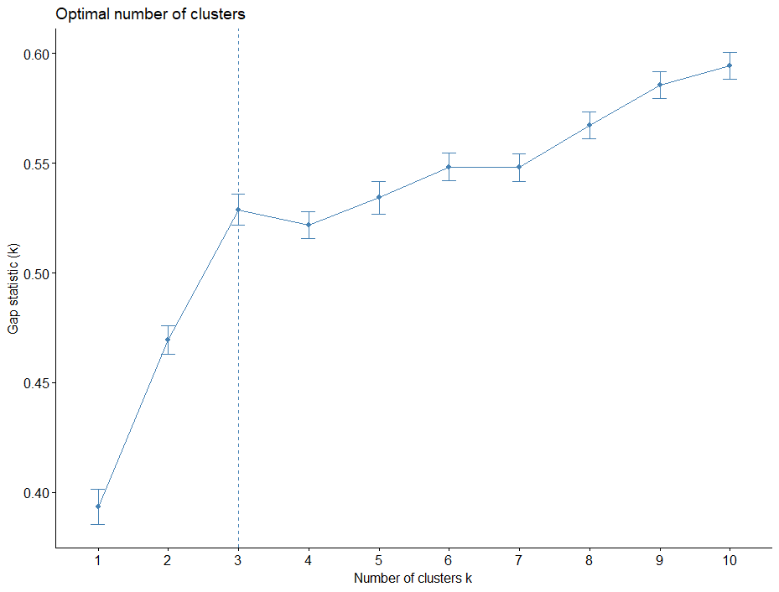When the code part is run, it shows that the dataset has 3 good centres for clusters, as shown below.

Figure :Gap_output

### Kmeans clustering investigation

K-means clustering uses the following code section when the cluster number is 2.

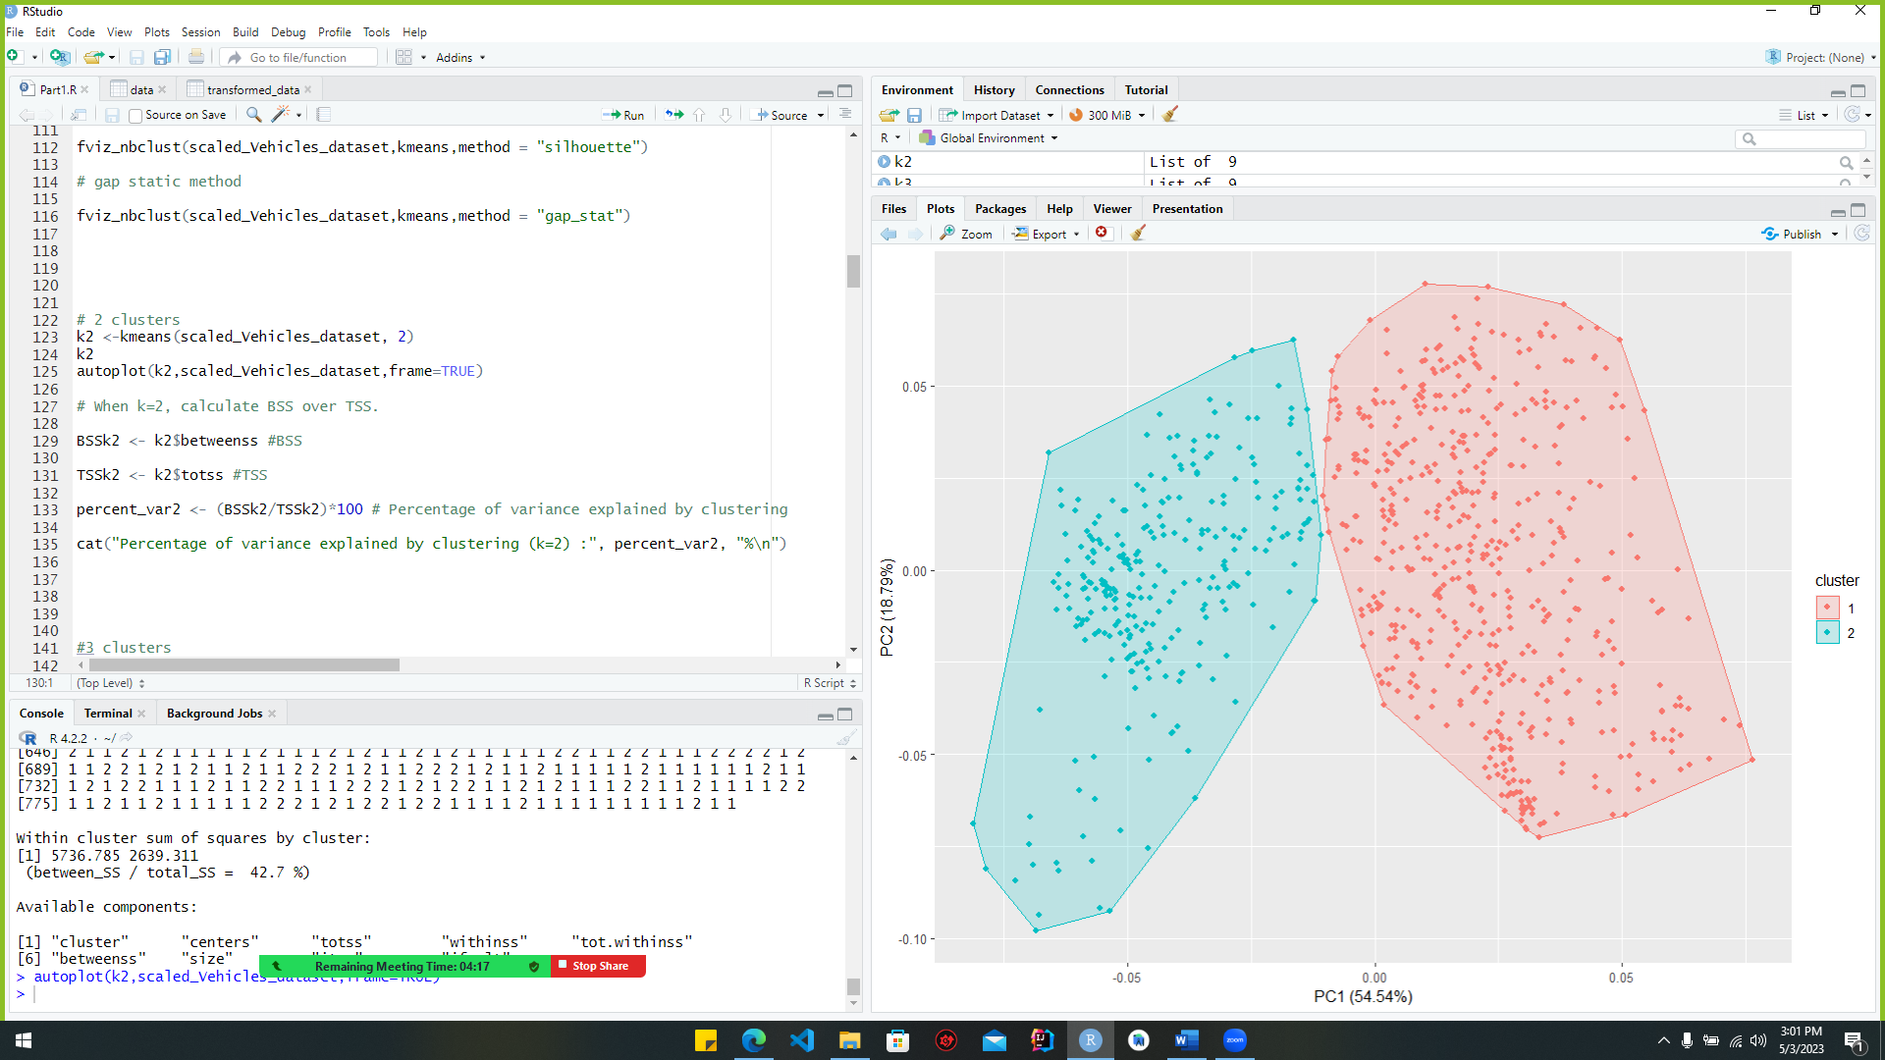

Figure :clustering_code(k=2)

Above code is used to do k-means clustering with two groups on the scaled_Vehicles_dataset. The clustering is done with the "kmeans()" method, and the resulting object is saved in the "k2" variable. For the plotting, the "autoplot()" function from the "ggfortify" package is used. The first input to the function is the "k2" object, the second is the original data set, and the frame is set to "TRUE" to put a bounding box around each cluster. The result is a plot that shows the two groups in different colours, with each point labelled according to the row in the original data set. This picture can help you see how well the k-means clustering algorithm separates the data into two different groups.

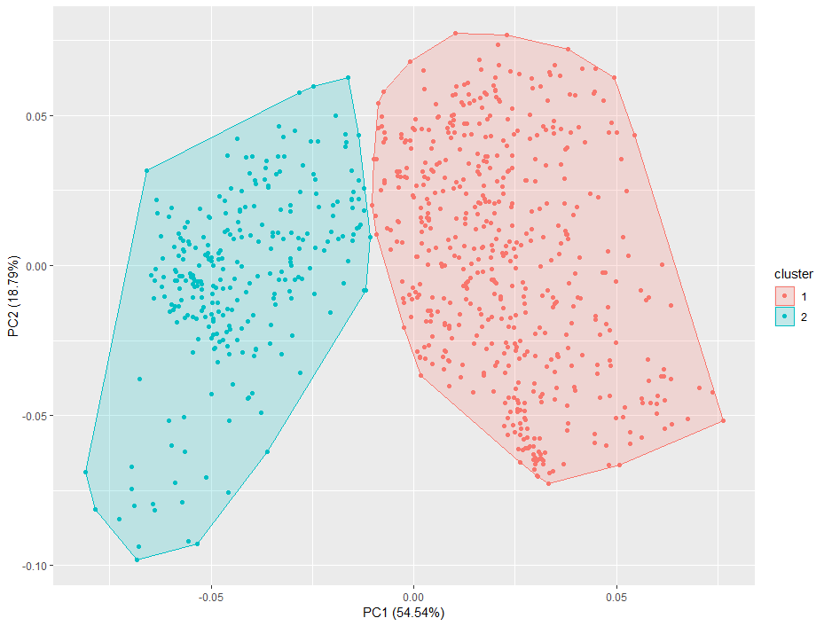***Output***

Figure :clutering_output(k=2)

Find the ratio of the number of squares to the number of square groups when k = 2.

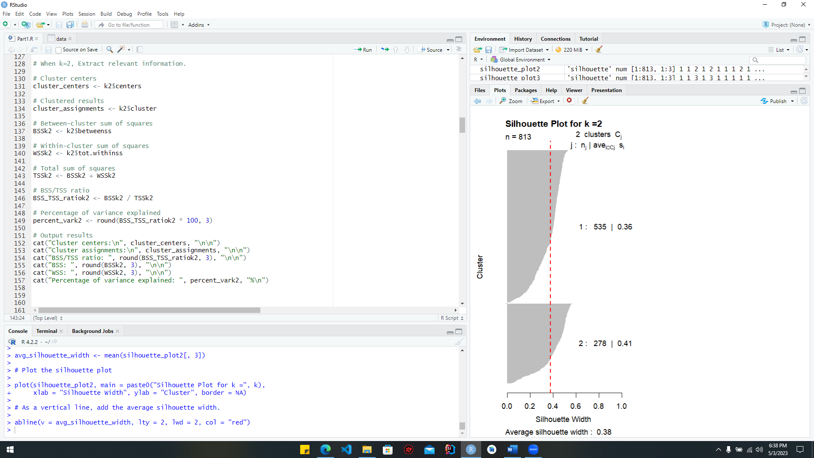

Figure :ratio_calculation(k=2)

***Output***

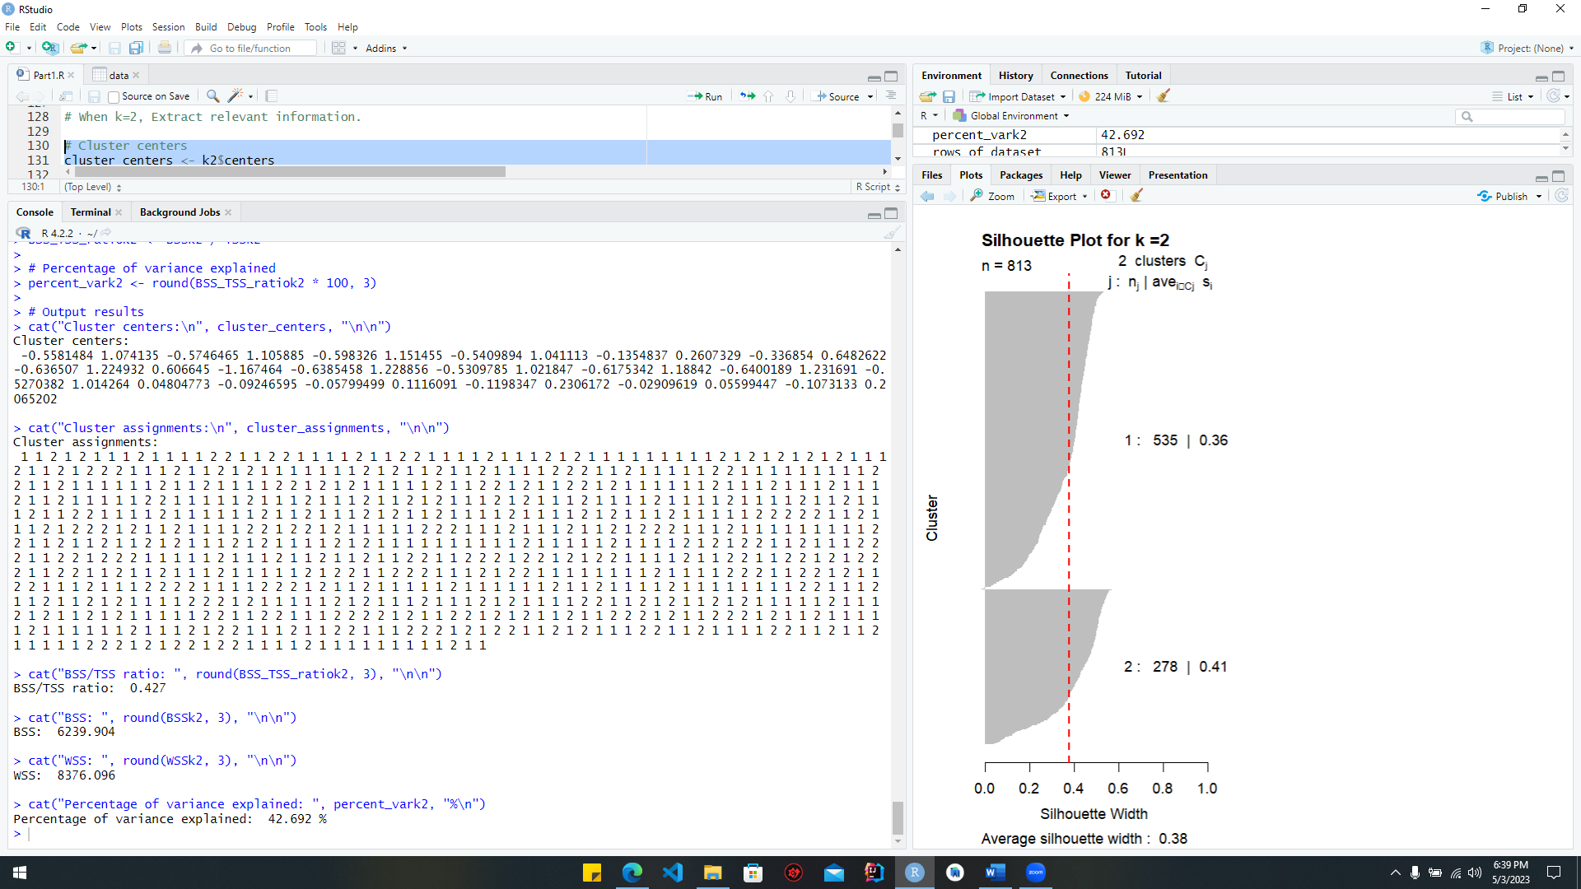

Figure :ratio_calculation_output(k=2)

K-means clustering uses the following code section when the cluster number is 3.

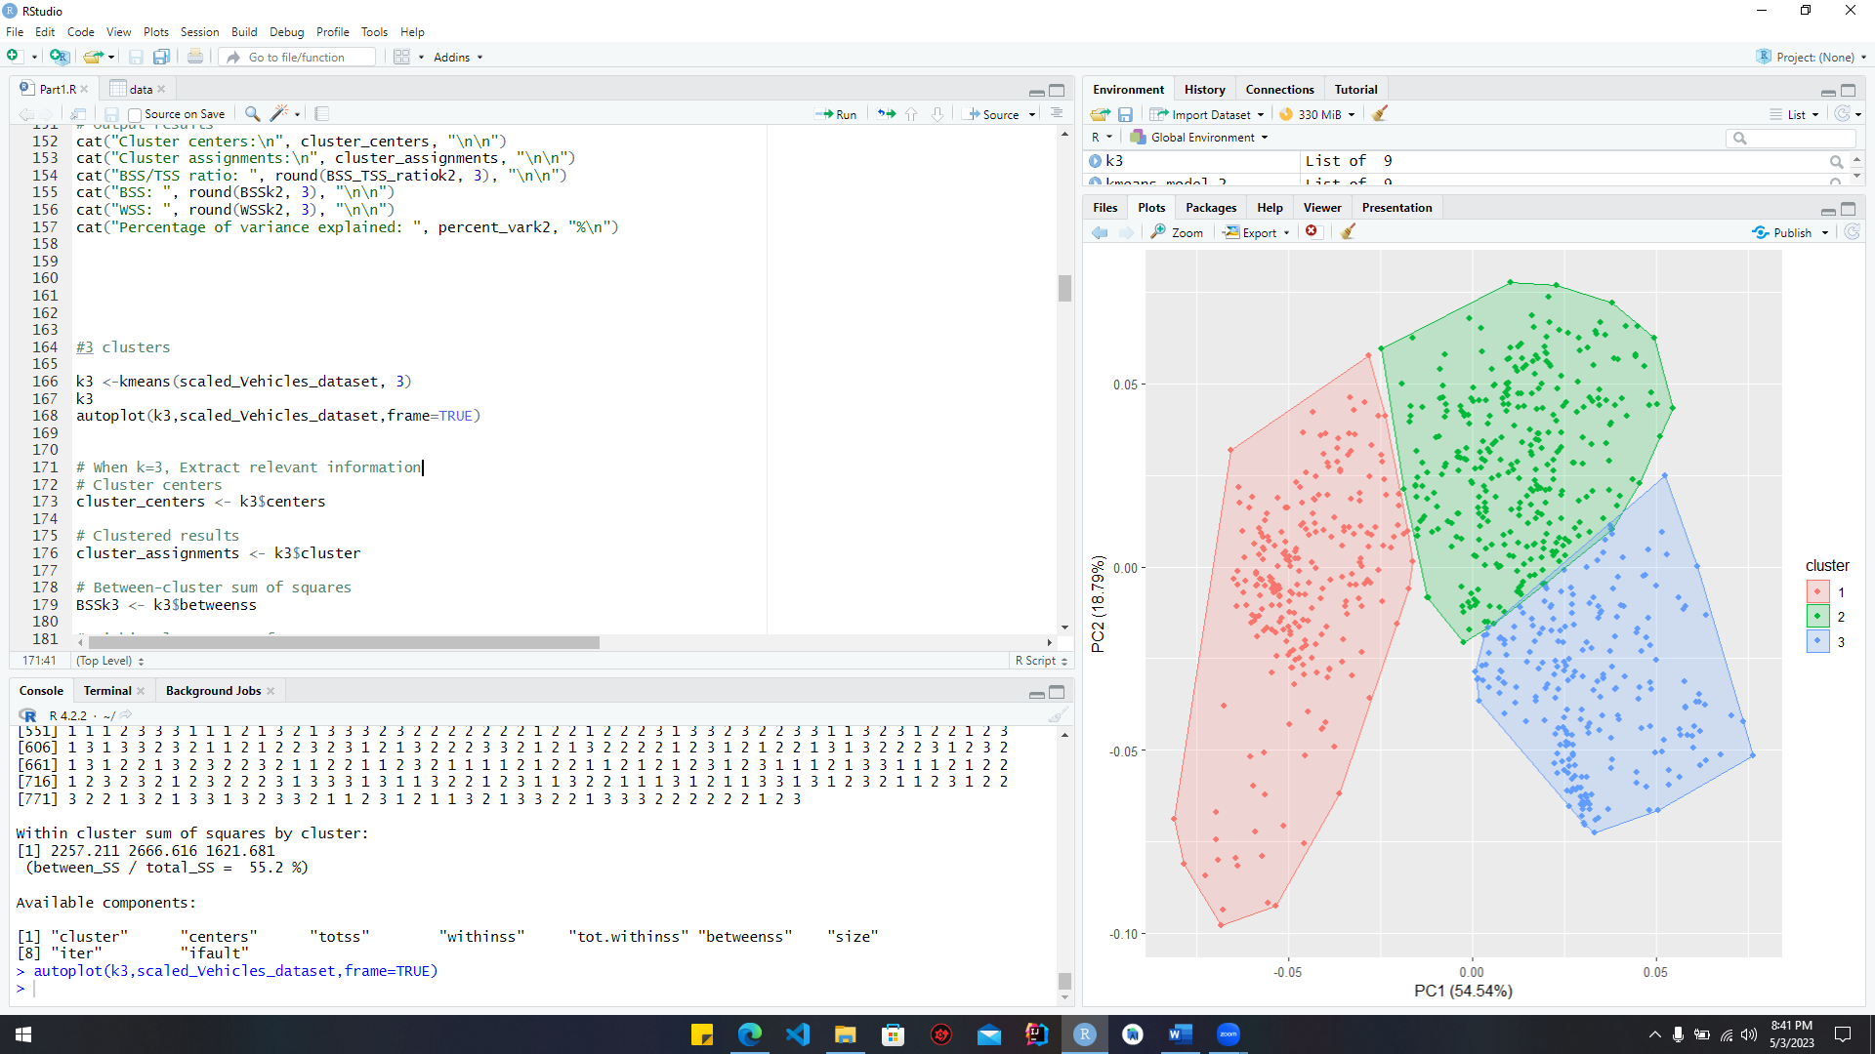

Figure :clutering_code(k=3)

The "scaled_Vehicles_dataset" is being clustered using k-means with 3 clusters by the code. On the first line, the "kmeans()" function is used to perform k-means clustering and the result is stored in the "k3" variable. In the second line, we use the "autoplot()" function from the "ggplot2" package to output the result and generate a plot of the clustering outcomes. The generated scatter plot displays cluster midpoints and data points shaded according to their cluster membership.

***Output***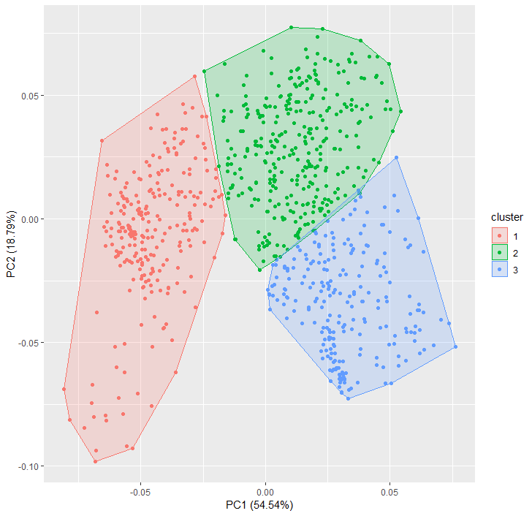

Figure :clutering_output(k=3)

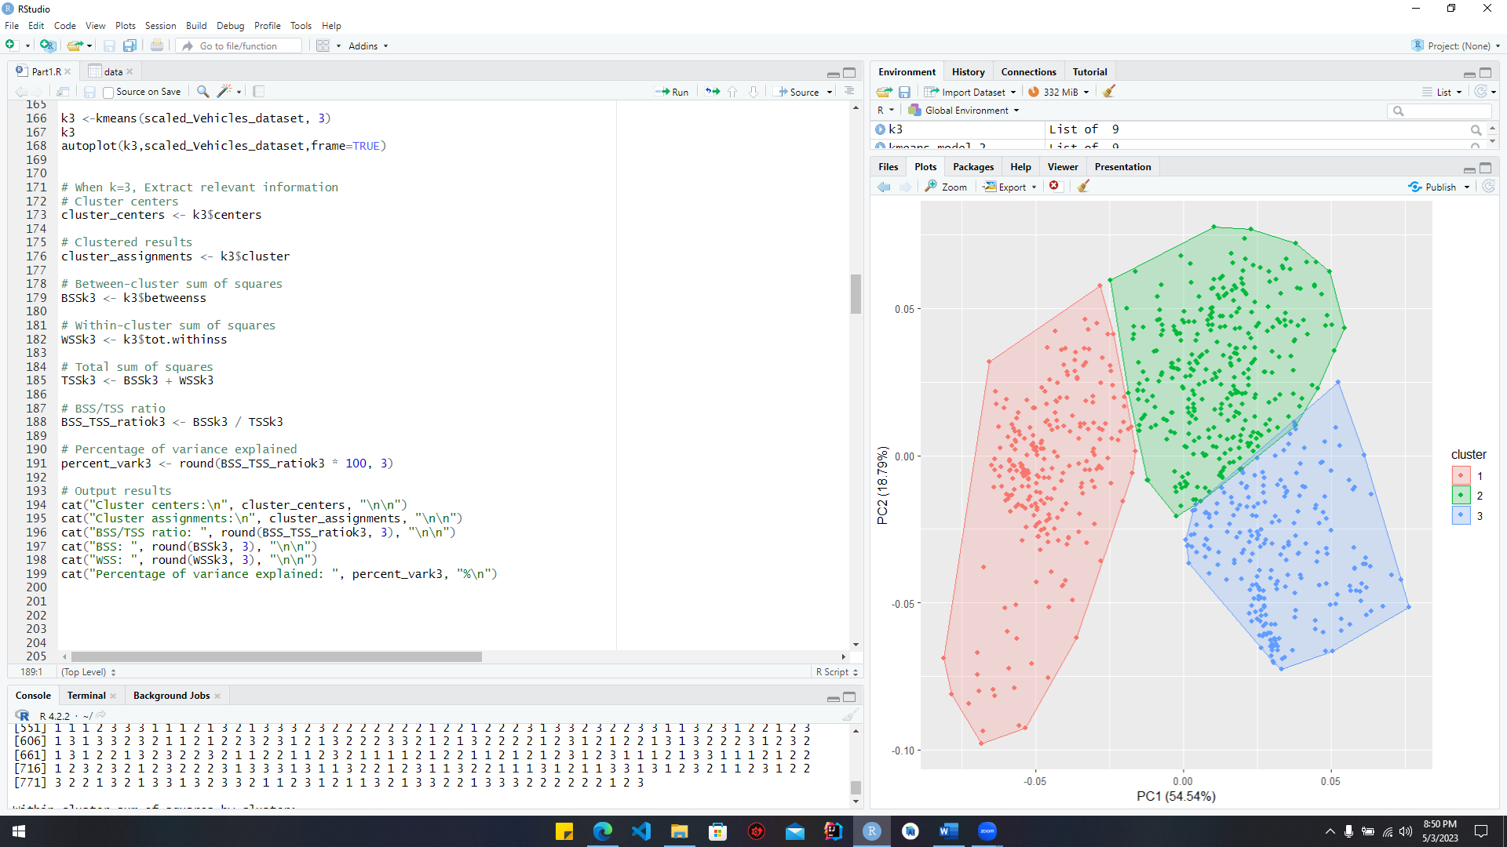Calculate the ratio between the total squares and the square clusters when k = 3

Figure :ratio_calculation(k=3)

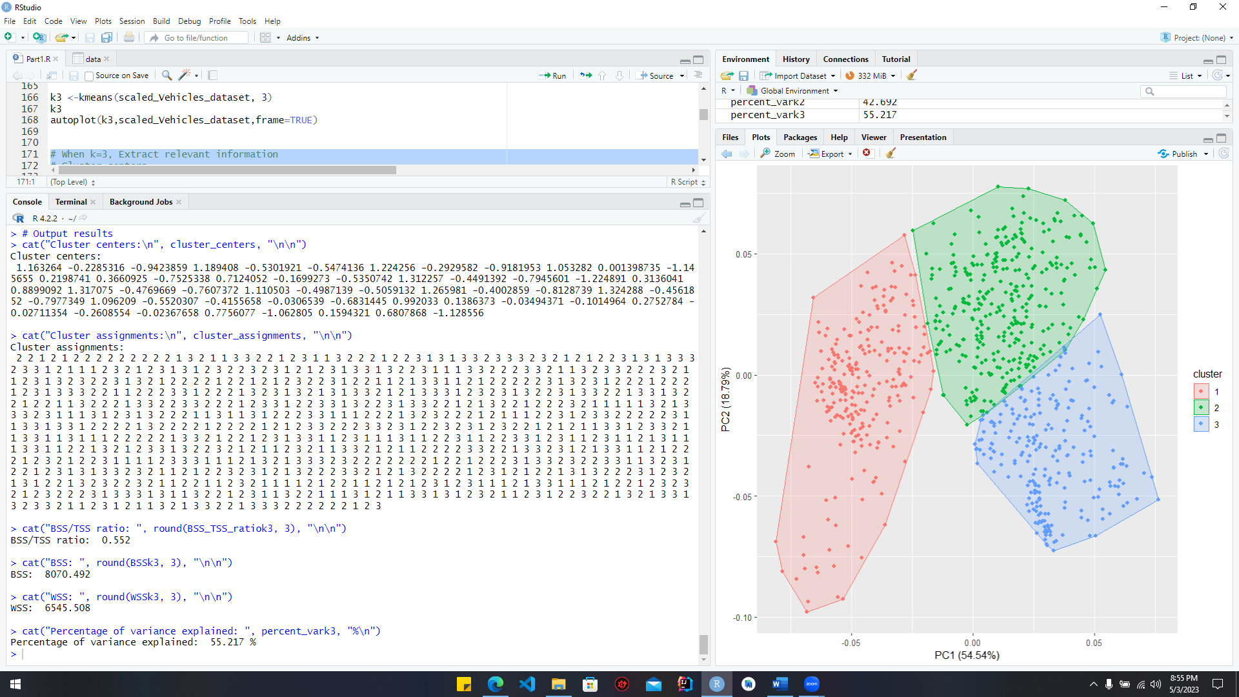***Output***

Figure :ratio_calculation_output(k=3)

### Code section for silhouette plot

When Fit k-means model with k=2

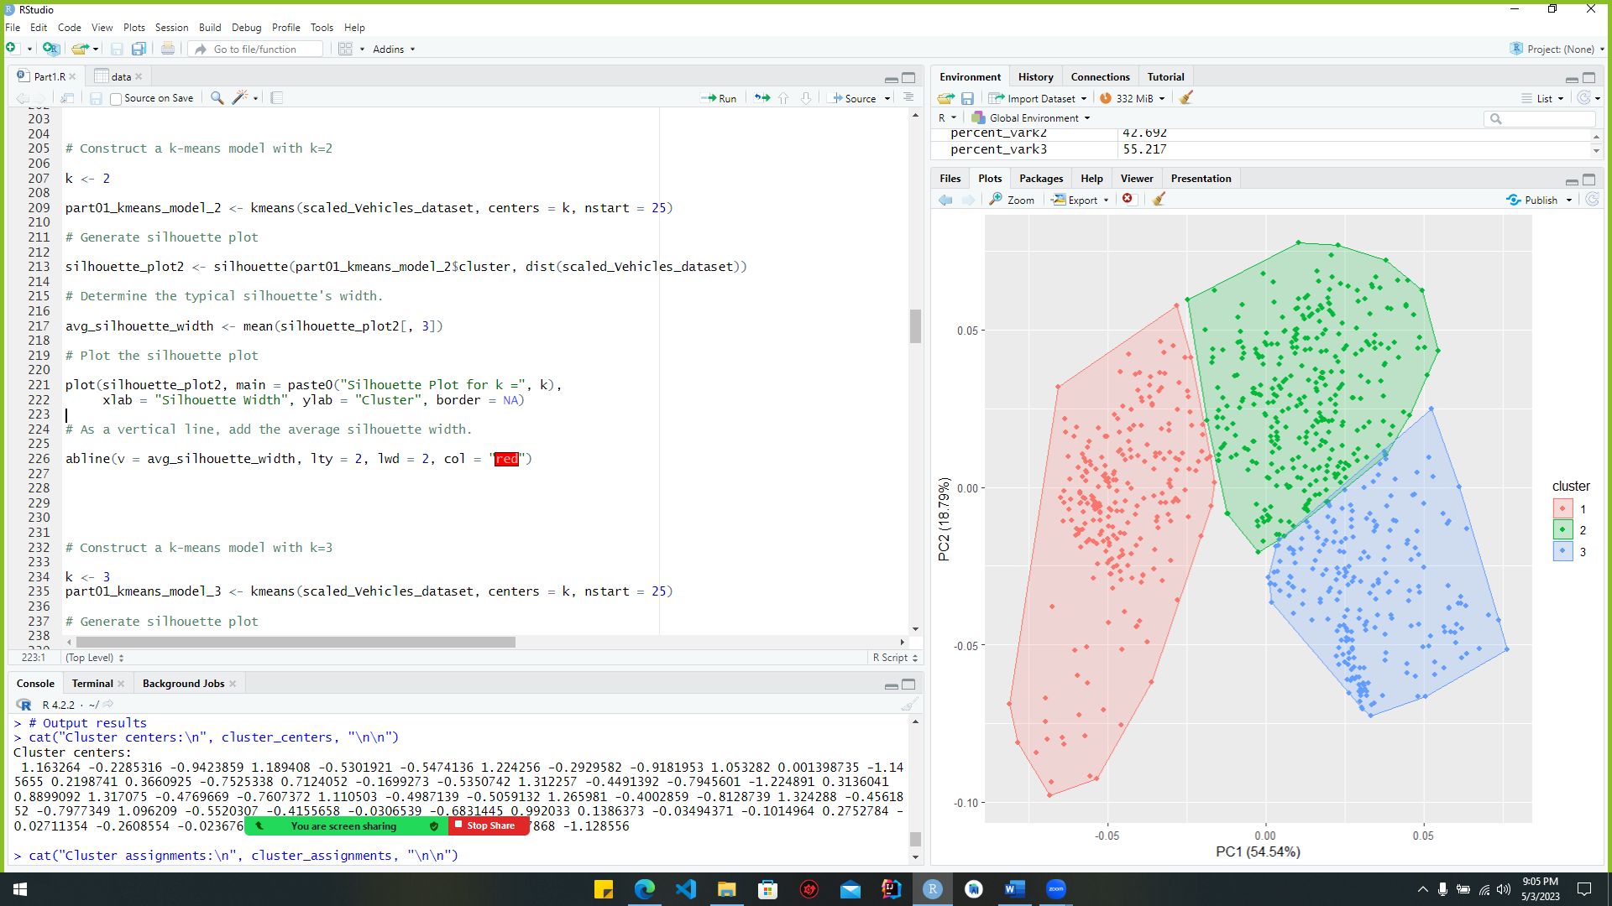

Figure :sihoutte_plot(k=2)

The code uses the "kmeans()" function to fit a k-means clustering algorithm to the scaled car dataset. The number of clusters, represented by the centres parameter, and the number of times the algorithm should be repeated with various initial centres, represented by the nstart parameter. The "part01_kmeans_model_2" object contains the final k-means model. The distances between the observations in the scaled vehicle dataset are utilised in conjunction with the cluster assignments in "part01_kmeans_model_2" to produce a silhouette plot via the "silhouette()" function. The average silhouette width is displayed as a red vertical line in the silhouette plot, generated with the" plot() "method. In addition to the main argument, which sets the plot's title, the "xlab" and "ylab" arguments, which set the plot's axis names, and the border argument, which makes the plot's borders transparent, are all required.

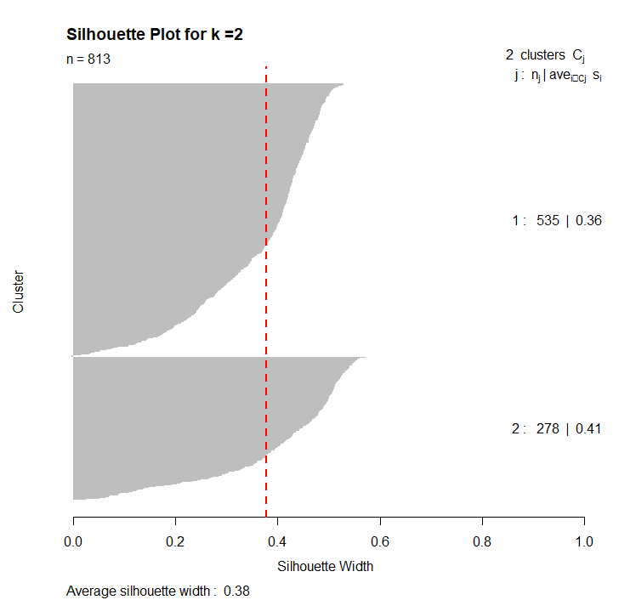***Output***

Figure :sihoutte_plot_output(k=2)

When Fit k-means model with k=3

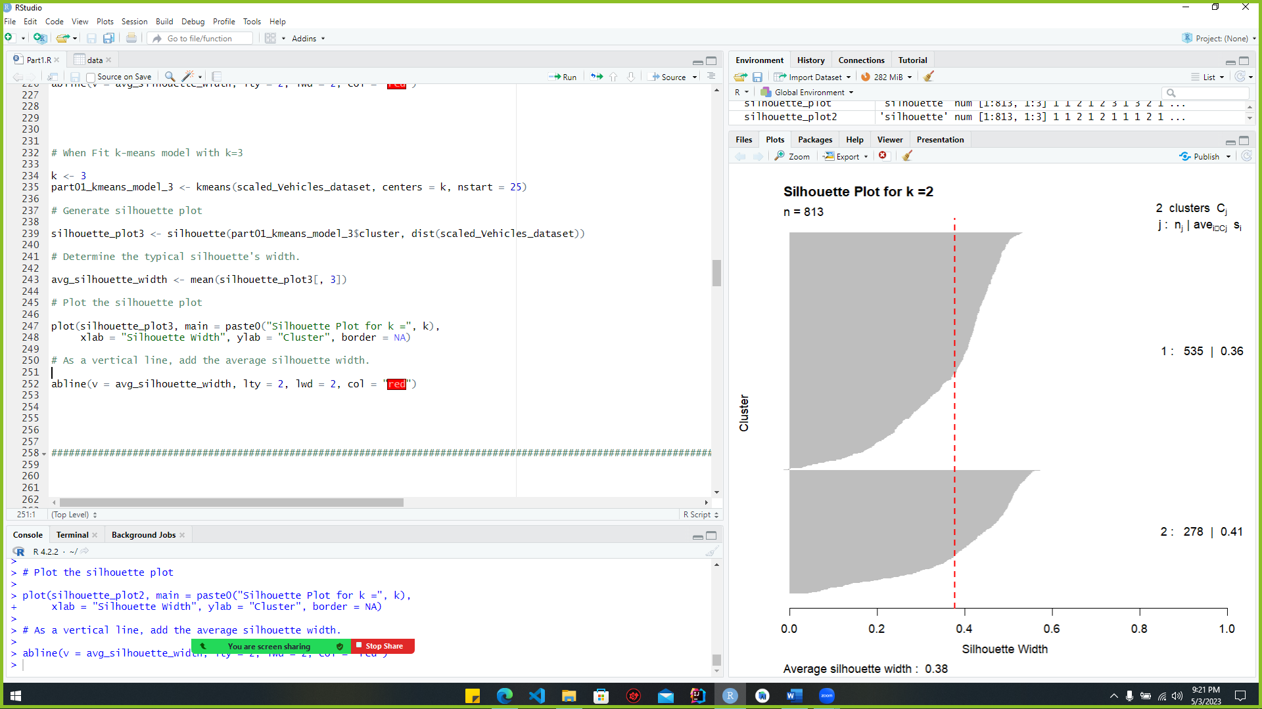

Figure :Figure 23:sihoutte_plot(k=3)

For a k=3 k-means clustering model, the code to generate a Silhouette plot is shown. Using k = 3 as the number of clusters, a k-means model is fit to the scaled Vehicles dataset. The "silhouette()" function uses the model's cluster assignments and the data's distance matrix to produce the Silhouette plot. When applied to the third column of the "silhouette_plot3" object, the "mean()" function yields the average width of the Silhouette. A vertical line is added to the plot using the "abline()" function, and the plot is displayed using the "plot()" function with descriptive labels.The Silhouette plot provides a graphical representation for assessing the accuracy of the clustering results by contrasting the distance between a data point and its fellow members within the same cluster with that between the data point and its nearest neighbouring cluster members. Better clustering results can be expected from Silhouettes with wider average widths.

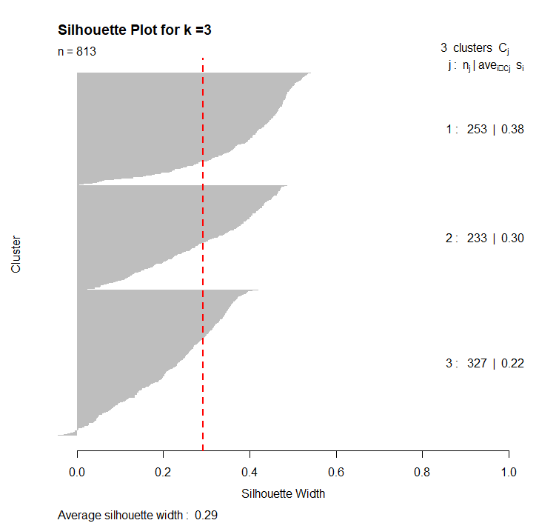***Output***

Figure :sihoutte_plot_output(k=3)

## **2nd Subtask Objectives**

### What is pcs principle?

Principal Component Analysis is a statistical method for reducing the number of dimensions in a large dataset. Finding the linear combinations of the original variables that capture the most variation in the data—the principal components—is how it works. To minimize the dimensionality of a dataset while preserving as much information as possible, it is common practice to keep only the most salient main components. To determine the most influential aspects of a system, such as the elements that influence consumer behavior or the features of a dataset that best predict an outcome, PCA is frequently used in disciplines including data science, economics, and engineering.

### PCs that provide at least cumulative score

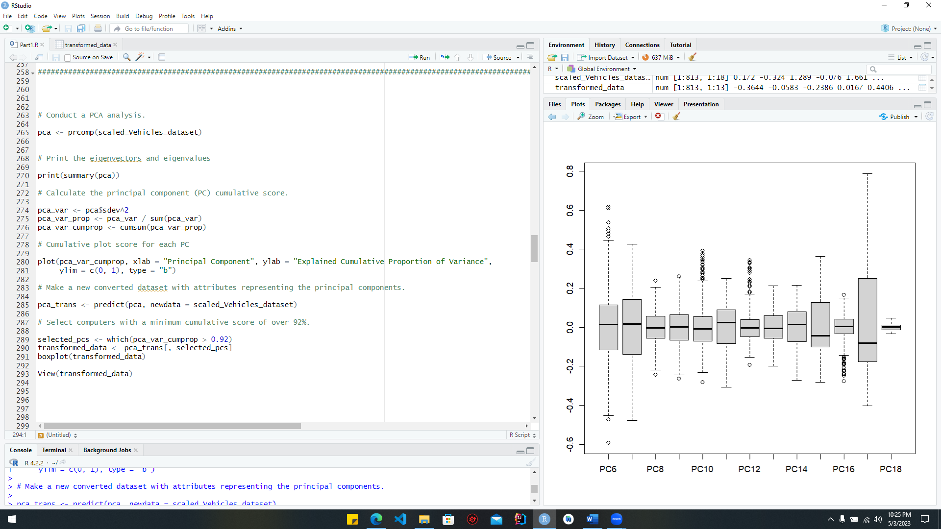 Principal Component Analysis (PCA) is performed on the "scaled_Vehicles_dataset" using the belove code. The principal component analysis (PCA) is executed with the "prcomp()" function, and the eigenvectors and eigenvalues are displayed with the "summary()" function. The proportion of variance explained by each principle component is then calculated, and the results are displayed graphically in the form of a cumulative plot.Then, the "predict() "function is used to create a new dataset from the original one, this time with attributes representing the principal components. A new converted dataset is generated by selecting the PCs with a cumulative score of 92% or higher. Finally, the "boxplot()" function is used to create a graphical representation of the changed data's distribution, and the "View()" function is employed to examine the modified dataset in a new window.

Figure :code for pca

***Output***

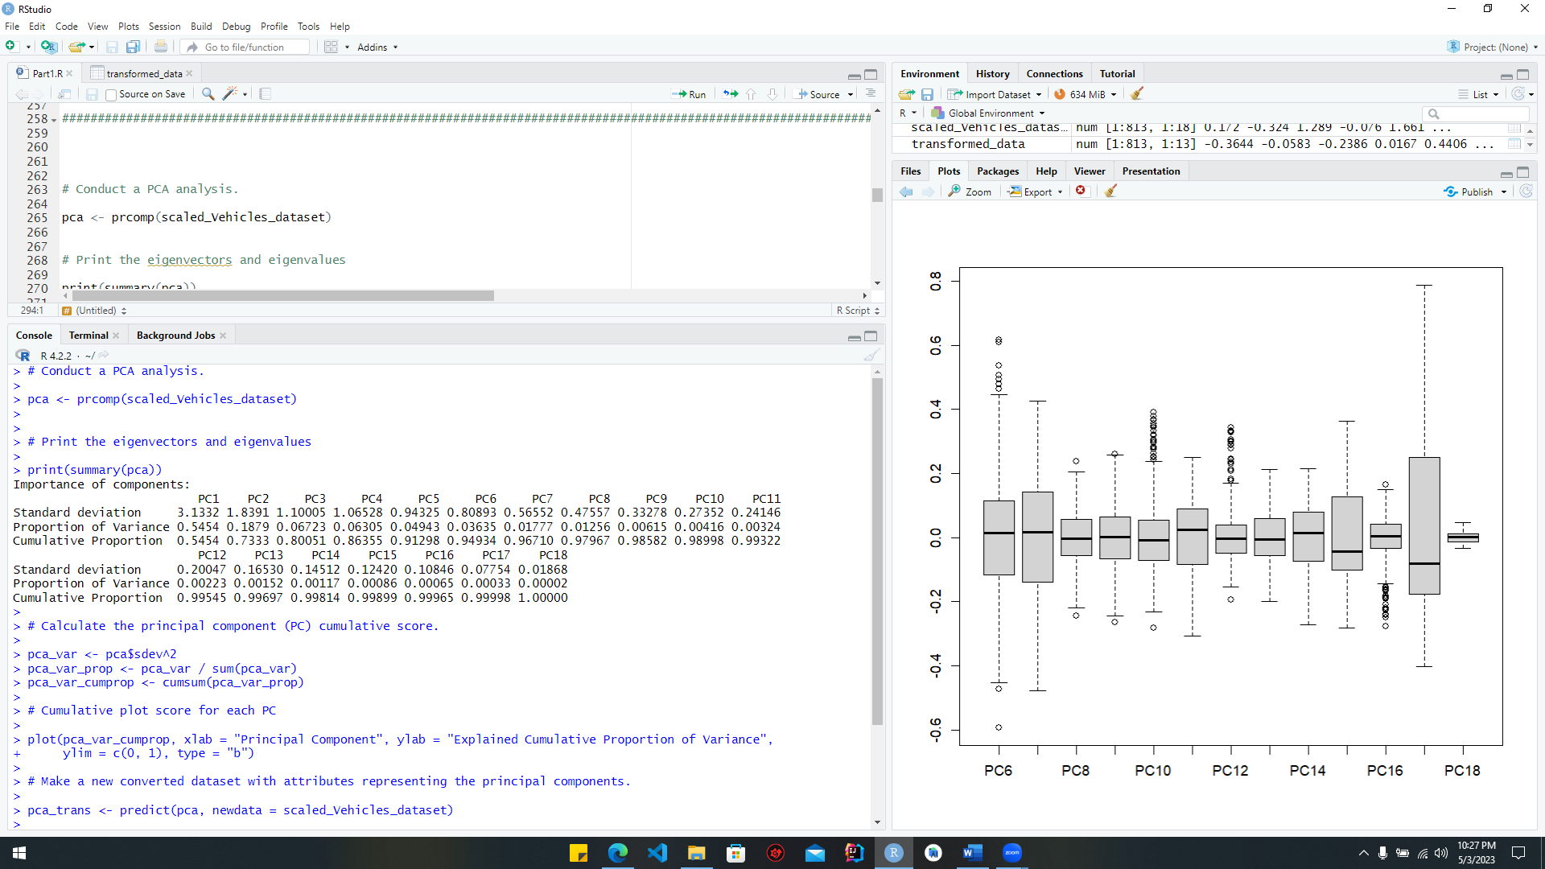

Figure :pca_out_1

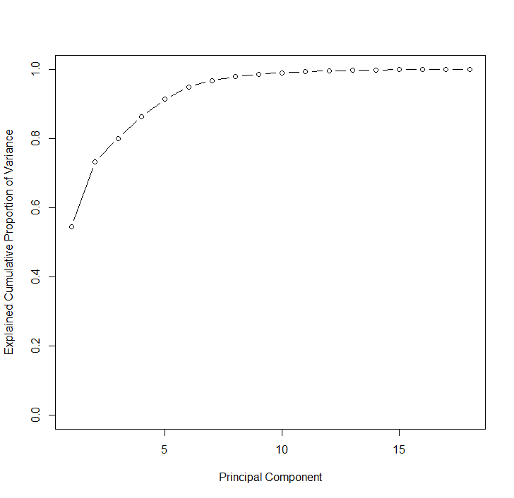

Figure :pca_output_3

Figure :pca_output_2

### Determine the number of cluster centers via four “automated tools.”

#### NBclust

**The Euclidean distance and the gap is used in the following NBclust method**

Code :

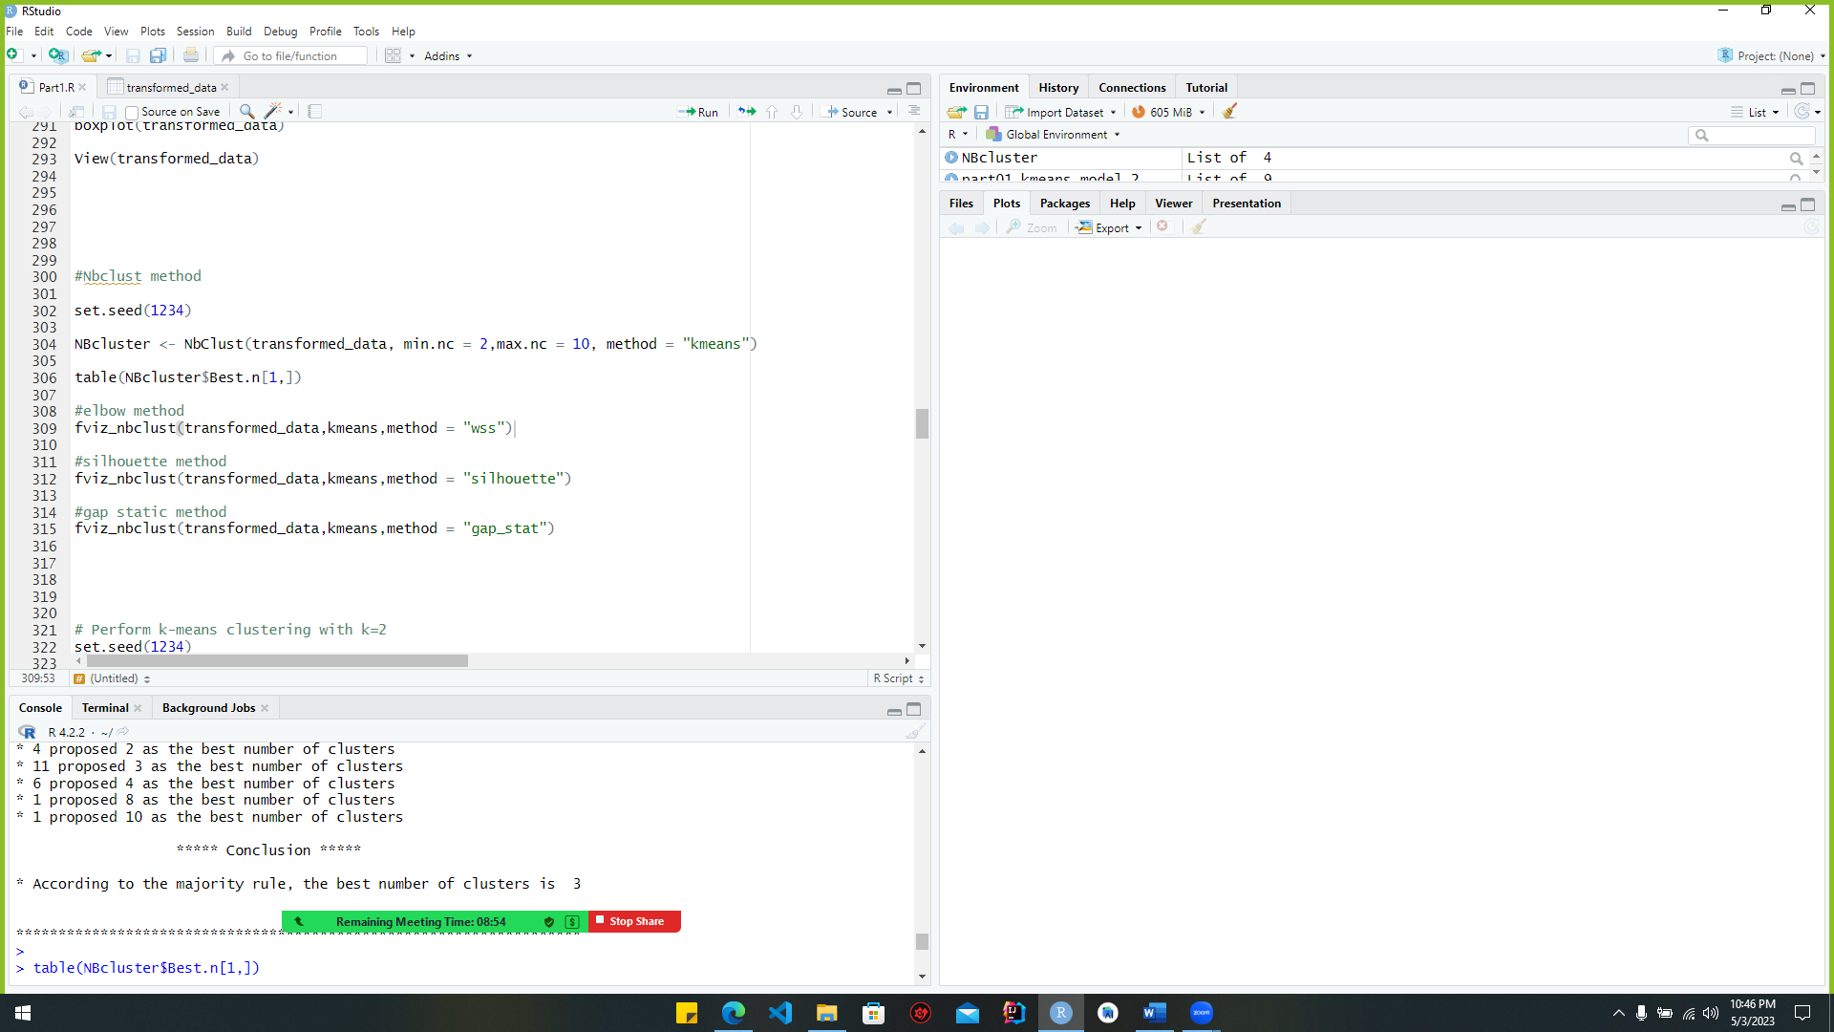

Figure :Nbclust_code

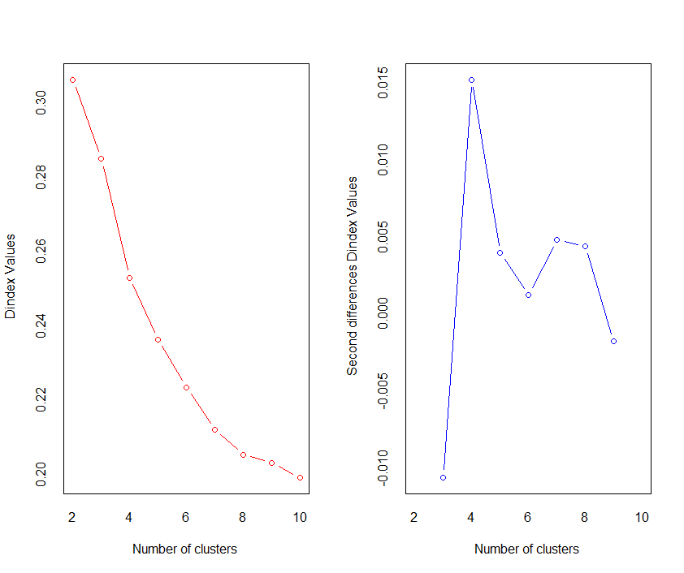***Output*** :

Figure :NbClust_output

#### 1.2.3.2. Code section for elbow function

***Code***

Figure :elbow_code_pca

***Output***

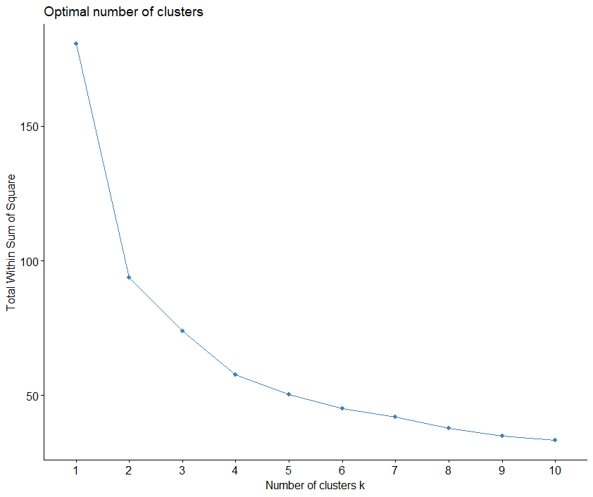

Figure :elbow_output_pca

#### 1.2.3.4. Code section for Silhouette method

***Code:***



Figure :code_section_silhouette

***Output***:

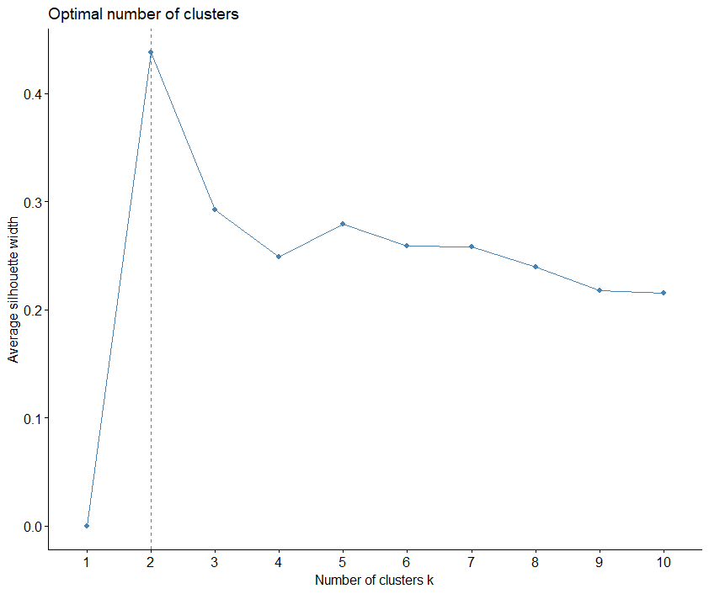

Figure :silhoutte_pca_output

#### 1.2.3.4.5. Code section for Gap statistics method

***Code:***

Figure :gap_code_pca

***Output***:

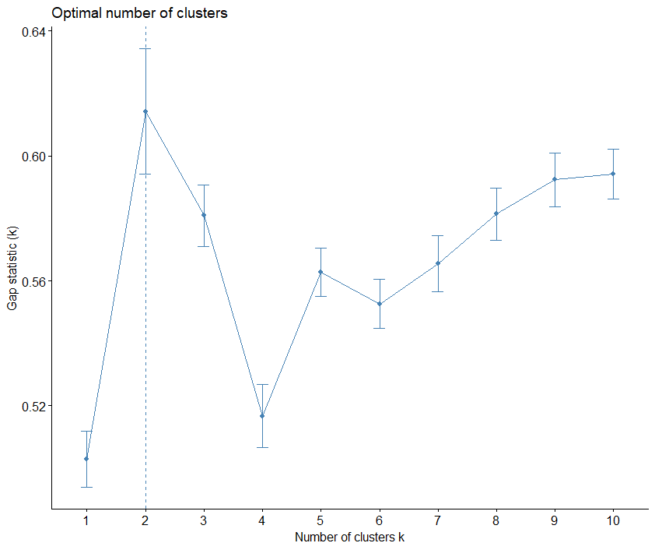

Figure :gap_output_pca

### Evaluation metrics for k-means clustering.

K mean = 2

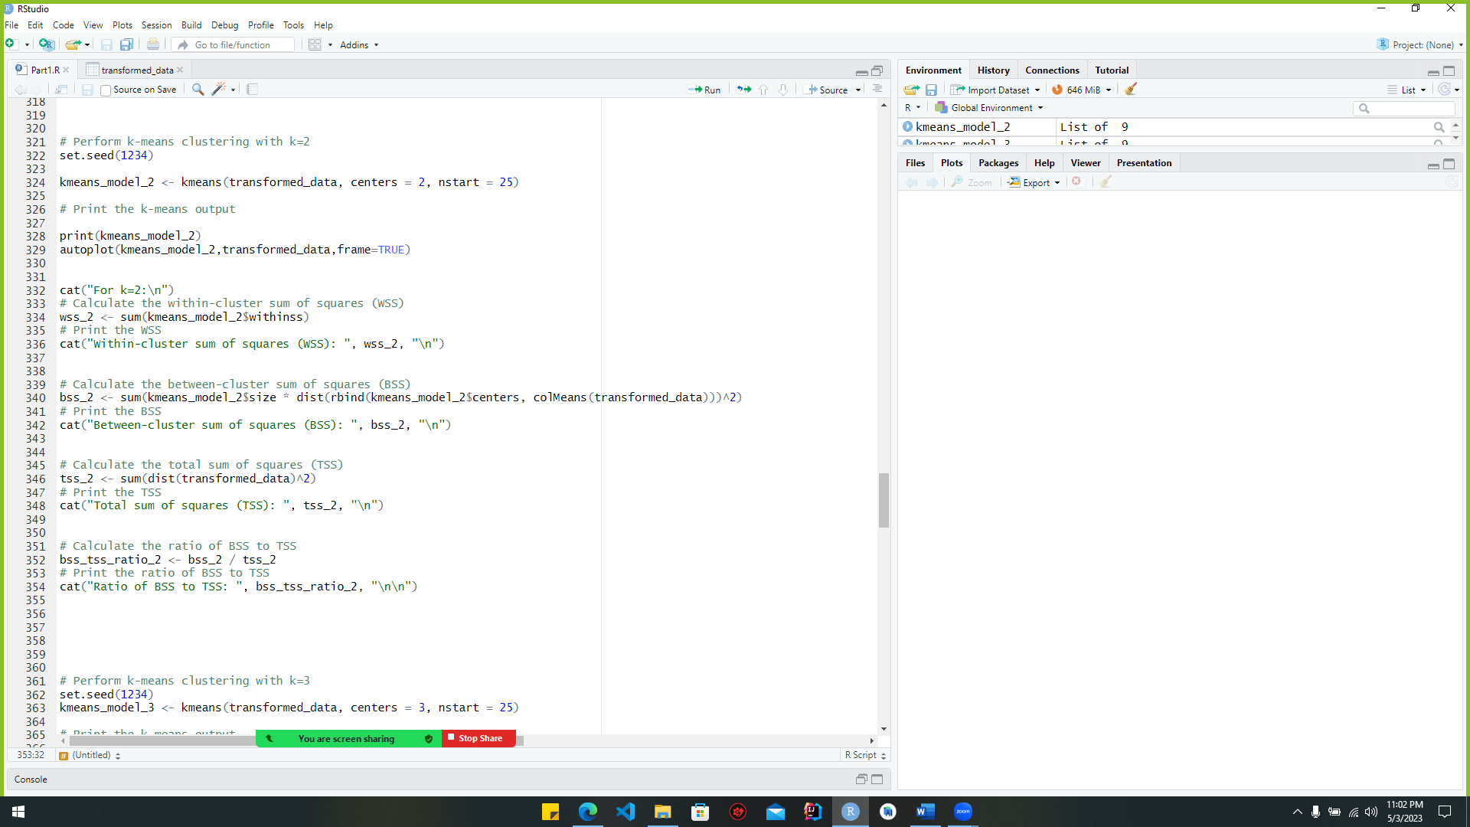***code***

Figure :code_ for_kmean_pca(k=2)

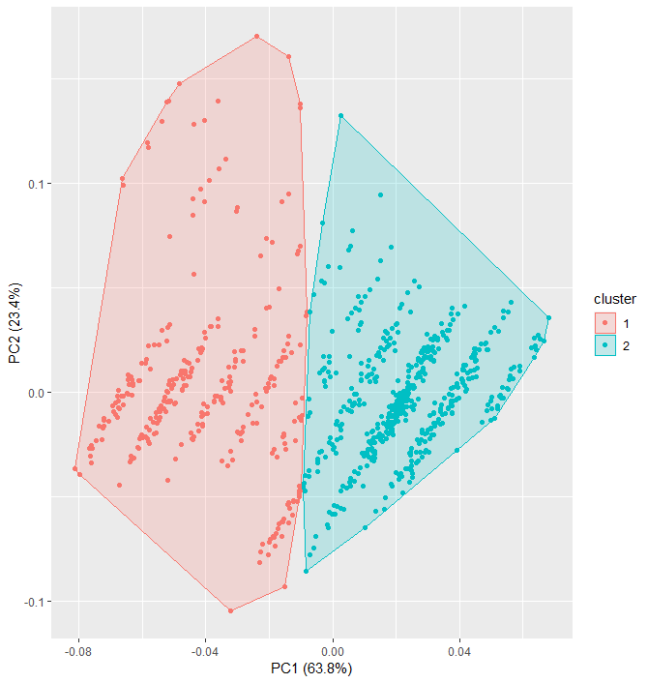***outputs***

Figure :cluster_pca_output_1(k=2)

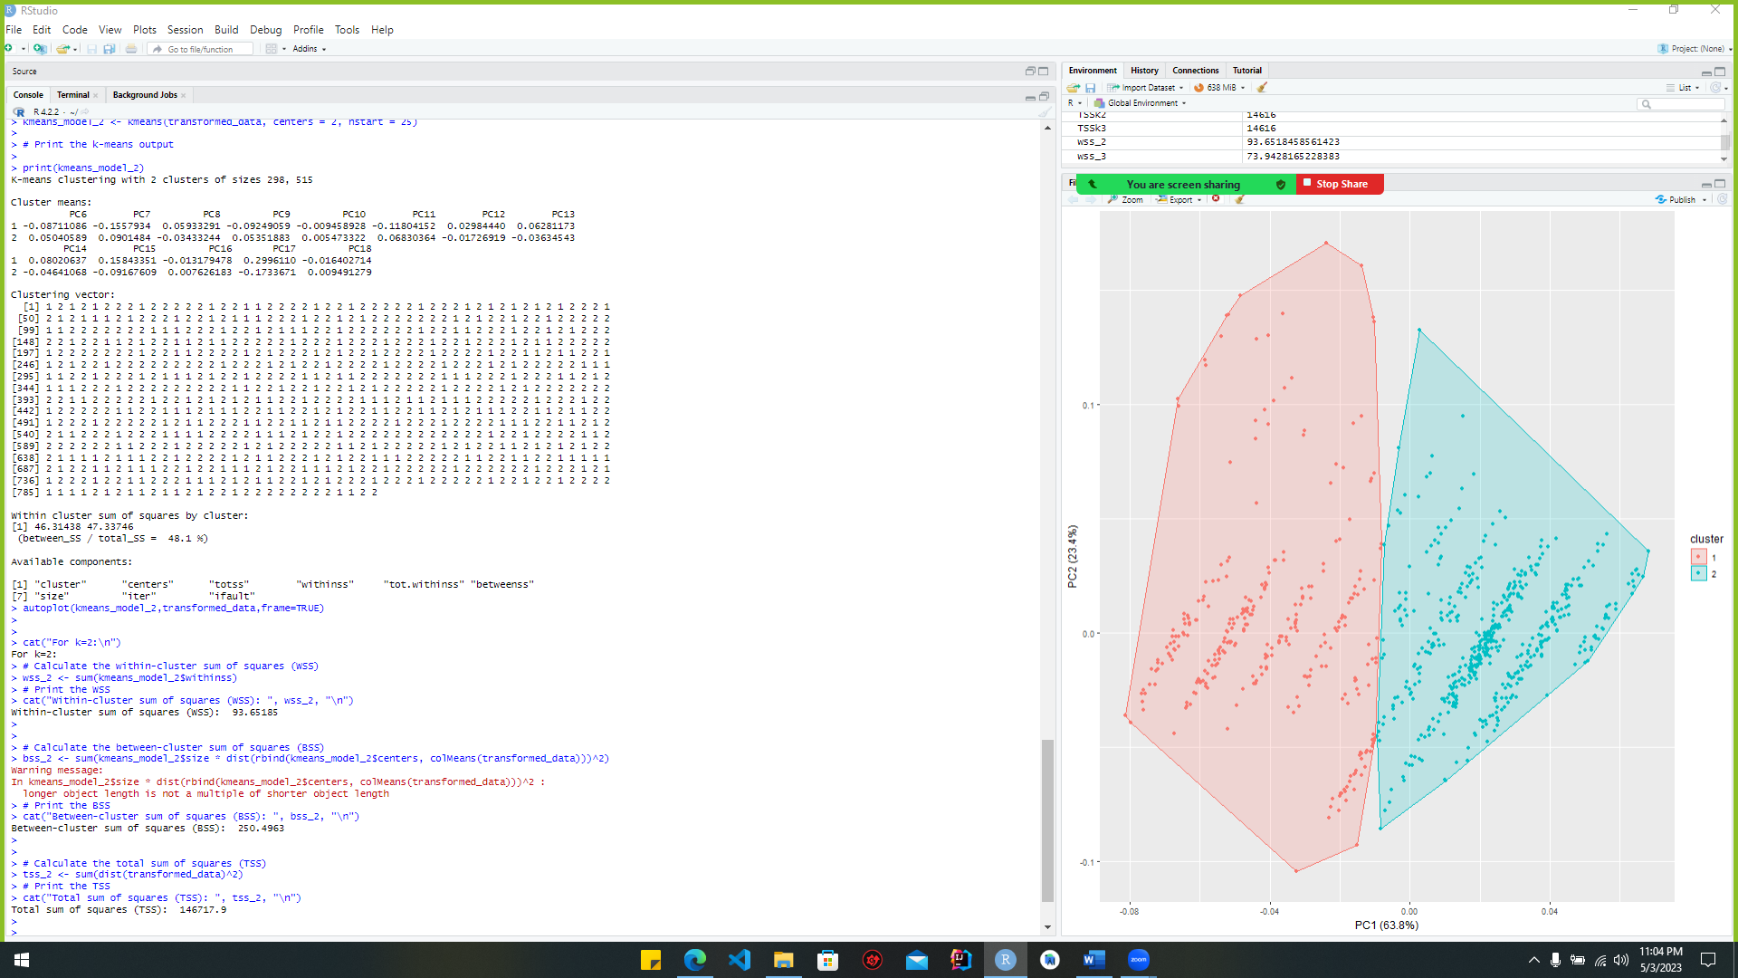

Figure :cluster_pca_output(k=2)

K mean =3

Figure :code_ for_kmean_pca(k=3)

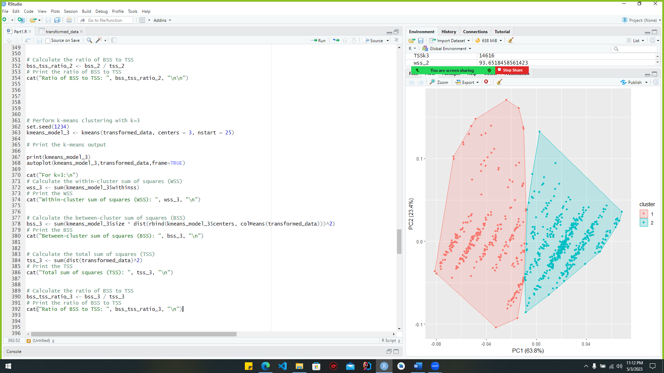***code***

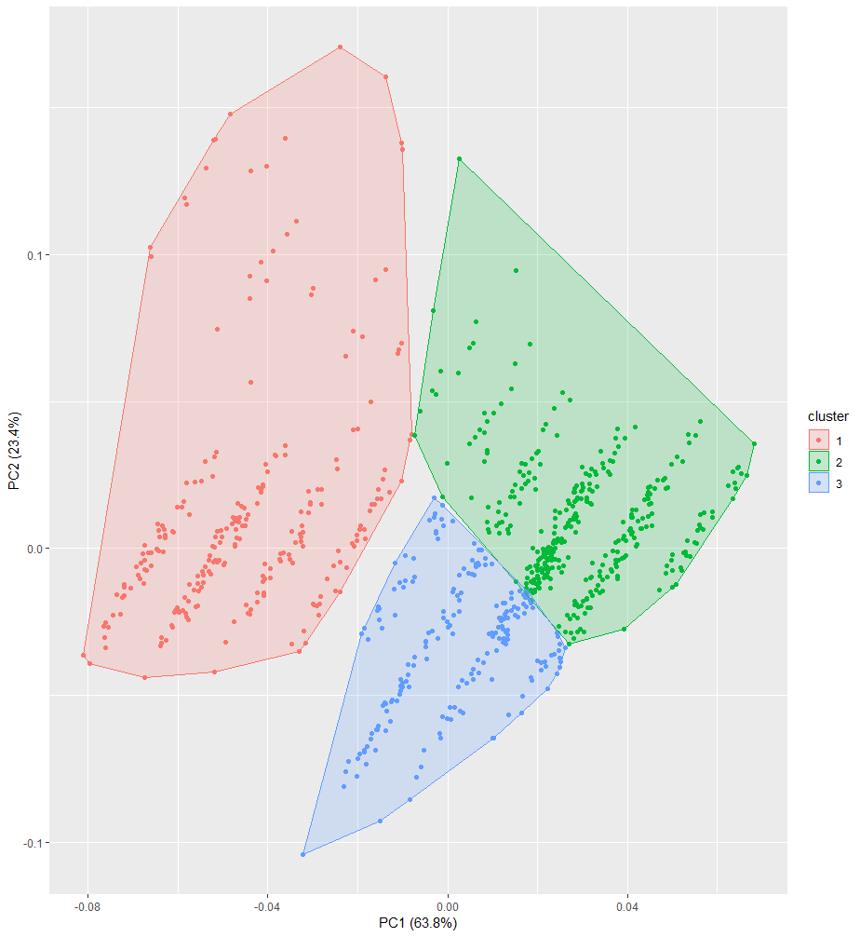***Outputs***

Figure :cluster_pca_output1(k=3)

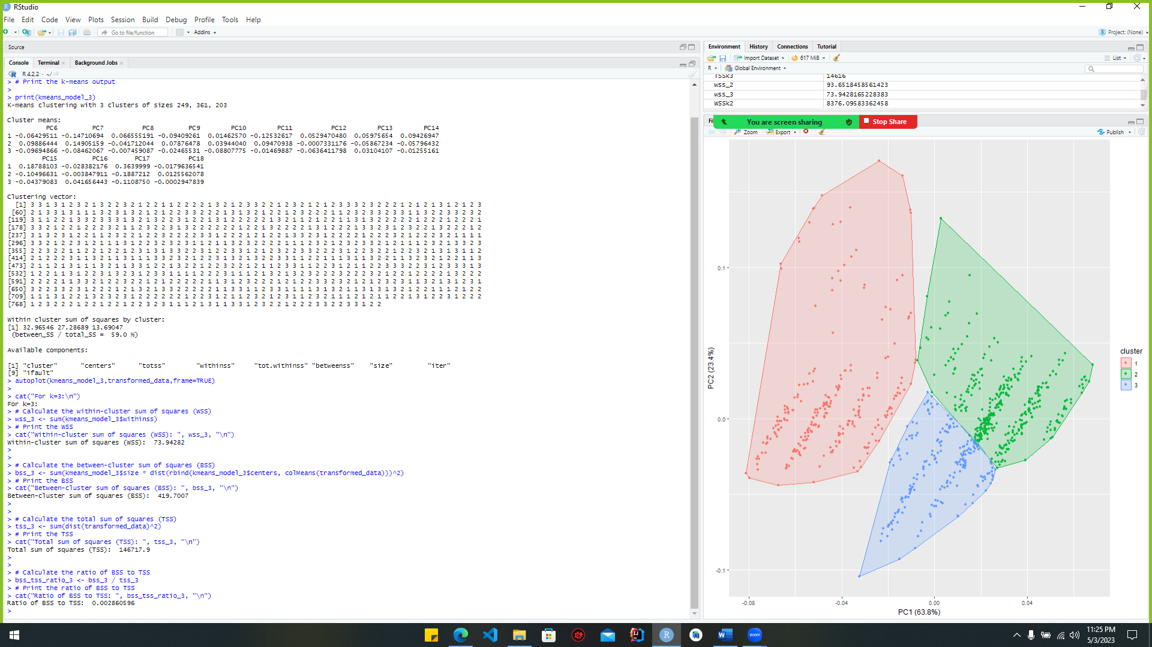

Figure :cluster_pca_output2(k=3)

### Provide the silhouette plot which displays how close each point.

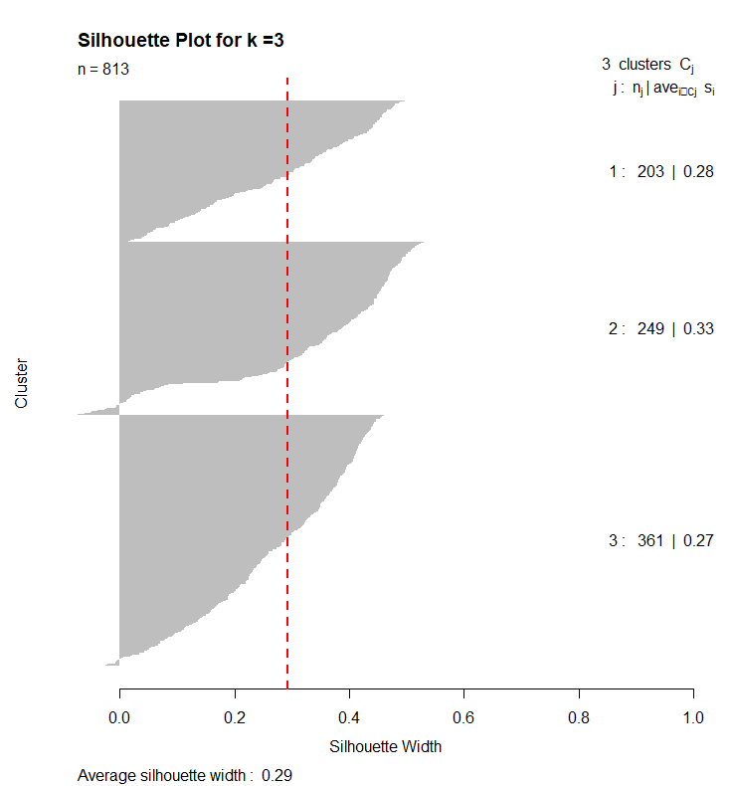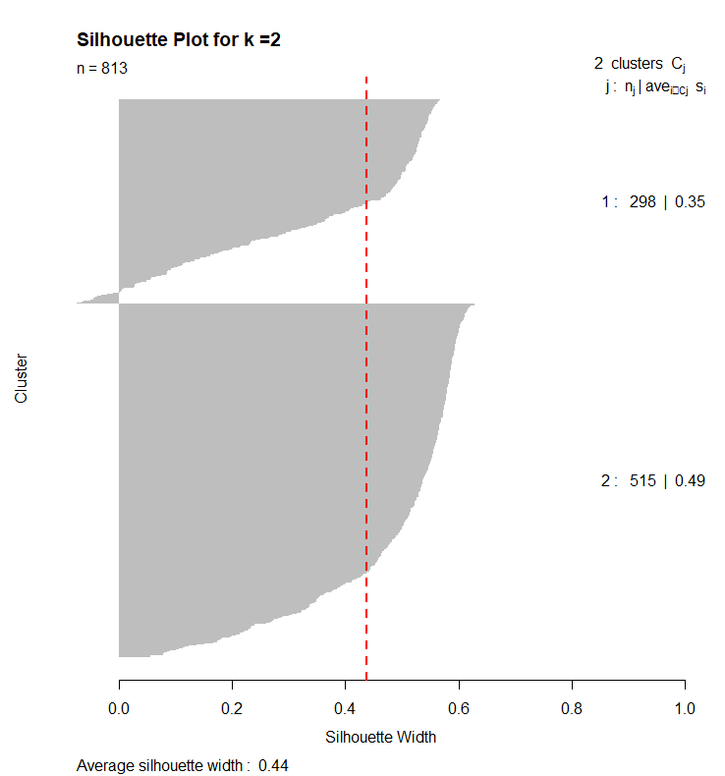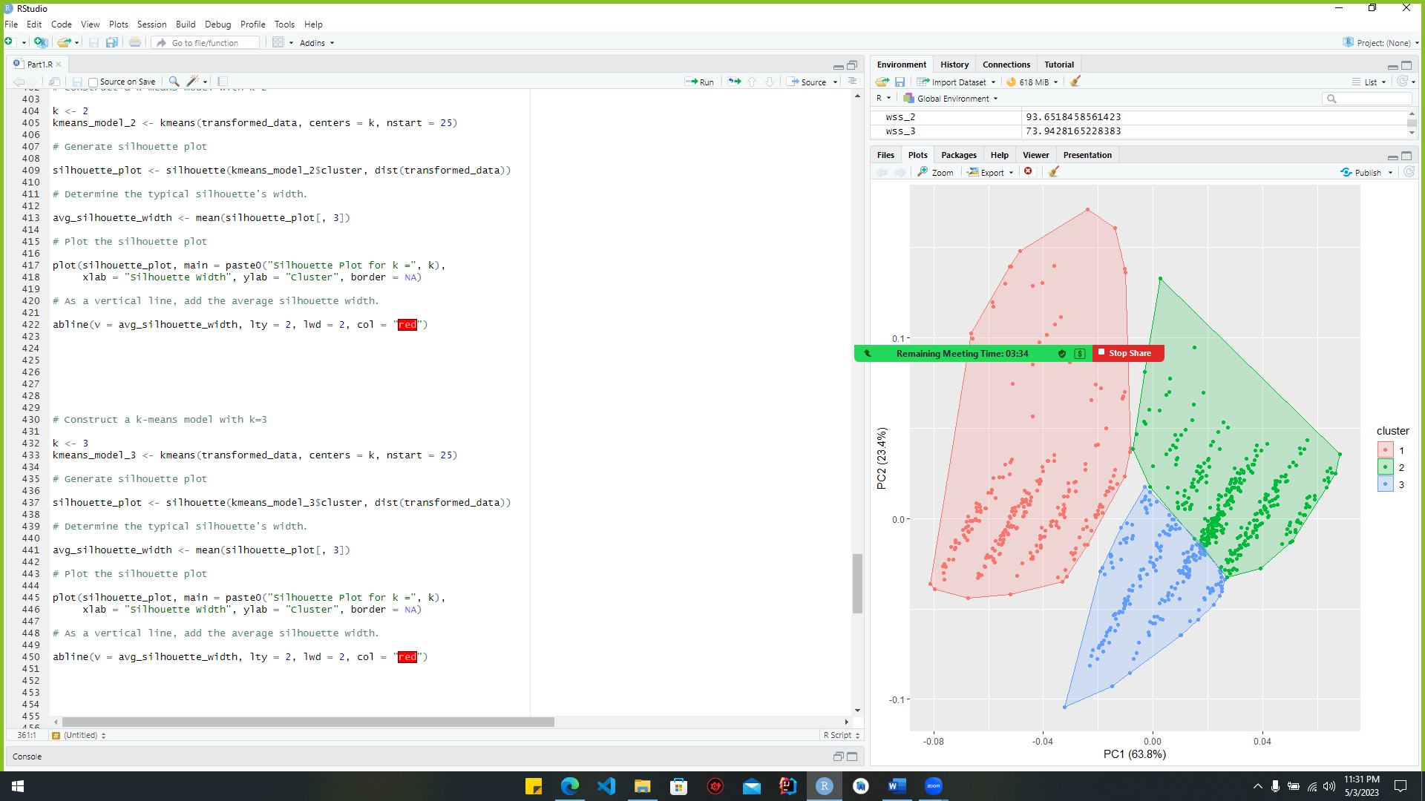***Code*** ***And*** ***Output:***

Figure :silhoutte_plot_pca(k=2)

Figure :silhouette_code_pca(k=3)

Figure :silhoutte_plot_pca(k=3)

### Implement and show the Calinski-Harabasz index

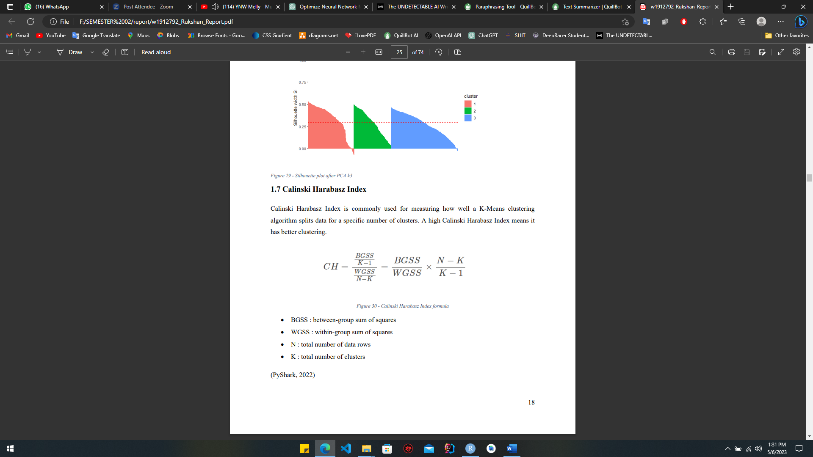In cluster analysis, the validity of the clusters is evaluated using the Calinski-Harabasz index. It is determined by dividing the total squared distances between cluster centers by the total squared distances within each cluster times the number of clusters minus one to get the ratio of the between-cluster dispersion mean to the within-cluster dispersion mean. How well the data points are grouped and how different the clusters are from one another are also factors that the index considers. Better clustering are represented by higher values of the Calinski-Harabasz index.

Figure : the Calinski-Harabasz _formular

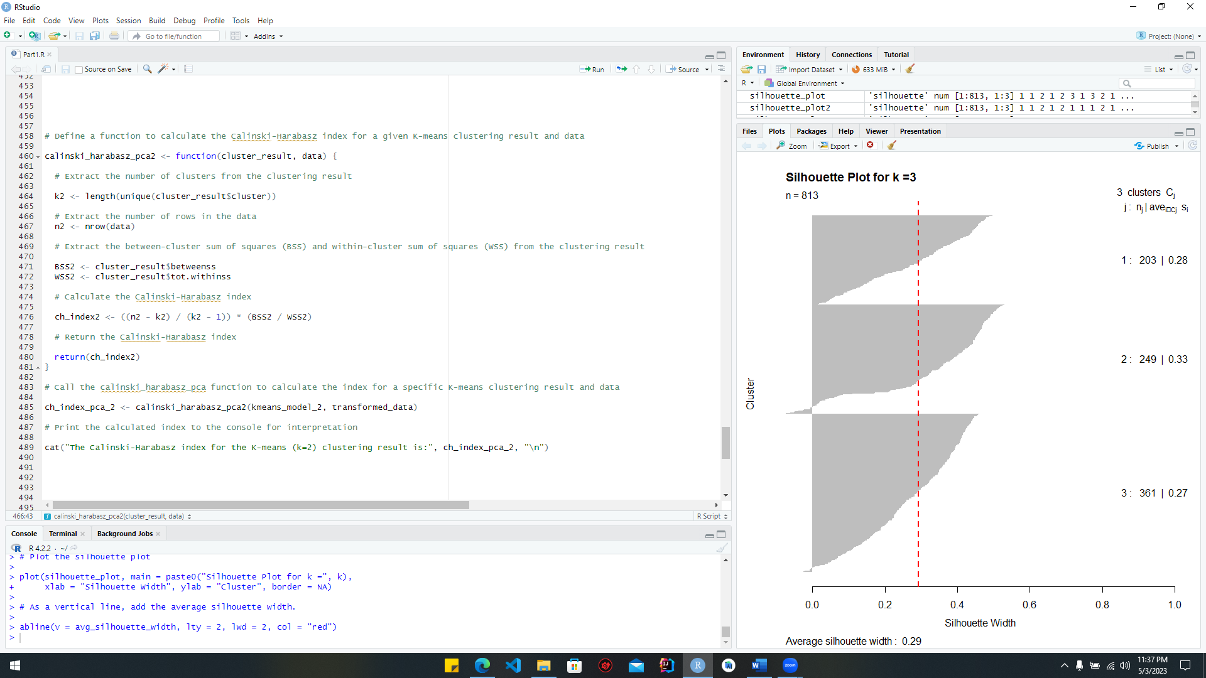Code for k=2:

Figure :the Calinski-Harabasz code(K=2)

The "calinski_harabasz_pca2" function is defined in this code, and it accepts a K-means clustering result (cluster_result) and the data that was used to perform the clustering (data). Adjusted for the number of clusters and the total number of data points, the function computes the Calinski-Harabasz index, which is the ratio of the sum of squares between clusters to the sum of squares within clusters. First, it takes the clustering result and the data and extracts the number of clusters (k2) and the number of rows in the data (n2). Next, it takes the clustering result and returns the between- and within-cluster sums of squares (BSS2 and WSS2, respectively). The Calinski-Harabasz index for the 2-cluster K-means clustering result is then computed by passing the clustering result (kmeans_model_2) and the modified data (transformed_data) as inputs to the function. The console will display the computed index for analysis.

***Output***:

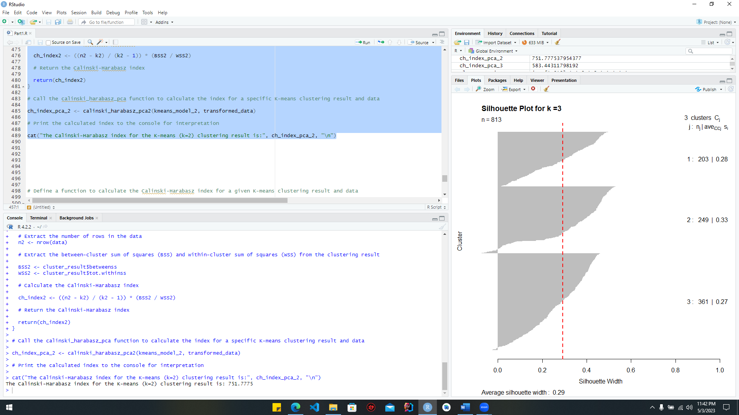

Figure :Calinski-Harabasz code_output(k=2)

Code for k=3:

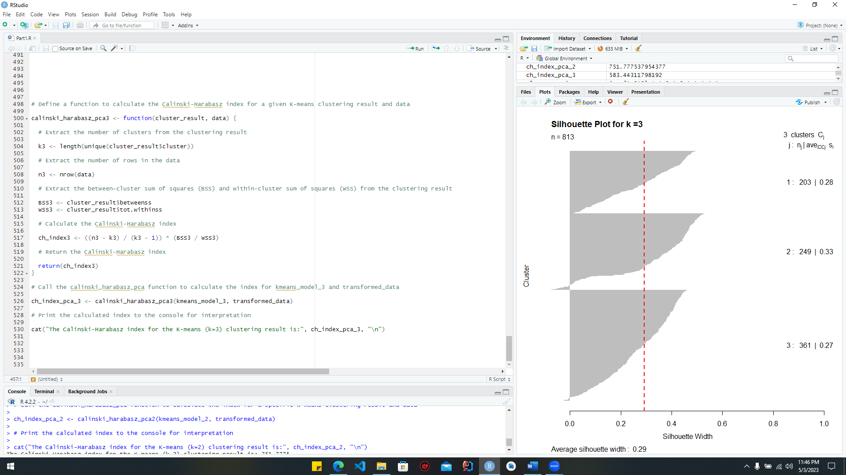***code:***

Figure :Calinski-Harabasz code(k=3)

***Output:***

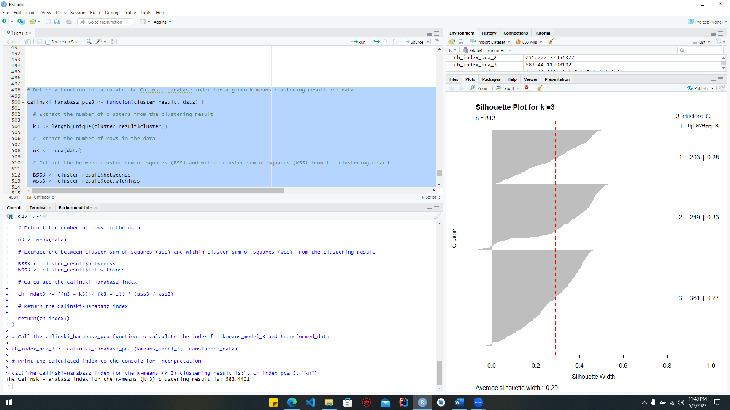

Figure :Calinski-Harabasz code_output(k=3)

# Multi-layer Neural Network

## 1st Subtask Objectives

### Part A

#### Electricity load forecasting

The input vector is a crucial feature of MLP models developed for energy load forecasting. It is made up of many factors that are utilized to foretell power usage in the next time period. Input vectors for MLP models can be defined in several different ways, each with its own implementation and design approach. The following are examples of several common methods now in use.

**Autoregressive (AR) approach:** Time series analysis, including power demand forecasting, frequently employs the autoregressive (AR) method as a modelling tool. Predicting future power use requires utilizing historical data on current use as inputs. The model predicts that a variable's future value will be a linear mixture of its past values at specified delays. The number of time-lags between the data employed in the AR model is defined by its order, indicated by p.

**Moving Average (MA) approach:** In the MA method of electrical load forecasting, prior measurements of electricity use are averaged and then used as inputs to make predictions about future use. The model assumes that the present value of the variable is in some way related to the weighted average of its error components at various time delays in the past. The number of lagged error terms that are utilized as inputs is designated by the MA model's order, which is indicated by q.

***Fourier transform approach:*** Data on electrical consumption may be analyzed for periodic patterns by first converting it from the time domain to the frequency domain.

**Weather data approach** : Electricity usage is correlated with meteorological variables including temperature, humidity, and wind speed**.**

As part of our coursework, This MLP model was trained using a dataset that included columns for things like "data," "electricity consumption," "19th hour," and "20th hour." Next day (future) 20th hour energy usage must be predicted using historical data. The 20th hour's energy usage can be predicted in several different ways.

* According to power use during the 20th hour.
* According to power use during the 19th hour.
* According to power use during the 18th hour.

We may extrapolate previous 20-hour usages, such as tomorrow's energy use, from today's and yesterday's combined consumption. The utilization of two data sets has resulted in a more precise forecast. Similarly, we can extrapolate tomorrow's energy use from data as far back as a week ago. The consumption of the following hour, the 20, may be estimated from the consumption of the previous hour, the 19. In addition to being able to foretell the 20th hour, the 18th hour has a strong correlation with it. More accurate predictions of energy use in the 20th hour may be made by combining data from the 18th and 19th hours of use. These parameters can be used to estimate energy use in the next 20 hours.

#### Graphical user interface, text Description automatically generatedInput vectors & I/O matrix

Figure :crate_matrix

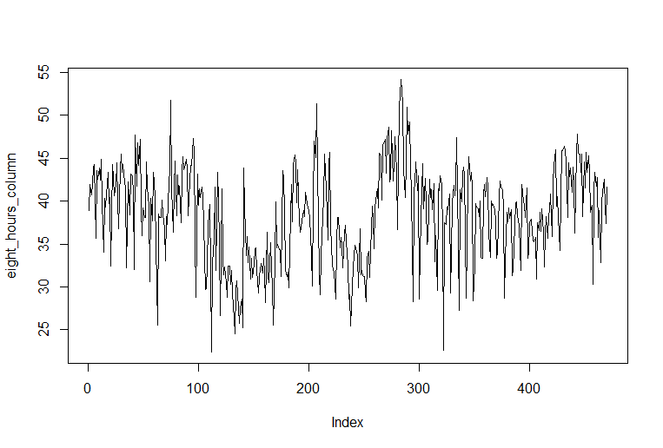This function takes a data column with the name "eight_hours_column" and generates a matrix with a delay of eight hours. Create a matrix where each column is a time-delayed version of "eight_hours_column" using the "bind_cols()" function in the "dplyr" package. A new matrix called "time_delayed_matrix" is created as a consequence. However, rows with missing values are omitted using the "na.omit()" method, and the resultant matrix is stored in the delayed_matrix variable. The following code may be used to convert a single column of data into a time series matrix for use in machine learning model training. It contains data that may be used to make predictions about the future value of the target variable (eight_hoursHour) and other related variables.

### *Normalization*

* + - 1. *What is normalization and why is it important?*

The process of normalization, a type of data preparation, involves the rescaling of numbers to fit a predetermined range. By minimizing the influence of feature size, outliers, and training convergence, it helps to boost machine learning model performance. It is widely employed in a wide variety of machine learning methods, including k-nearest neighbor’s, support vector machines, and neural networks.

#### Using Normalization on a Model

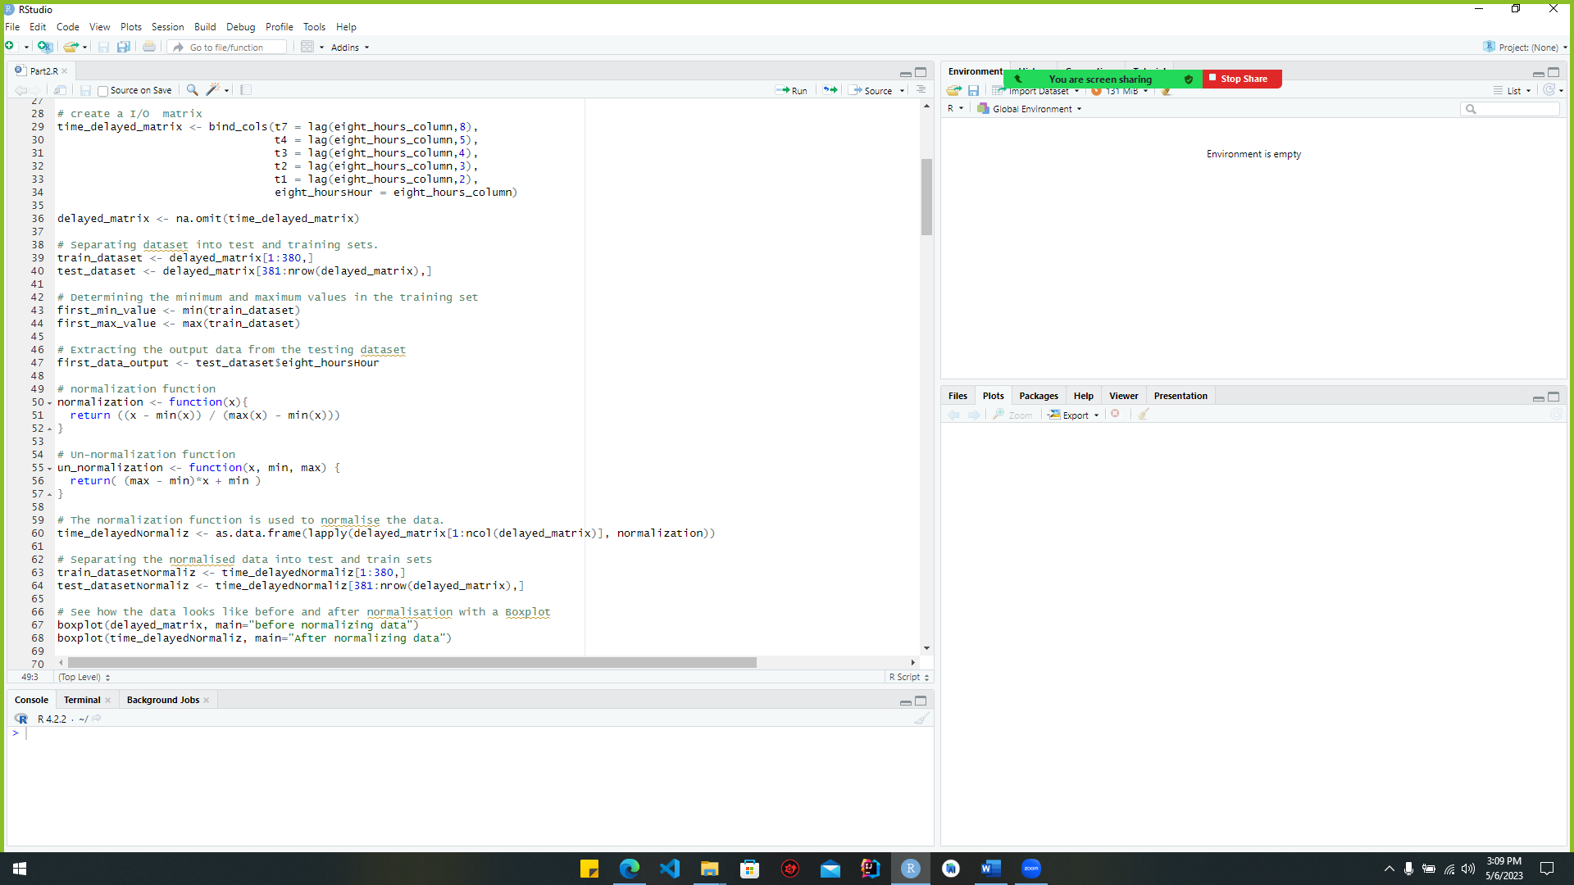

Figure :normalization_code

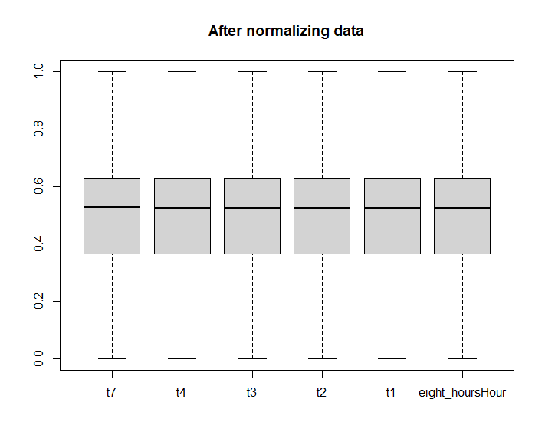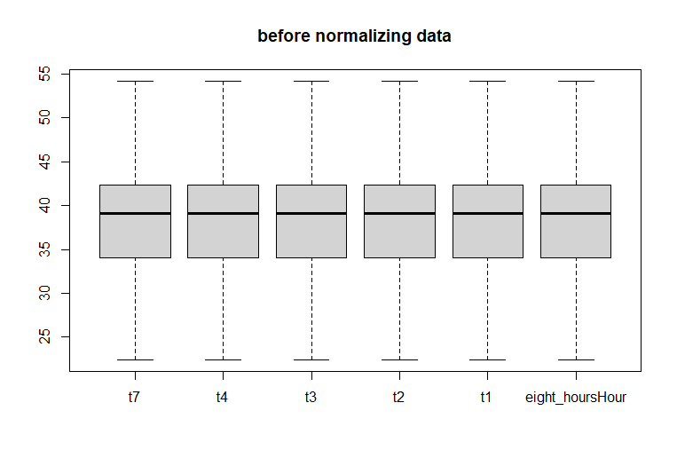Using the min-max normalization technique, this code provides a function that accepts a vector of numbers as input and returns the normalized values. By removing the least value of the input vector from each element and dividing by the difference between the maximum and minimum values, this technique scales the input values to a range between 0 and 1. This ensures that smaller features have an equal impact on the output when using machine learning techniques like k-nearest neighbor’s and support vector networks, which rely on distance measures.

Figure :after_normalization

Figure :before_normalization

Values between 25 and 55 may be seen in both graphs before normalization, but only 0 and 1 remain in the final graph.

### Training Neural Networks

##### Splitting data for training and testing

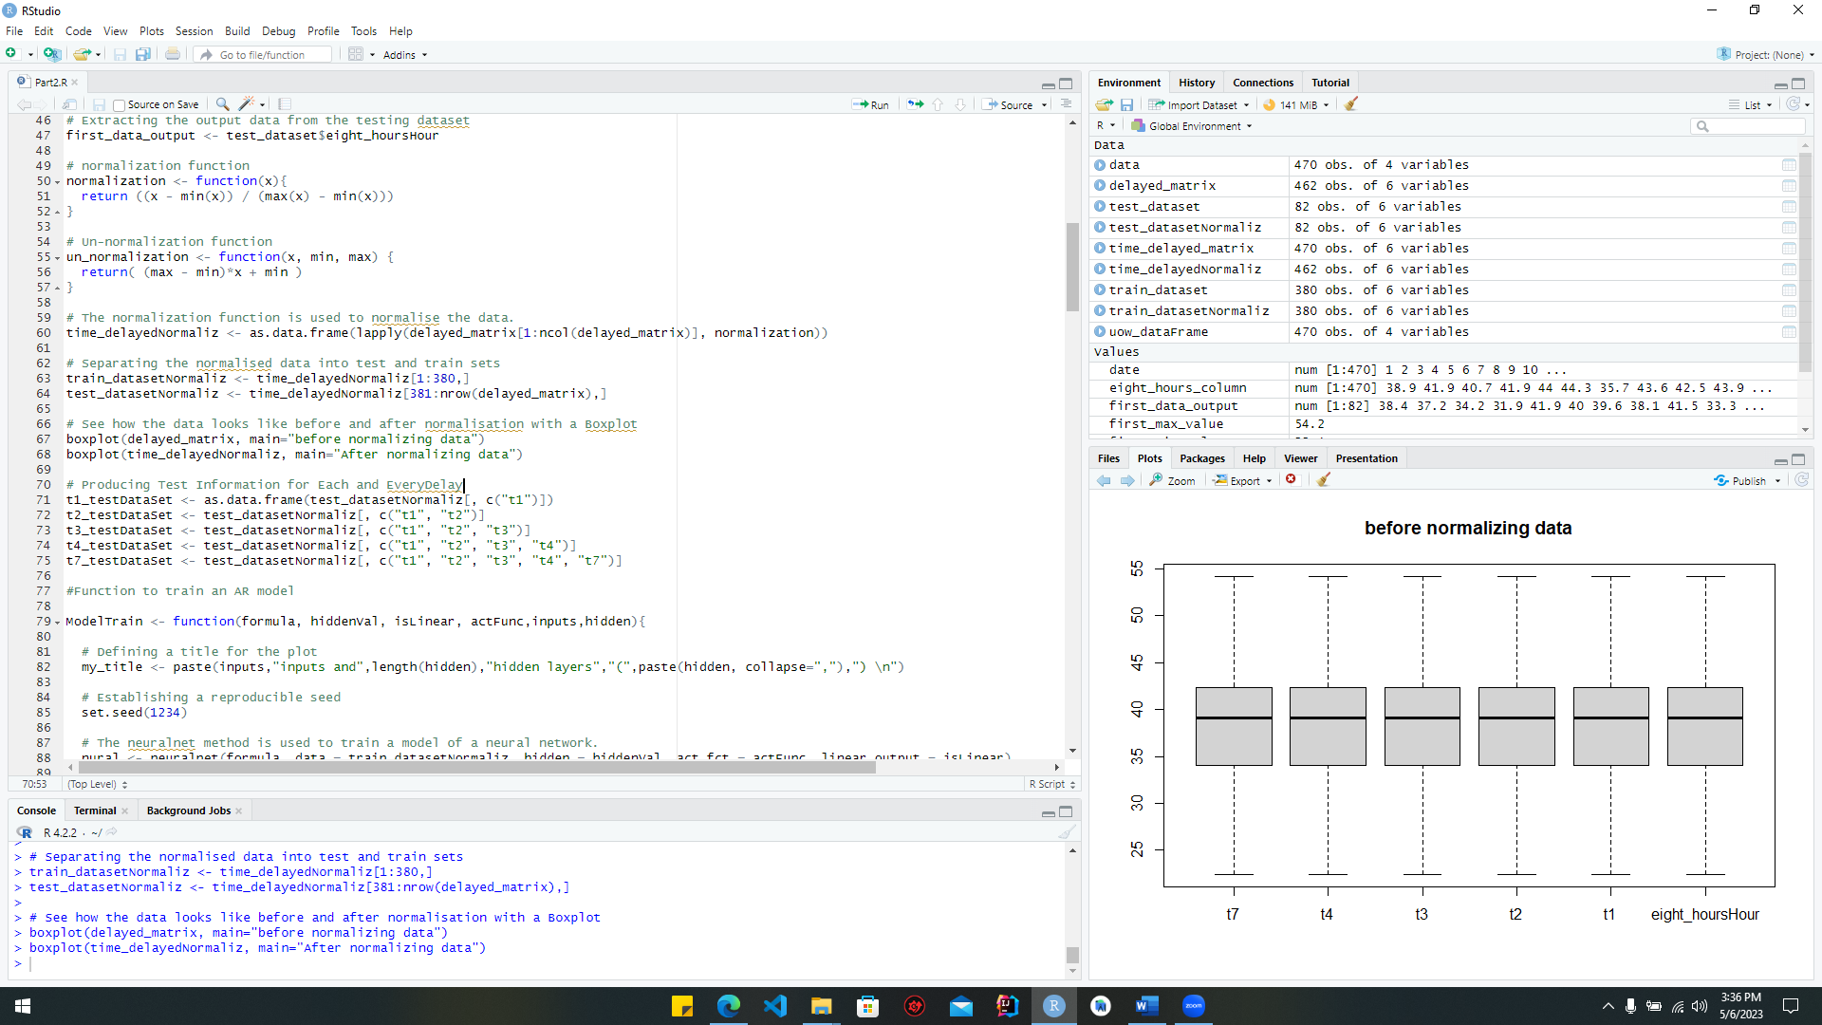

Figure :splitting_code

This code divides the standardized data into a training set and a test set. The first line copies the first 380 rows from the "time_delayedNormaliz” data frame" into a new data frame called "train_datasetNormaliz." The second line extracts rows 381–final from the “time_delayedNormaliz” data frame and stores them in a new data frame called “test_datasetNormaliz”. By separating the data into training and testing sets, we can evaluate the accuracy and generalizability of the models by training them on a part of the data and then testing their performance with the remaining data.

#### testing data for each time delay

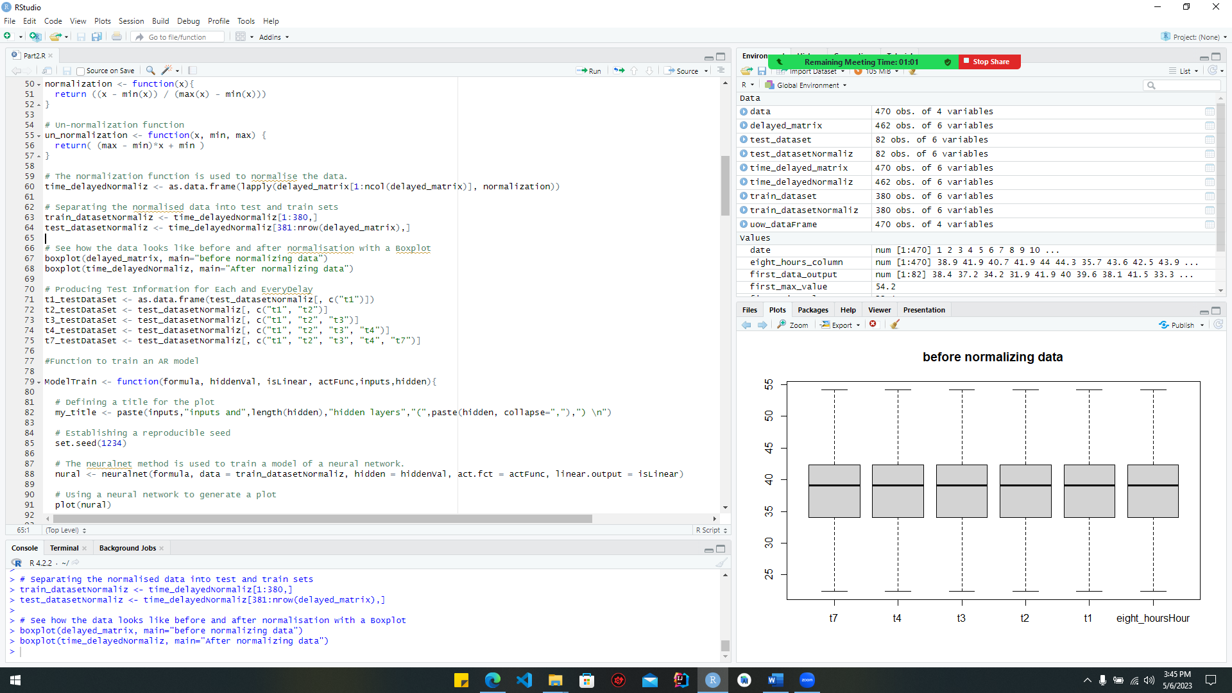

Figure :testingdata

Only the required columns from the test data section will be chosen for model testing.

#### Training the model

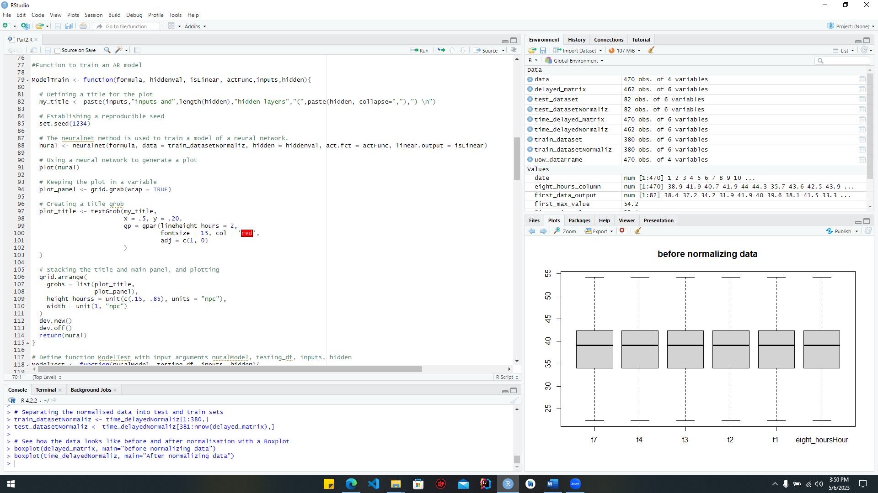

Figure :model_code

This code specifies a function named "ModelTrain" that accepts numerous parameters, including the inputs and hidden layers of the neural network, as well as the activation function, the number of hidden layers, and whether the output is linear. The "neuralnet" technique is used to train the network, a plot is generated, a title grob is made, and the plot of the title and major panel grobs is stacked and plotted using the "grid.arrange" function inside the function. At last, the function gives back the object that represents the trained neural network.

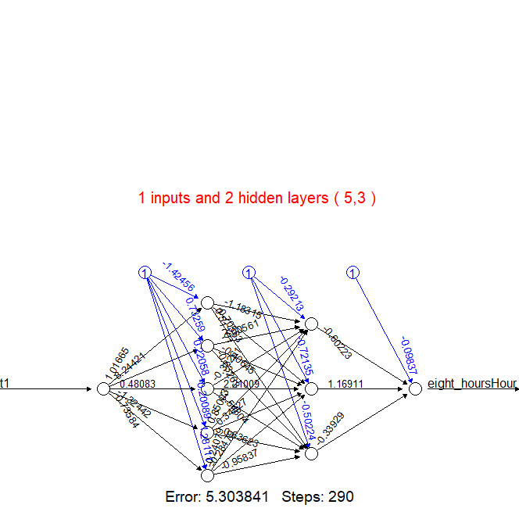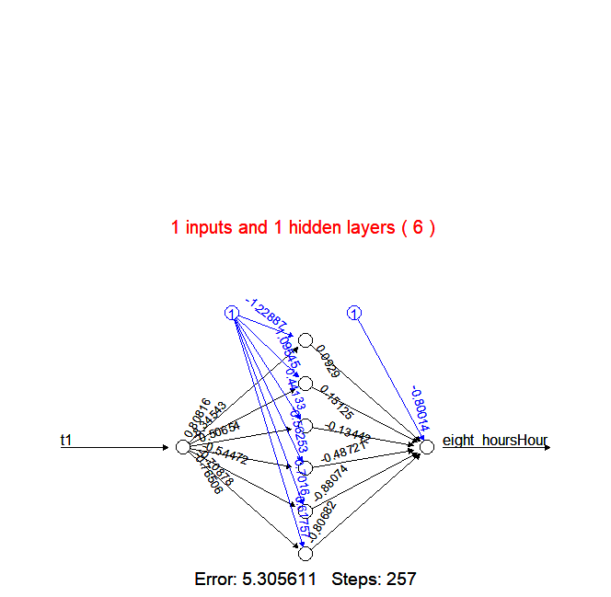

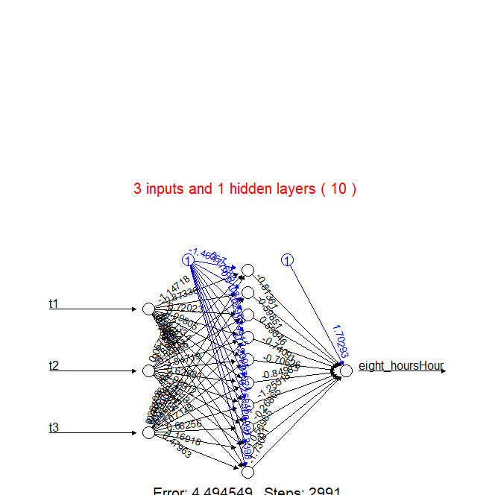

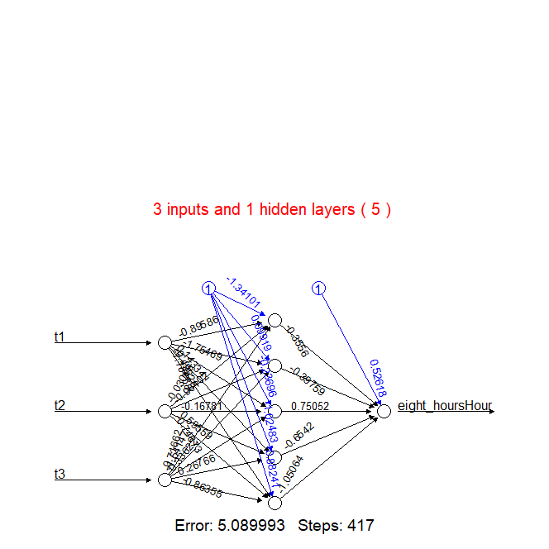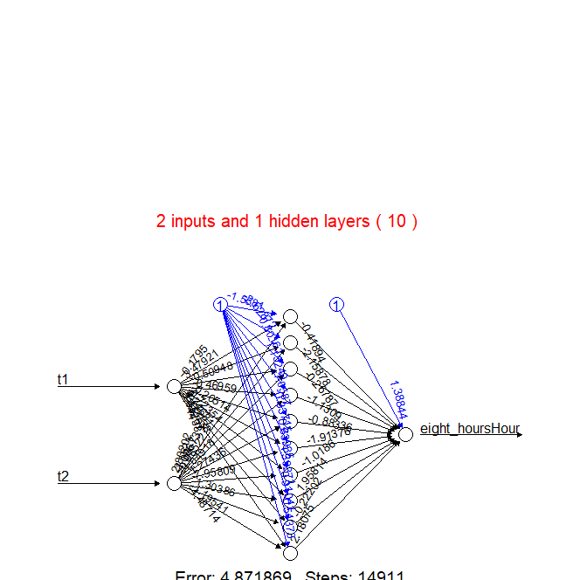

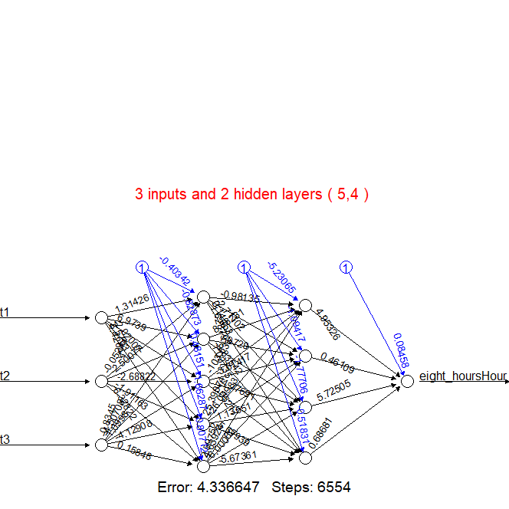

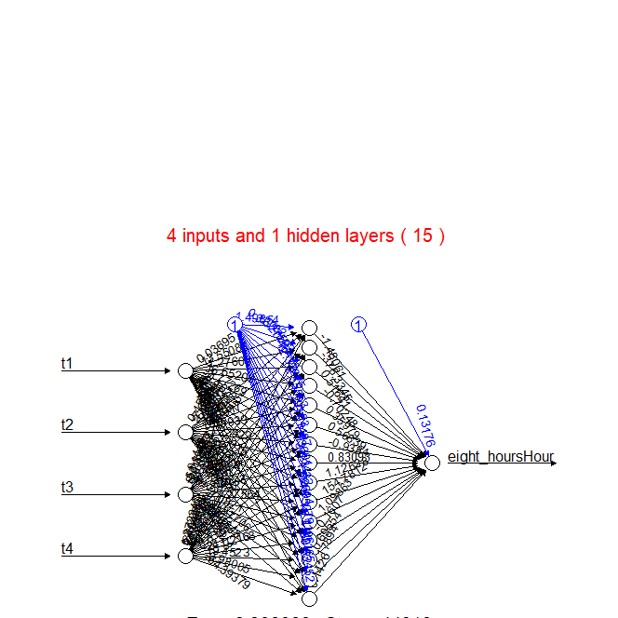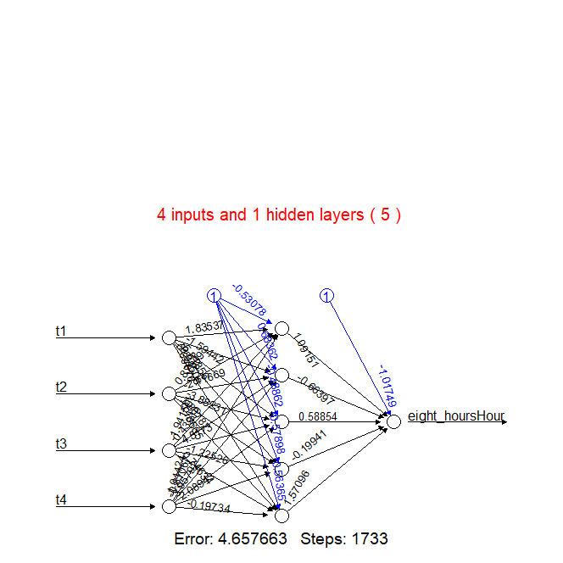

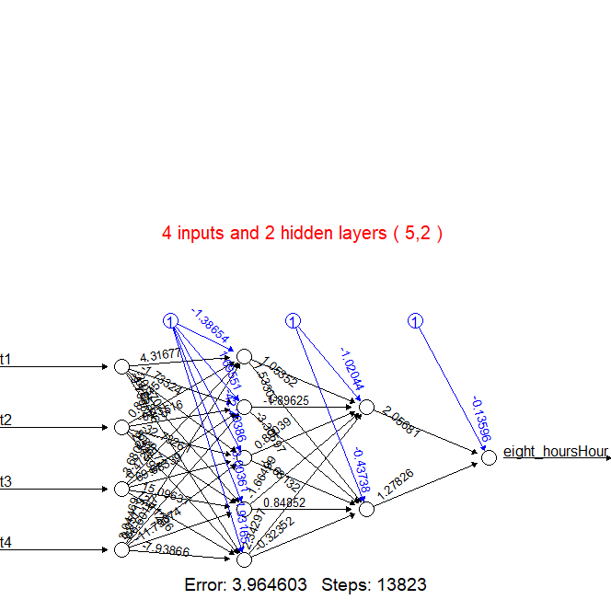

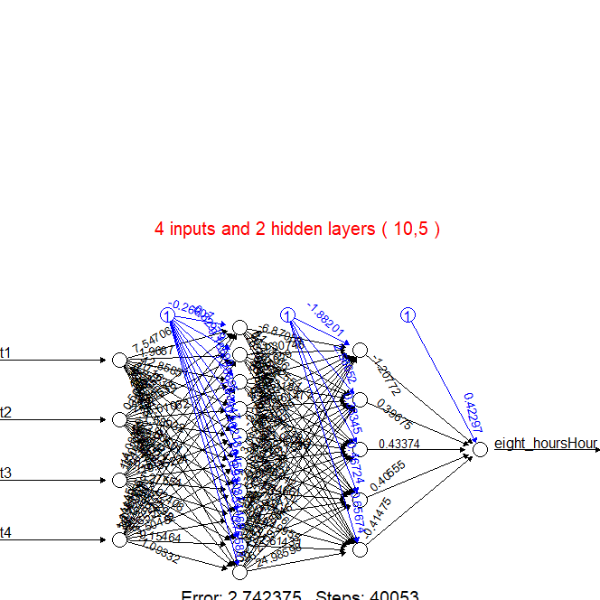

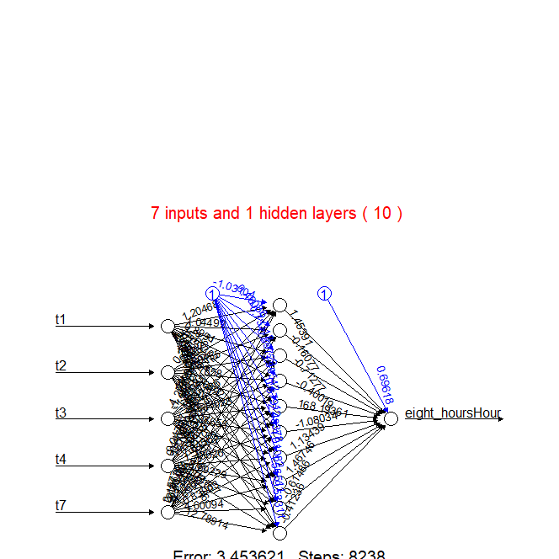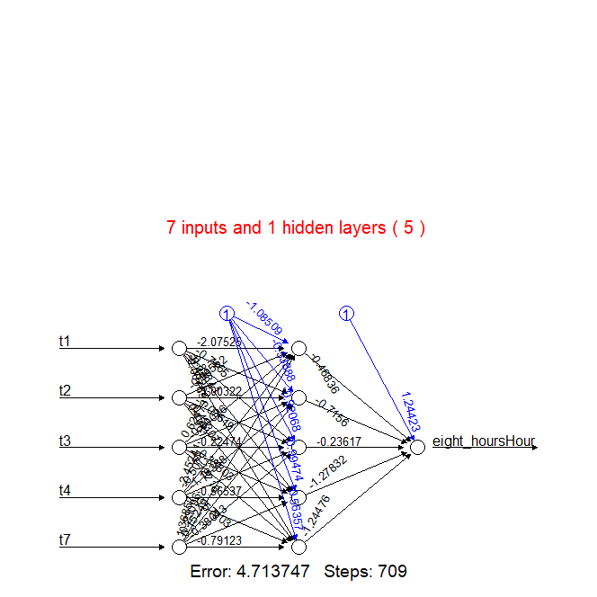

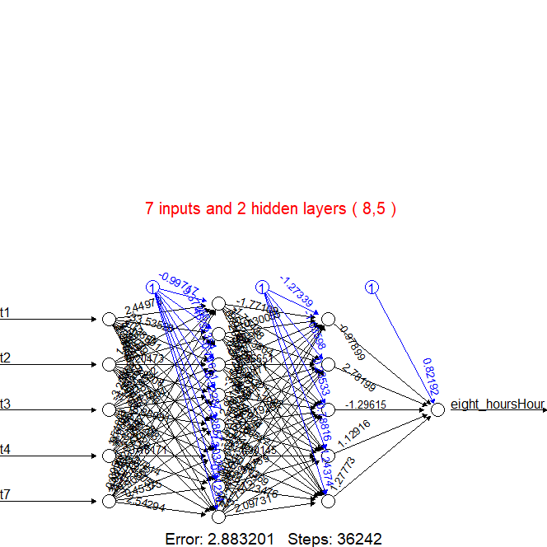

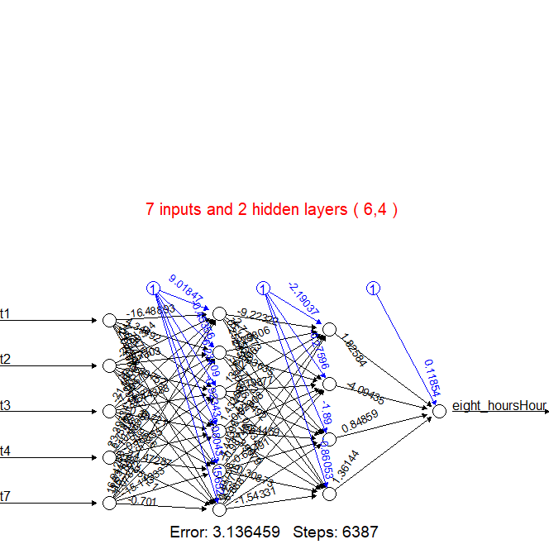

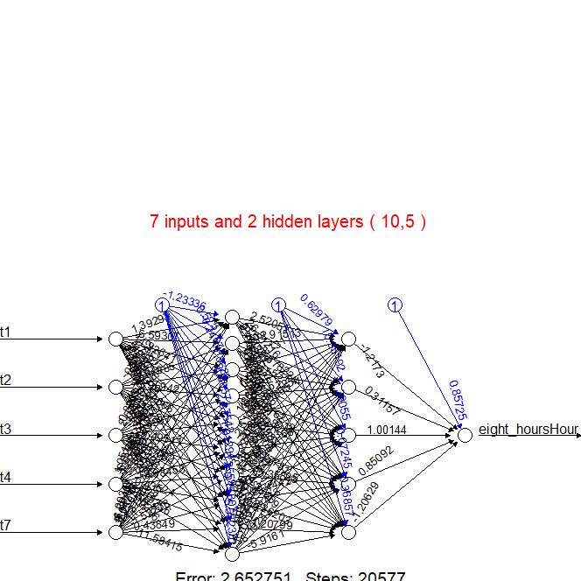

### RMSE, MAE, MAPE, and sMAPE

In regression and forecasting tasks, the RMSE, MAE, MAPE, and sMAPE metrics are frequently employed to evaluate model accuracy and performance. Absolute differences, relative mistakes, and symmetric adjustments are all taken into account by the various metrics, providing a comprehensive picture of the accuracy of the forecasts.

• RMSE (Root Mean Square Error)

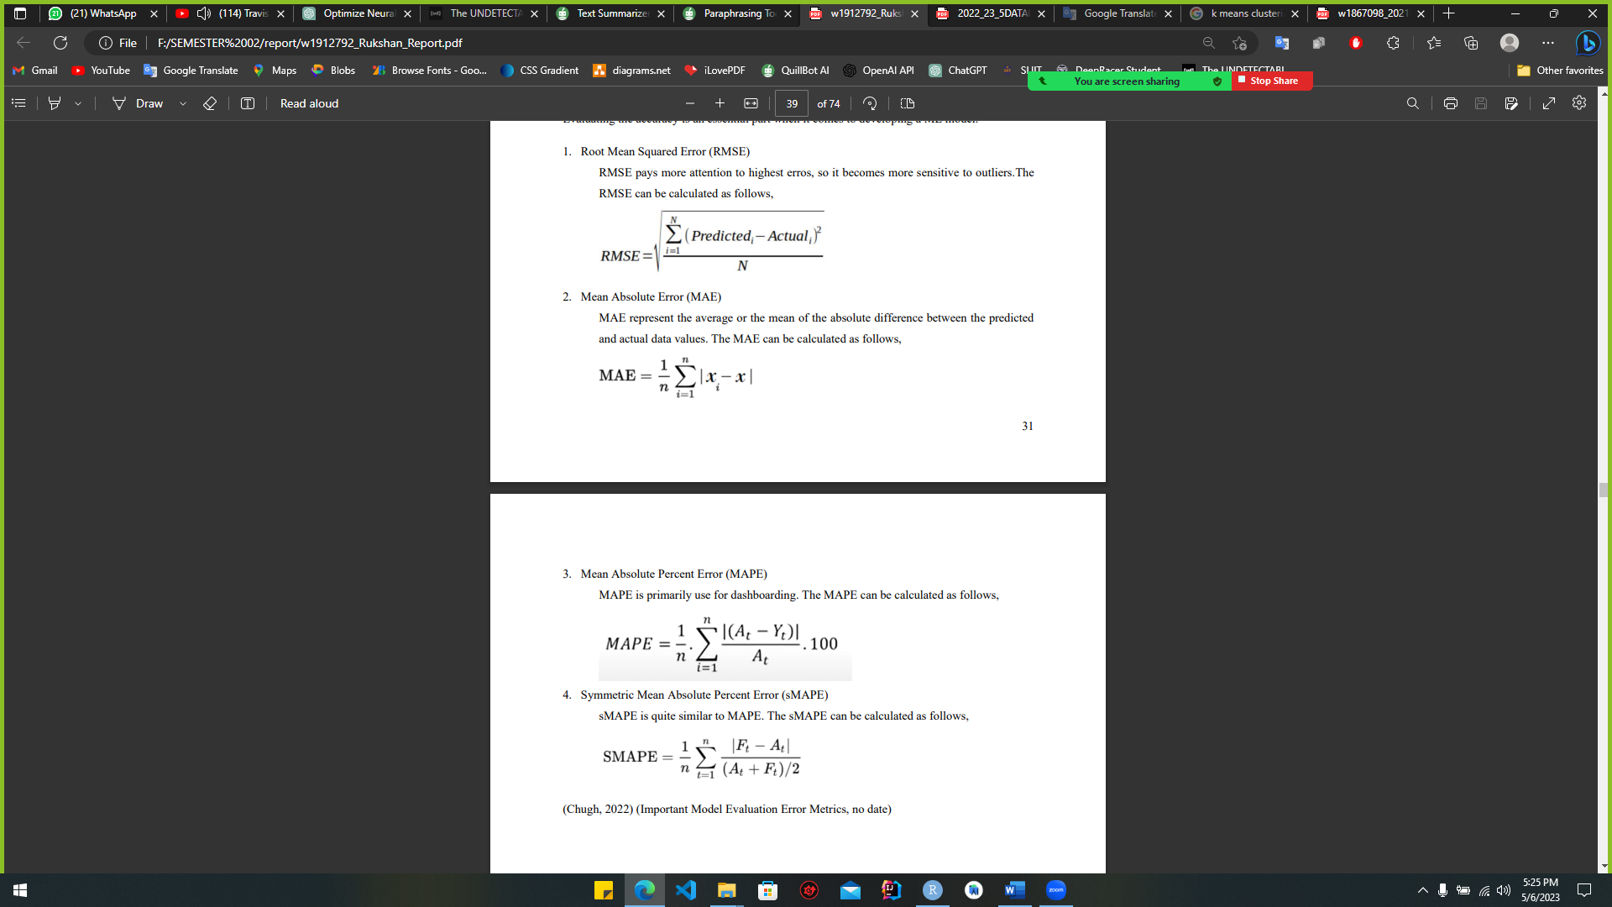In regression analysis, the statistic known as the Root Mean Squared Error (RMSE) is used to measure the degree to which observed values deviate from those predicted. It is calculated by taking the mean squared deviation from the predicted and observed values. The root-mean-squared error (RMSE) is a common metric used to compare the precision of various machine learning models. A smaller RMSE number indicates that the model is more accurate.

• MAE (Mean Absolute Error)

Mean Absolute Error (MAE) is a statistic used in regression analysis to quantify the degree to which estimates deviate from reality. It is easier to read since it uses the same units as the target variable, and it is produced by averaging the absolute differences between the anticipated and actual values.



• MAPE (Mean Absolute Percentage Error)

Mean Absolute Percentage Error (MAPE) is a statistic used in regression analysis to quantify the percentage error between the predicted and actual values. It is used to assess the accuracy of different machine learning models but has several drawbacks, such as being undefined when the real value is 0.

• sMAPE (Symmetric Mean Absolute Percentage Error)

For the purpose of regression analysis, the standardised mean absolute percentage error (sMAPE) is a useful indicator. To determine this, we use the mean of the percentages by which predictions deviate from observations, with the total of predictions and observations serving as the denominator. If the sMAPE value is low, the accuracy is high.



### Comparison table

|  |  |  |  |  |  |  |  |  |  |
| --- | --- | --- | --- | --- | --- | --- | --- | --- | --- |
| ***Input count*** | ***Hidden layers*** | ***neurons*** | ***Activation function*** | ***Linear*** | ***Accuracy*** | ***RMSE*** | ***MAE*** | ***MAPE*** | ***sMAPE*** |
| 1 | 1 | 6 | tanh | FALSE | 98.08 % | 3.96811 | 3.281691 | 0.08219015 | 0.08335449 |
| 2 | 5, 3 | tanh | FALSE | 98.03 % | 3.951561 | 3.265439 | 0.08172144 | 0.08290732 |
|  | | | | | | | | | |
| 2 | 1 | 10 | logistic | TRUE | 97.91 % | 3.681026 | 3.015663 | 0.07545289 | 0.07640198 |
|  | | | | | | | | | |
| 3 | 1 | 5 | logistic | TRUE | 98.93 % | 3.857852 | 3.159695 | 0.07992375 | 0.07993308 |
| 1 | 10 | logistic | TRUE | 97.61 % | 3.750374 | 2.930764 | 0.0732769 | 0.07432807 |
| 2 | 5,4 | logistic | TRUE | 97.71 % | 3.878686 | 3.059654 | 0.07659256 | 0.07758889 |
|  | | | | | | | | | |
| 4 | 1 | 5 | logistic | TRUE | 97.99 % | 3.853526 | 3.160198 | 0.07934702 | 0.08003193 |
| 1 | 15 | logistic | TRUE | 98.25 % | 4.409359 | 3.43928 | 0.08703834 | 0.08785926 |
| 2 | 5,2 | logistic | TRUE | 97.04 % | 4.571932 | 3.596863 | 0.08996218 | 0.09198034 |
| 2 | 10,5 | logistic | TRUE | 98.94 % | 4.209867 | 3.480765 | 0.08761536 | 0.08792799 |
|  | | | | | | | | | |
| 7 | 1 | 5 | logistic | TRUE | 99.35 % | 3.661854 | 2.970384 | 0.07559341 | 0.07517955 |
|  | 1 | 10 | logistic | TRUE | 97.63 % | 4.144396 | 3.333606 | 0.08353244 | 0.08494433 |
|  | 2 | 6,4 | logistic | TRUE | 97.68 % | 4.831348 | 3.670521 | 0.09346433 | 0.09523758 |
|  | 2 | 8,5 | logistic | TRUE | 97.89 % | 4.813866 | 3.748068 | 0.09419091 | 0.09571004 |
|  | 2 | 10,5 | logistic | TRUE | 97.99 % | 5.005324 | 4.085764 | 0.1030105 | 0.1048161 |

Table :comparison table 01

### Best one-hidden layer & two-hidden layer

#### Best one hidden layer

The following comparison table suggests that a neural network with seven inputs and five hidden neurons is the optimal model for a single hidden layer. This model was chosen because, according to the comparison table, it achieved the highest accuracy (99.35%).

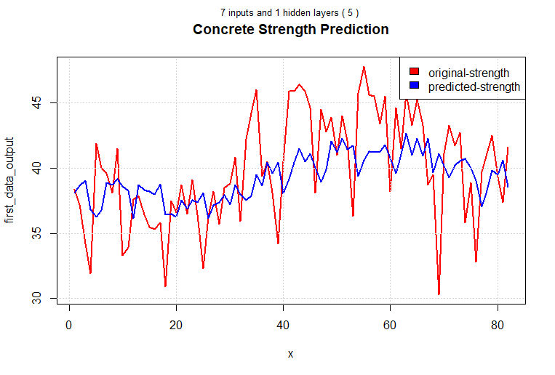

Figure :best one hidden layer

#### Best two hidden layer

The neural network with 4 inputs and 10 and 5 neurons on two hidden layers performs the best in the above comparison table. Since its accuracy (98.94%) exceeds that of competing two-hidden-layer neural network models, it has been chosen as the finest of its kind.

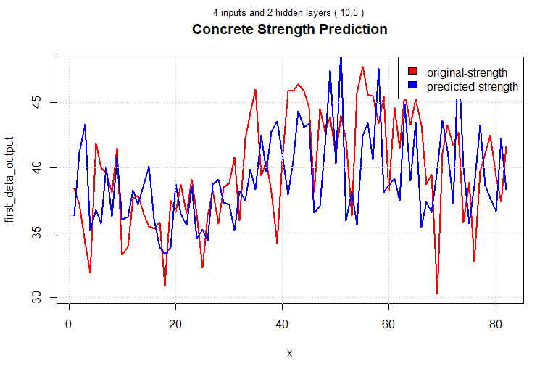

Figure :best two hidden layer

## 2nd Subtask Objectives

### make a matrix of inputs

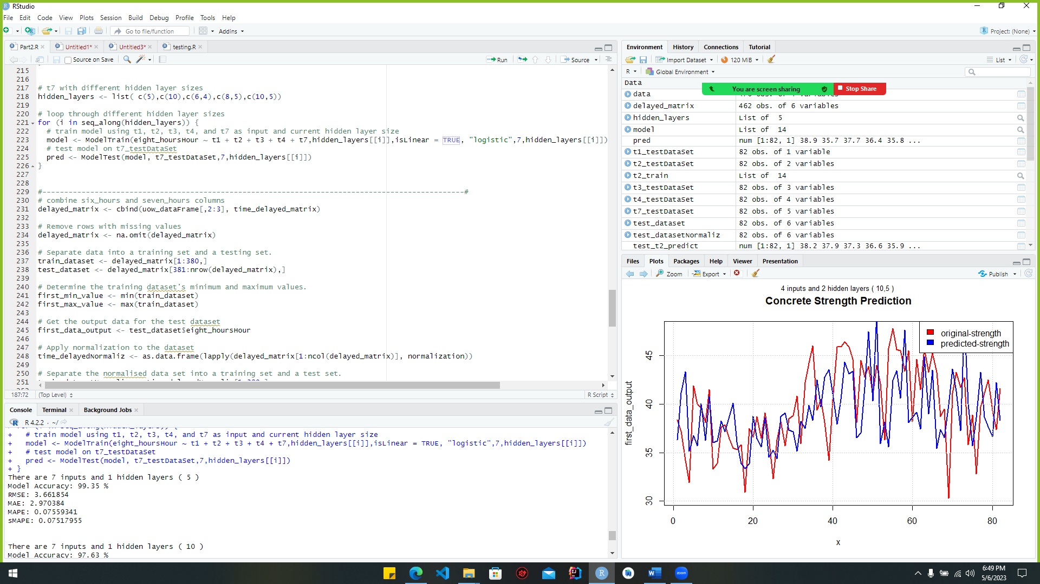

Figure :make_matrix

The above code uses the "time_delayed_matrix" to link together columns 2 and 3 of the current data frame "uow_dataFrame" with the "delayed_matrix." These columns are concatenated using the "cbind()" function, and the resulting "delayed_matrix" data frame is returned.

Figure :before_normalization_2nd

Figure :after_normalization_2nd

### Diagram Description automatically generatedChart Description automatically generatedCreation of a NN model

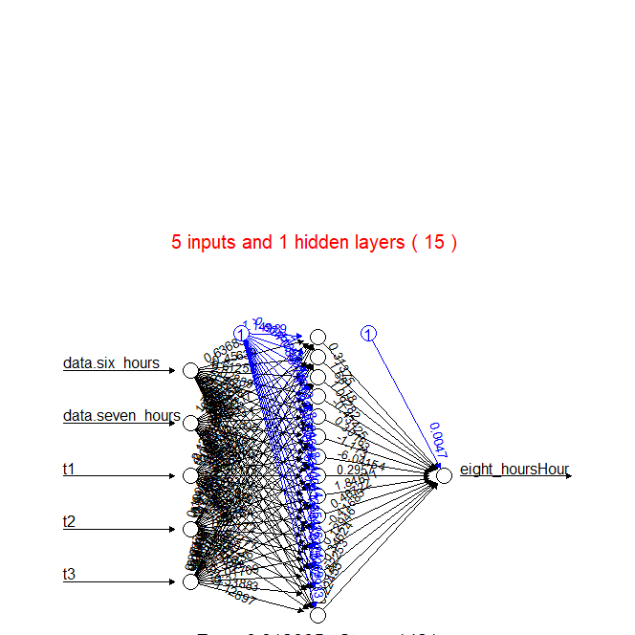

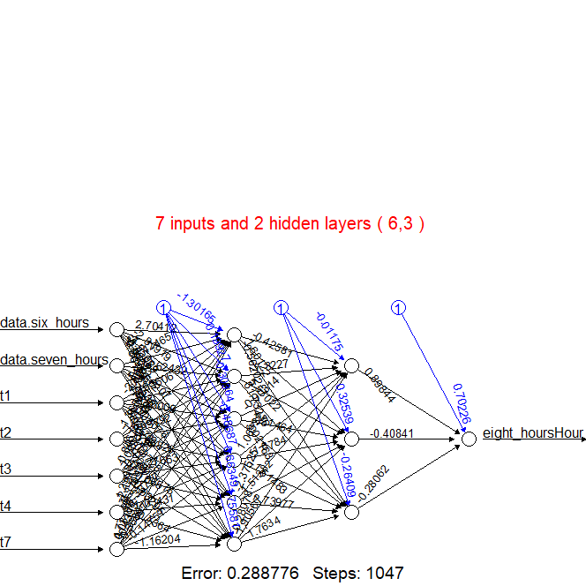

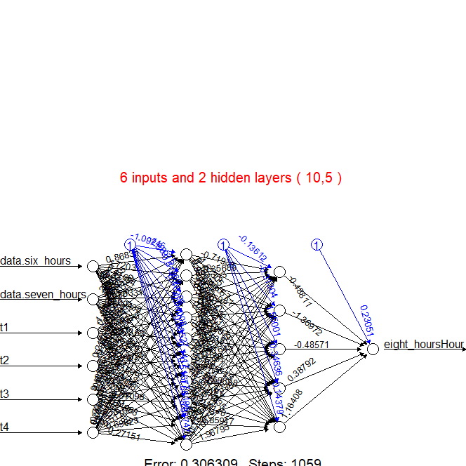

### 2.3.4. Comparison table

|  |  |  |  |  |  |  |  |  |  |
| --- | --- | --- | --- | --- | --- | --- | --- | --- | --- |
| ***Input count*** | ***Hidden layers*** | ***neurons*** | ***Activation function*** | ***Linear*** | ***Accuracy*** | ***RMSE*** | ***MAE*** | ***MAPE*** | ***sMAPE*** |
| 3 | 1 | 5 | logistic | TRUE | 94.1 % | 2.688929 | 2.310642 | 0.05896598 | 0.05660477 |
|  | | | | | | | | | |
| 4 | 1 | 10 | logistic | TRUE | 94.19 % | 2.681459 | 2.288516 | 0.05826366 | 0.05593023 |
|  | | | | | | | | | |
| 5 | 1 | 15 | logistic | TRUE | 94.3 % | 2.64334 | 2.257533 | 0.05713579 | 0.05490405 |
|  | | | | | | | | | |
| 6 | 2 | 10,5 | logistic | TRUE | 94.18 % | 2.660069 | 2.299145 | 0.05816606 | 0.05591089 |
|  | | | | | | | | | |
| 7 | 2 | 15,5 | logistic | TRUE | 94.25 % | 2.663941 | 2.290847 | 0.05779902 | 0.0555692 |
| 2 | 6,3 | logistic | TRUE | 94.04 % | 2.750781 | 2.372198 | 0.05980683 | 0.0574475 |

Table :comparison_table_2nd

### 2.3.5. Best MLP network

#### 2.3.5.1. Top MLP model for augmented reality

The neural network with seven inputs and five neurons in the hidden layer is the optimal MLP network for the AR approach. This network should be chosen because it has a higher degree of accuracy than others. The graph depicting actual versus predicted values is shown below.

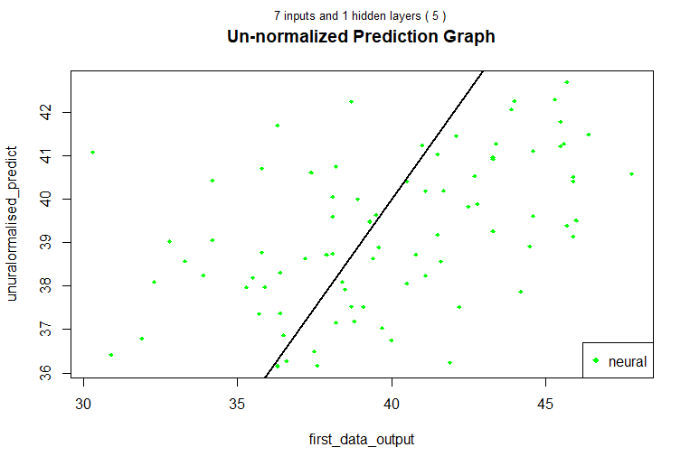

Figure :best_MLP_AR_Approch

#### 2.3.5.2. Top MLP network for NARX design

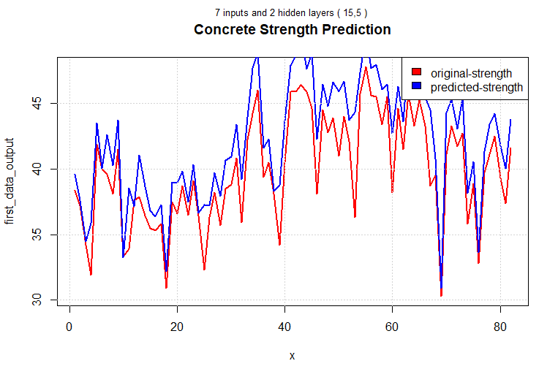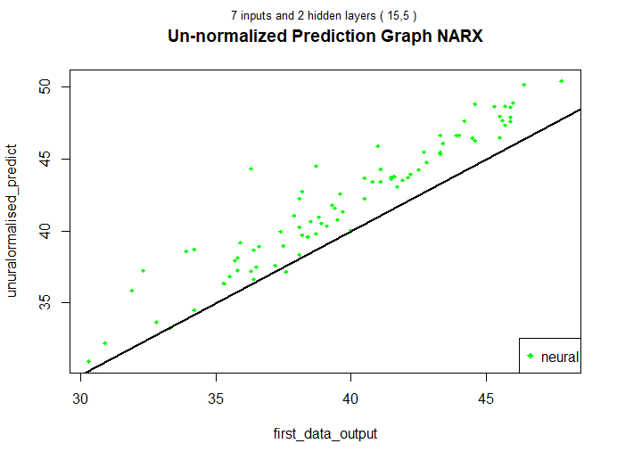The neural network with seven inputs and fifteen and five neurons in the two hidden layers is regarded as the optimal MLP network for the NARX approach. This network should be chosen because it has a higher degree of accuracy than others. The actual versus predicted graph is depicted in the figure below.

Figure :Best_MLP_NARX_network

# References

Cortez, P., 2022. UCI Machine Learning Repository: Wine Quality Data Set. [online] Archive.ics.uci.edu.Available at: <https://archive.ics.uci.edu/ml/datasets/wine+quality> [Accessed 13 April 2022].

Grob, A., Lenders, A., Schwenker, F., Braun, D. and Fischer, D., 2021. Comparison of short-term

electrical load forecasting methods for different building types.

Hammad, M., Jereb, B., Rosi, B. and Dragan, D., 2020. Methods and Models for Electric Load

Forecasting: A Comprehensive Review. [online] Sciendo.com. Available at: <https://sciendo.com/pdf/10.2478/jlst-2020-0004> [Accessed 1 May 2022].

Khan, M., 2018. White Wine Exploratory Data Analysis. [online] Rstudio-pubsstatic.s3.amazonaws.com. Available at: <https://rstudio-pubsstatic.s3.amazonaws.com/377211_0f3055951ba34266aa8a5ba28cf45cfe.html> [Accessed 4 April 2022].

Rpubs.com. 2021. RPubs - K-means clustering analysis of the white wine dataset using RStudio. [online] Available at: <https://rpubs.com/HassanOUKHOUYA/K-means> [Accessed 4 April 2022].

Singh, A., Ibraheem, Khatoon, S., Muazzam, M. and Chaturvedi, D., 2022. Load forecasting techniques and methodologies: A review. [online] Ieeexplore.ieee.org. Available at: <https://ieeexplore.ieee.org/stamp/stamp.jsp?tp=&arnumber=6508132> [Accessed 1 May 2022].

Verilog, C., 2019. Load Forecasting using Artificial Neural Networks. [online] Available at: <https://www.google.com/url?sa=t&rct=j&q=&esrc=s&source=video&cd=&cad=rja&uact=8&ved=2ahUKEwiU1sjrz9D3AhVYeXAKHTYYCF0QtwJ6BAgPEAI&url=https%3A%2F%2Fwww.youtube.com%2Fwatch%3Fv%3D_eeqqQbKUF8&usg=AOvVaw2m8OQR42lRtHzEtR4Zfset> [Accessed 1 April 2022].

Views, R., 2020. Building A Neural Net from Scratch Using R - Part 1. [online] Rviews.rstudio.com. Available at: <https://rviews.rstudio.com/2020/07/20/shallow-neural-net-from-scratch-using-rpart-1/> [Accessed 2 April 2022]

Goodfellow, I., Bengio, Y., & Courville, A. (2016). Deep Learning (Adaptive Computation and Machine Learning series). MIT Press.

Bishop, C. M. (1995). Neural Networks for Pattern Recognition. Oxford University Press.

Haykin, S. (2009). Neural Networks and Learning Machines (3rd ed.). Prentice Hall.

Rumelhart, D. E., Hinton, G. E., & Williams, R. J. (1986). Learning Internal Representations by Error Propagation. In Parallel Distributed Processing: Explorations in the Microstructure of Cognition (Vol. 1). MIT Press.

Nielsen, M. A. (2015). Neural Networks and Deep Learning: A Textbook. Determination Press.

Hinton, G. E., & Salakhutdinov, R. R. (2006). Reducing the dimensionality of data with neural networks. Science, 313(5786), 504-507.

# Appendix

## Part 01

library(readxl)

library(dplyr)

library(fpc)

library(MASS)

library(ggplot2)

library(ggcorrplot)

library(caret)

library(flexclust)

library(factoextra)

library(NbClust)

library(caret)

library(ggfortify)

library(FactoMineR)

library(cluster)

# Read the XLSX file by opening it.

Vehicles_dataset <- read_excel("F://SEMESTER 02//5DATA001C.2 Machine Learning and Data Mining//CW//MyCW//vehicles.xlsx")

# Delete the first column.

Vehicles_dataset <- Vehicles_dataset[-1]

# Examine the data type to determine which columns are strings.

string_cols <- sapply(Vehicles_dataset, class) == "character"

#Use the subset function to eliminate the string column(s).

data <- Vehicles_dataset[, !string_cols]

View(data)

boxplot(data, main = "Before Outlier Removal", outcol="red")

# Before removing the outliers, count the rows and columns and print the results.

rows_of_dataset <- nrow(data)

columns_of_dataset <- ncol(data)

# print the results

cat("Rows to delete before outliers :", rows_of_dataset, "\n")

cat("columns to delete before outliers:", columns_of_dataset, "\n")

# Create a function to remove outliers from a single column using the boxplot method.

outliers_remove <- function(x) {

bp <- boxplot.stats(x)$stats

x[x < bp[1] | x > bp[5]] <- NA

return(x)

}

# Apply the function to each data frame column.

whithout_outliers_dataset <- apply(data, 2, outliers_remove)

# Remove any rows with missing values

whithout_outliers_dataset <- na.omit(whithout_outliers_dataset)

# After removing the outliers, count the rows and columns and print the results.

rows_of_dataset <- nrow(whithout_outliers_dataset)

columns_of_dataset <- ncol(whithout_outliers_dataset)

# print the results

cat("Rows to delete before outliers :", rows_of_dataset, "\n")

cat("Columns to delete before outliers:", columns_of_dataset, "\n")

boxplot(whithout_outliers_dataset,main = "After Outlier Removal")

# Scale up the data set.

scaled_Vehicles_dataset <- scale(whithout_outliers_dataset)

head(scaled_Vehicles_dataset)

boxplot(scaled_Vehicles_dataset)

# Nbclust method

# Set the random seed to 1234 for reproducibility

set.seed(1234)

NBcluster <- NbClust(scaled_Vehicles_dataset, min.nc = 2,max.nc = 10, method = "kmeans")

# table(NBcluster$Best.n[1,])

barplot(table(NBcluster$Best.n[1,]),

xlab="Numer of Clusters",

ylab="Number of Criteria",

main="Number of Clusters Chosen")

# elbow method

fviz_nbclust(scaled_Vehicles_dataset,kmeans,method = "wss")

# silhouette method

fviz_nbclust(scaled_Vehicles_dataset,kmeans,method = "silhouette")

# gap static method

fviz_nbclust(scaled_Vehicles_dataset,kmeans,method = "gap_stat")

# 2 clusters

k2 <-kmeans(scaled_Vehicles_dataset, 2)

k2

autoplot(k2,scaled_Vehicles_dataset,frame=TRUE)

# When k=2, Extract relevant information.

# Cluster centers

cluster_centers <- k2$centers

# Clustered results

cluster_assignments <- k2$cluster

# Between-cluster sum of squares

BSSk2 <- k2$betweenss

# Within-cluster sum of squares

WSSk2 <- k2$tot.withinss

# Total sum of squares

TSSk2 <- BSSk2 + WSSk2

# BSS/TSS ratio

BSS_TSS_ratiok2 <- BSSk2 / TSSk2

# Percentage of variance explained

percent_vark2 <- round(BSS_TSS_ratiok2 * 100, 3)

# Output results

cat("Cluster centers:\n", cluster_centers, "\n\n")

cat("Cluster assignments:\n", cluster_assignments, "\n\n")

cat("BSS/TSS ratio: ", round(BSS_TSS_ratiok2, 3), "\n\n")

cat("BSS: ", round(BSSk2, 3), "\n\n")

cat("WSS: ", round(WSSk2, 3), "\n\n")

cat("Percentage of variance explained: ", percent_vark2, "%\n")

#3 clusters

k3 <-kmeans(scaled_Vehicles_dataset, 3)

k3

autoplot(k3,scaled_Vehicles_dataset,frame=TRUE)

# When k=3, Extract relevant information

# Cluster centers

cluster_centers <- k3$centers

# Clustered results

cluster_assignments <- k3$cluster

# Between-cluster sum of squares

BSSk3 <- k3$betweenss

# Within-cluster sum of squares

WSSk3 <- k3$tot.withinss

# Total sum of squares

TSSk3 <- BSSk3 + WSSk3

# BSS/TSS ratio

BSS_TSS_ratiok3 <- BSSk3 / TSSk3

# Percentage of variance explained

percent_vark3 <- round(BSS_TSS_ratiok3 * 100, 3)

# Output results

cat("Cluster centers:\n", cluster_centers, "\n\n")

cat("Cluster assignments:\n", cluster_assignments, "\n\n")

cat("BSS/TSS ratio: ", round(BSS_TSS_ratiok3, 3), "\n\n")

cat("BSS: ", round(BSSk3, 3), "\n\n")

cat("WSS: ", round(WSSk3, 3), "\n\n")

cat("Percentage of variance explained: ", percent_vark3, "%\n")

# When Fit k-means model with k=2

k <- 2

part01_kmeans_model_2 <- kmeans(scaled_Vehicles_dataset, centers = k, nstart = 25)

# Generate silhouette plot

silhouette_plot2 <- silhouette(part01_kmeans_model_2$cluster, dist(scaled_Vehicles_dataset))

# Determine the typical silhouette's width.

avg_silhouette_width <- mean(silhouette_plot2[, 3])

# Plot the silhouette plot

plot(silhouette_plot2, main = paste0("Silhouette Plot for k =", k),

xlab = "Silhouette Width", ylab = "Cluster", border = NA)

# As a vertical line, add the average silhouette width.

abline(v = avg_silhouette_width, lty = 2, lwd = 2, col = "red")

# When Fit k-means model with k=3

k <- 3

part01_kmeans_model_3 <- kmeans(scaled_Vehicles_dataset, centers = k, nstart = 25)

# Generate silhouette plot

silhouette_plot3 <- silhouette(part01_kmeans_model_3$cluster, dist(scaled_Vehicles_dataset))

# Determine the typical silhouette's width.

avg_silhouette_width <- mean(silhouette_plot3[, 3])

# Plot the silhouette plot

plot(silhouette_plot3, main = paste0("Silhouette Plot for k =", k),

xlab = "Silhouette Width", ylab = "Cluster", border = NA)

# As a vertical line, add the average silhouette width.

abline(v = avg_silhouette_width, lty = 2, lwd = 2, col = "red")

####################################################################################################################################################################################################################

# Conduct a PCA analysis.

pca <- prcomp(scaled_Vehicles_dataset)

# Print the eigenvectors and eigenvalues

print(summary(pca))

# Calculate the principal component (PC) cumulative score.

pca_var <- pca$sdev^2

pca_var_prop <- pca_var / sum(pca_var)

pca_var_cumprop <- cumsum(pca_var_prop)

# Cumulative plot score for each PC

plot(pca_var_cumprop, xlab = "Principal Component", ylab = "Explained Cumulative Proportion of Variance",

ylim = c(0, 1), type = "b")

# Make a new converted dataset with attributes representing the principal components.

pca_trans <- predict(pca, newdata = scaled_Vehicles_dataset)

# Select computers with a minimum cumulative score of over 92%.

selected_pcs <- which(pca_var_cumprop > 0.92)

transformed_data <- pca_trans[, selected_pcs]

boxplot(transformed_data)

View(transformed_data)

#Nbclust method

set.seed(1234)

NBcluster <- NbClust(transformed_data, min.nc = 2,max.nc = 10, method = "kmeans")

barplot(table(NBcluster$Best.n[1,]),

xlab="Numer of Clusters",

ylab="Number of Criteria",

main="Number of Clusters Chosen after PCA2")

#elbow method

fviz_nbclust(transformed_data,kmeans,method = "wss")

#silhouette method

fviz_nbclust(transformed_data,kmeans,method = "silhouette")

#gap static method

fviz_nbclust(transformed_data,kmeans,method = "gap_stat")

# Perform k-means clustering with k=2

set.seed(1234)

kmeans_model_2 <- kmeans(transformed_data, centers = 2, nstart = 25)

# Print the k-means output

print(kmeans_model_2)

autoplot(kmeans_model_2,transformed_data,frame=TRUE)

cat("For k=2:\n")

# Calculate the within-cluster sum of squares (WSS)

wss_2 <- sum(kmeans_model_2$withinss)

# Print the WSS

cat("Within-cluster sum of squares (WSS): ", wss_2, "\n")

# Calculate the between-cluster sum of squares (BSS)

bss_2 <- sum(kmeans_model_2$size * dist(rbind(kmeans_model_2$centers, colMeans(transformed_data)))^2)

# Print the BSS

cat("Between-cluster sum of squares (BSS): ", bss_2, "\n")

# Calculate the total sum of squares (TSS)

tss_2 <- sum(dist(transformed_data)^2)

# Print the TSS

cat("Total sum of squares (TSS): ", tss_2, "\n")

# Calculate the ratio of BSS to TSS

bss_tss_ratio_2 <- bss_2 / tss_2

# Print the ratio of BSS to TSS

cat("Ratio of BSS to TSS: ", bss_tss_ratio_2, "\n\n")

# Perform k-means clustering with k=3

set.seed(1234)

kmeans_model_3 <- kmeans(transformed_data, centers = 3, nstart = 25)

# Print the k-means output

print(kmeans_model_3)

autoplot(kmeans_model_3,transformed_data,frame=TRUE)

cat("For k=3:\n")

# Calculate the within-cluster sum of squares (WSS)

wss_3 <- sum(kmeans_model_3$withinss)

# Print the WSS

cat("Within-cluster sum of squares (WSS): ", wss_3, "\n")

# Calculate the between-cluster sum of squares (BSS)

bss_3 <- sum(kmeans_model_3$size * dist(rbind(kmeans_model_3$centers, colMeans(transformed_data)))^2)

# Print the BSS

cat("Between-cluster sum of squares (BSS): ", bss_3, "\n")

# Calculate the total sum of squares (TSS)

tss_3 <- sum(dist(transformed_data)^2)

# Print the TSS

cat("Total sum of squares (TSS): ", tss_3, "\n")

# Calculate the ratio of BSS to TSS

bss_tss_ratio_3 <- bss_3 / tss_3

# Print the ratio of BSS to TSS

cat("Ratio of BSS to TSS: ", bss_tss_ratio_3, "\n")

# Construct a k-means model with k=2

k <- 2

kmeans_model_2 <- kmeans(transformed_data, centers = k, nstart = 25)

# Generate silhouette plot

silhouette_plot <- silhouette(kmeans_model_2$cluster, dist(transformed_data))

# Determine the typical silhouette's width.

avg_silhouette_width <- mean(silhouette_plot[, 3])

# Plot the silhouette plot

plot(silhouette_plot, main = paste0("Silhouette Plot for k =", k),

xlab = "Silhouette Width", ylab = "Cluster", border = NA)

# As a vertical line, add the average silhouette width.

abline(v = avg_silhouette_width, lty = 2, lwd = 2, col = "red")

# Construct a k-means model with k=3

k <- 3

kmeans_model_3 <- kmeans(transformed_data, centers = k, nstart = 25)

# Generate silhouette plot

silhouette_plot <- silhouette(kmeans_model_3$cluster, dist(transformed_data))

# Determine the typical silhouette's width.

avg_silhouette_width <- mean(silhouette_plot[, 3])

# Plot the silhouette plot

plot(silhouette_plot, main = paste0("Silhouette Plot for k =", k),

xlab = "Silhouette Width", ylab = "Cluster", border = NA)

# As a vertical line, add the average silhouette width.

abline(v = avg_silhouette_width, lty = 2, lwd = 2, col = "red")

# Define a function to calculate the Calinski-Harabasz index for a given K-means clustering result and data

calinski_harabasz_pca2 <- function(cluster_result, data) {

# Extract the number of clusters from the clustering result

k2 <- length(unique(cluster_result$cluster))

# Extract the number of rows in the data

n2 <- nrow(data)

# Extract the between-cluster sum of squares (BSS) and within-cluster sum of squares (WSS) from the clustering result

BSS2 <- cluster_result$betweenss

WSS2 <- cluster_result$tot.withinss

# Calculate the Calinski-Harabasz index

ch_index2 <- ((n2 - k2) / (k2 - 1)) * (BSS2 / WSS2)

# Return the Calinski-Harabasz index

return(ch_index2)

}

# Call the calinski_harabasz_pca function to calculate the index for a specific K-means clustering result and data

ch_index_pca_2 <- calinski_harabasz_pca2(kmeans_model_2, transformed_data)

# Print the calculated index to the console for interpretation

cat("The Calinski-Harabasz index for the K-means (k=2) clustering result is:", ch_index_pca_2, "\n")

# Define a function to calculate the Calinski-Harabasz index for a given K-means clustering result and data

calinski_harabasz_pca3 <- function(cluster_result, data) {

# Extract the number of clusters from the clustering result

k3 <- length(unique(cluster_result$cluster))

# Extract the number of rows in the data

n3 <- nrow(data)

# Extract the between-cluster sum of squares (BSS) and within-cluster sum of squares (WSS) from the clustering result

BSS3 <- cluster_result$betweenss

WSS3 <- cluster_result$tot.withinss

# Calculate the Calinski-Harabasz index

ch_index3 <- ((n3 - k3) / (k3 - 1)) * (BSS3 / WSS3)

# Return the Calinski-Harabasz index

return(ch_index3)

}

# Call the calinski_harabasz_pca function to calculate the index for kmeans_model_3 and transformed_data

ch_index_pca_3 <- calinski_harabasz_pca3(kmeans_model_3, transformed_data)

# Print the calculated index to the console for interpretation

cat("The Calinski-Harabasz index for the K-means (k=3) clustering result is:", ch_index_pca_3, "\n")

## Part 02

# import libraries

library(readxl)

library(dplyr)

library(neuralnet)

library(Metrics)

library(grid)

library(gridExtra)

# import dataset

data <- read_excel("F://SEMESTER 02//5DATA001C.2 Machine Learning and Data Mining//CW//MyCW//uow_consumption.xlsx", sheet = 1)

# change column names

names(data)[2] <- 'six_hours'

names(data)[3] <- 'seven_hours'

names(data)[4] <- 'eight_hours'

# change date to numeric

date <-factor(data$date)

date <-as.numeric(date)

# create data frame

uow_dataFrame <- data.frame(date,data$'six_hours',data$'seven_hours',data$'eight_hours')

# plot the eight_hours_column

eight_hours_column <- c(uow_dataFrame$data.eight_hours)

plot(eight_hours_column, type = "l")

# create a I/O matrix

time_delayed_matrix <- bind_cols(t7 = lag(eight_hours_column,8),

t4 = lag(eight_hours_column,5),

t3 = lag(eight_hours_column,4),

t2 = lag(eight_hours_column,3),

t1 = lag(eight_hours_column,2),

eight_hoursHour = eight_hours_column)

delayed_matrix <- na.omit(time_delayed_matrix)

# Separating dataset into test and training sets.

train_dataset <- delayed_matrix[1:380,]

test_dataset <- delayed_matrix[381:nrow(delayed_matrix),]

# Determining the minimum and maximum values in the training set

first_min_value <- min(train_dataset)

first_max_value <- max(train_dataset)

# Extracting the output data from the testing dataset

first_data_output <- test_dataset$eight_hoursHour

# normalization function

normalization <- function(x){

return ((x - min(x)) / (max(x) - min(x)))

}

# Un-normalization function

un_normalization <- function(x, min, max) {

return( (max - min)*x + min )

}

# The normalization function is used to normalise the data.

time_delayedNormaliz <- as.data.frame(lapply(delayed_matrix[1:ncol(delayed_matrix)], normalization))

# Separating the normalised data into test and train sets

train_datasetNormaliz <- time_delayedNormaliz[1:380,]

test_datasetNormaliz <- time_delayedNormaliz[381:nrow(delayed_matrix),]

# See how the data looks like before and after normalisation with a Boxplot

boxplot(delayed_matrix, main="before normalizing data")

boxplot(time_delayedNormaliz, main="After normalizing data")

# Producing Test Information for Each and EveryDelay

t1_testDataSet <- as.data.frame(test_datasetNormaliz[, c("t1")])

t2_testDataSet <- test_datasetNormaliz[, c("t1", "t2")]

t3_testDataSet <- test_datasetNormaliz[, c("t1", "t2", "t3")]

t4_testDataSet <- test_datasetNormaliz[, c("t1", "t2", "t3", "t4")]

t7_testDataSet <- test_datasetNormaliz[, c("t1", "t2", "t3", "t4", "t7")]

#Function to train an AR model

ModelTrain <- function(formula, hiddenVal, isLinear, actFunc,inputs,hidden){

# Defining a title for the plot

my_title <- paste(inputs,"inputs and",length(hidden),"hidden layers","(",paste(hidden, collapse=","),") \n")

# Establishing a reproducible seed

set.seed(1234)

# The neuralnet method is used to train a model of a neural network.

nural <- neuralnet(formula, data = train_datasetNormaliz, hidden = hiddenVal, act.fct = actFunc, linear.output = isLinear)

# Using a neural network to generate a plot

plot(nural)

# Keeping the plot in a variable

plot_panel <- grid.grab(wrap = TRUE)

# Creating a title grob

plot_title <- textGrob(my_title,

x = .5, y = .20,

gp = gpar(lineheight_hours = 2,

fontsize = 15, col = 'red',

adj = c(1, 0)

)

)

# Stacking the title and main panel, and plotting

grid.arrange(

grobs = list(plot_title,

plot_panel),

height_hourss = unit(c(.15, .85), units = "npc"),

width = unit(1, "npc")

)

dev.new()

dev.off()

return(nural)

}

# Define function ModelTest with input arguments nuralModel, testing_df, inputs, hidden

ModelTest <- function(nuralModel, testing_df, inputs, hidden){

# Print the number of inputs and hidden layers specified

cat("There are", inputs, "inputs and", length(hidden), "hidden layers", "(", paste(hidden, collapse=","), ") \n")

# Create a title for the plots based on the inputs and hidden layers specified

my_title <- paste(inputs, "inputs and", length(hidden), "hidden layers", "(", paste(hidden, collapse=","), ") \n")

# Use the test data to calculate the output of the neural network.

nnResults <- compute(nuralModel, testing_df)

# Extract the predicted values and un-normalize them using the min and max values of the original data

predict <- nnResults$net.result

unuralormalised_predict <- un_normalization(predict, first_min_value, first_max_value)

# Find the difference between your expected results and the actual ones.

devia = ((first_data_output - unuralormalised_predict) / first_data_output)

# Calculate the model accuracy as 1 minus the absolute mean deviation

modelAccu = 1 - abs(mean(devia))

accuracy = round(modelAccu * 100, digits = 2)

# Plot the predicted vs. actual output values with the un-normalized data

plot(first_data_output, unuralormalised_predict, col = 'green', main = "Un-normalized Prediction Graph", pch = 18, cex = 0.7)

mtext(my_title, side = 3, line = 2, cex = 0.8)

abline(0,1,lwd=2)

legend("bottomright", legend = 'neural', pch = 18, col = 'green')

# Create a new plot showing the original output values vs. the predicted values with un-normalized data

x = 1:length(first_data_output)

plot(x, first_data_output, col = "red", type = "l", lwd=2, main = "Concrete Strength Prediction")

mtext(my_title, side = 3, line = 2, cex = 0.8)

lines(x, unuralormalised_predict, col = "blue", lwd=2)

legend("topright", legend = c("original-strength", "predicted-strength"), fill = c("red", "blue"), col = 2:3, adj = c(0, 0.6))

grid()

# Calculate the RMSE, MAE, MAPE, and sMAPE metrics for the model

rmse = rmse(first_data_output, unuralormalised_predict)

mae = mae(first_data_output, unuralormalised_predict)

mape = mape(first_data_output, unuralormalised_predict)

smape = smape(first_data_output, unuralormalised_predict)

# Get the model's RMSE, MAE, MAPE, and sMAPE values.

cat("Model Accuracy:", accuracy, "%\n")

cat("RMSE:", rmse, "\n")

cat("MAE:", mae, "\n")

cat("MAPE:", mape, "\n")

cat("sMAPE:", smape, "\n")

cat("\n\n")

# Return the un-normalized predicted output values

return(unuralormalised_predict)

}

# t1 with different hidden layer sizes

hidden_layers <- list( c(6),c(5, 3))

# loop through different hidden layer sizes

for (i in seq_along(hidden_layers)) {

# train model using t1 as input and current hidden layer size

model <- ModelTrain(eight_hoursHour ~ t1, hidden_layers[[i]], isLinear = FALSE, "tanh",1,hidden_layers[[i]])

# test model on t1_testDataSet

pred <- ModelTest(model, t1_testDataSet,1,hidden_layers[[i]])

}

# t2 with different hidden layer sizes

# train model using t1 and t2 as input and hidden layer size of 10

t2_train <- ModelTrain(eight_hoursHour ~ t1 + t2, c(10),isLinear = TRUE, "logistic",2,c(10))

# test model on t2_testDataSet

test_t2_predict <- ModelTest(t2_train, t2_testDataSet,2,c(10))

# t3 with different hidden layer sizes

hidden_layers <- list( c(5),c(10),c(5,4))

# loop through different hidden layer sizes

for (i in seq_along(hidden_layers)) {

# train model using t1, t2, and t3 as input and current hidden layer size

model <- ModelTrain(eight_hoursHour ~ t1 + t2 + t3 ,hidden_layers[[i]],isLinear = TRUE, "logistic",3,hidden_layers[[i]])

# test model on t3_testDataSet

pred <- ModelTest(model, t3_testDataSet,3,hidden_layers[[i]])

}

# t4 with different hidden layer sizes

hidden_layers <- list( c(5),c(15),c(5,2),c(10,5))

# loop through different hidden layer sizes

for (i in seq_along(hidden_layers)) {

# train model using t1, t2, t3, and t4 as input and current hidden layer size

model <- ModelTrain(eight_hoursHour ~ t1 + t2 + t3 + t4,hidden_layers[[i]],isLinear = TRUE, "logistic",4,hidden_layers[[i]])

# test model on t4_testDataSet

pred <- ModelTest(model, t4_testDataSet,4,hidden_layers[[i]])

}

# t7 with different hidden layer sizes

hidden_layers <- list( c(5),c(10),c(6,4),c(8,5),c(10,5))

# loop through different hidden layer sizes

for (i in seq_along(hidden_layers)) {

# train model using t1, t2, t3, t4, and t7 as input and current hidden layer size

model <- ModelTrain(eight_hoursHour ~ t1 + t2 + t3 + t4 + t7,hidden_layers[[i]],isLinear = TRUE, "logistic",7,hidden_layers[[i]])

# test model on t7_testDataSet

pred <- ModelTest(model, t7_testDataSet,7,hidden_layers[[i]])

}

#-------------------------------------------------------------------------------------------------#

# combine six_hours and seven_hours columns

delayed_matrix <- cbind(uow_dataFrame[,2:3], time_delayed_matrix)

# Remove rows with missing values

delayed_matrix <- na.omit(delayed_matrix)

# Separate data into a training set and a testing set.

train_dataset <- delayed_matrix[1:380,]

test_dataset <- delayed_matrix[381:nrow(delayed_matrix),]

# Determine the training dataset's minimum and maximum values.

first_min_value <- min(train_dataset)

first_max_value <- max(train_dataset)

# Get the output data for the test dataset

first_data_output <- test_dataset$eight_hoursHour

# Apply normalization to the dataset

time_delayedNormaliz <- as.data.frame(lapply(delayed_matrix[1:ncol(delayed_matrix)], normalization))

# Separate the normalised data set into a training set and a test set.

train_datasetNormaliz <- time_delayedNormaliz[1:380,]

test_datasetNormaliz <- time_delayedNormaliz[381:nrow(delayed_matrix),]

# Plot boxplots to visualize the data before and after normalization

boxplot(delayed_matrix, main="before normalizating data")

boxplot(time_delayedNormaliz, main="After normalizating data")

# Create testing data for each timeDelay

t1_testDataSet <- test_datasetNormaliz[, c("data.six_hours","data.seven_hours", "t1")]

t2_testDataSet <- test_datasetNormaliz[, c("data.six_hours","data.seven_hours", "t1", "t2")]

t3_testDataSet <- test_datasetNormaliz[, c("data.six_hours","data.seven_hours", "t1", "t2", "t3")]

t4_testDataSet <- test_datasetNormaliz[, c("data.six_hours","data.seven_hours", "t1", "t2", "t3", "t4")]

t7_testDataSet <- test_datasetNormaliz[, c("data.six_hours","data.seven_hours", "t1", "t2", "t3", "t4", "t7")]

# Define the input features and their corresponding test data

inputs <- c("t1", "t2", "t3","t4","t7")

test_dataset <- list(t1_testDataSet, t2_testDataSet, t3_testDataSet, t4_testDataSet, t7_testDataSet)

# Define the different hidden layer configurations to test

h1 <- list(c(5))

h2 <- list(c(10))

h3 <- list(c(15))

h4 <- list(c(10,5))

h5 <- list(c(15,5),c(6,3))

hidden_layers <- list(h1,h2,h3,h4,h5)

# Loop through the different numbers of input variables

for (i in seq_along(inputs)) {

# Iterate over the possible arrangements of hidden layers given the current number of input variables.

for(j in seq_along(hidden_layers[[i]])){

# Get the current input variables

current_inputs <- inputs[1:i]

# Get the current hidden layer configuration

currentHidden <- hidden_layers[[i]][[j]]

# Train the model using the current input variables and hidden layer configuration

formula <- as.formula(paste("eight_hoursHour ~ data.six_hours + data.seven_hours +", paste(current_inputs, collapse="+")))

model <- ModelTrain(formula, currentHidden, isLinear = TRUE, "logistic", (length(current_inputs)+2), currentHidden)

# Test the model using the test dataset and print the predictions

test_predict <- ModelTest(model, test_dataset[[i]], (length(current_inputs)+2), currentHidden)

}

}